May is the time to capture the progress that your students have made on CollegeInColorado.org by running your end of the year reports. Each student’s grade level will be updated in the system on July 1st.

Sign into your Professional Center account [http://procenter.collegeincolorado.org].
If you do not have a professional center account, please click on Create a Professional Center Account. To obtain a Professional Account Access Key (PAAK) or Administrator Code, contact Twyla Esquibel at Twyla.Esquibel@cic.state.co.us
- ENSURE REPORT ACCURACY
Review and update any student groups you have created (in this example, we use the concurrent enrollment student group I created):
  - Click on the Students & Groups tab
  - Click on the group name you wish to review in the Groups panel
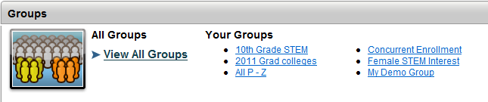

  - Review the list of students for accuracy; who is missing; who is obsolete?

  - To remove names from the group, click the check box next to student name(s), click the Remove From Group button
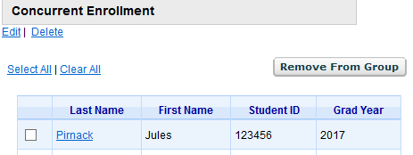

  - To add names to the group, click on Students & Groups tab; use the Search box, Browse by Class or Last Name in the Students panel to find student(s)

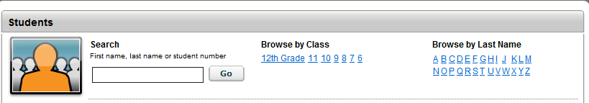

  - Click the check box next to student name(s), click the arrow in the Add selected to group box, click on your group name, click Add button
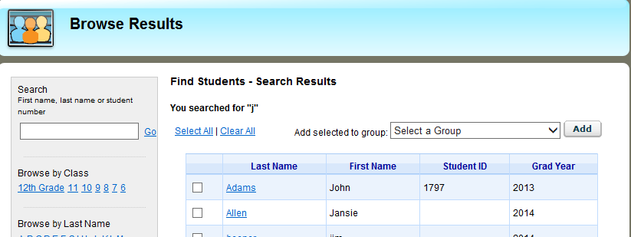

Review and update system-defined groups:
- Click on Students & Groups tab
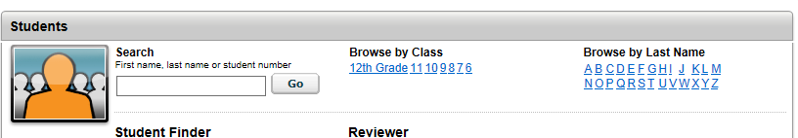
- Click on the class list you wish to review in the Students panel

- To remove a student from a class list:
- If the student’s graduation year is incorrect, the student must correct it by signing in to their CollegeInColorado.org account, clicking Your Portfolio > Your Profile > The Basics > Edit > Year of Graduation
- If the student has graduated or left your school, click on Students & Groups tab, then Release Student Accounts in the Manage Student Accounts panel
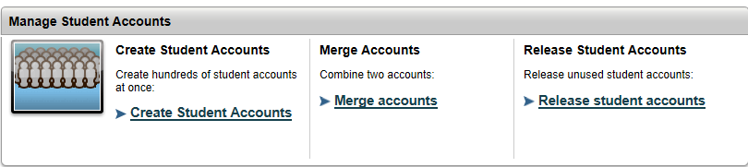
To add a student to a class list:
- If the student’s graduation year is incorrect, the student must correct it by signing in to their CollegeInColorado.org account, clicking Your Portfolio > Your Profile > The Basics > Edit > Year of Graduation
- If the student does not have a CollegeInColorado.org account, *the student must create an account, entering the correct graduation year during the process. If the student has an account but is not listed in the system at your school, the student must connect their account to your school (Your Portfolio > Your Profile > The Basics)

*Except in Customized Portfolio districts new students will have an account created for them during the next processing cycle.

- DETERMINE THE REPORTS MOST SUITED TO YOUR SCHOOL
IMPLEMENTED SITE SET UP | REPORT TO RUN
Individual Career and Academic Planning Page (ICAP)  You set up the system so that students see an ICAP in their portfolio  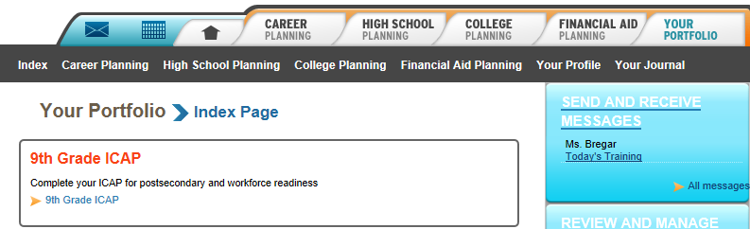 | ICAP Tracking Report
Milestones  You set up the system so that students see milestones in their portfolio  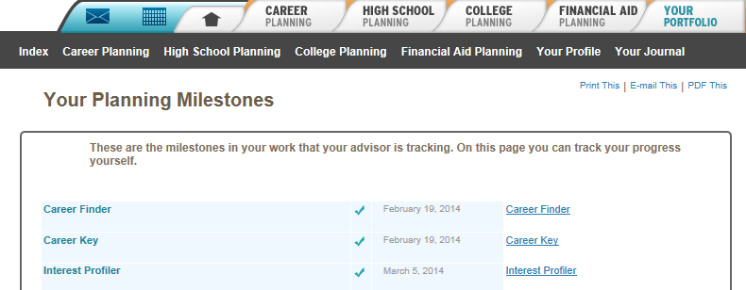 | Milestone Tracking Reports
Online Coursework Planning  Students complete their coursework plan online  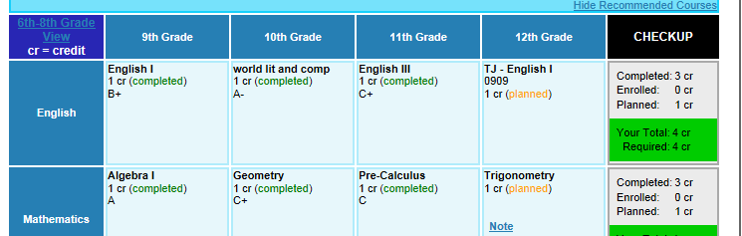 | Tracking Plans of Study
Guideways  You have students using grade level or ICAP Guideways  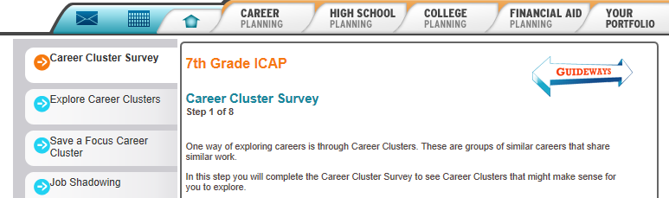 | Guideways Tracking Report
Single Activity  You expect student to complete specific activities but may not have set up the system with an ICAP page, Milestones or Guideways | Dozens of single activity usage and outcome pre-formatted reports

- CREATE AND RUN REPORTS
Sign into your Professional Center account [http://procenter.collegeincolorado.org] for student record-level reports or Report Central [www.ReportCentral.XAP.com] for aggregated, district-level reports.
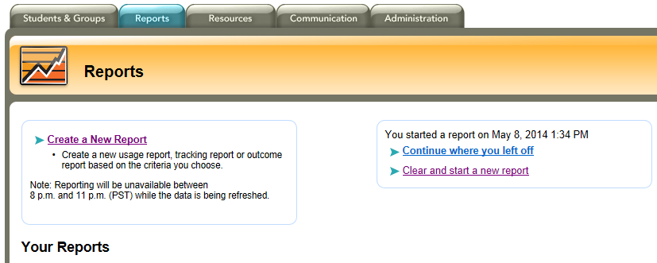
Click on the Reports tab

Click on Create a New Report then click on the report title of interest
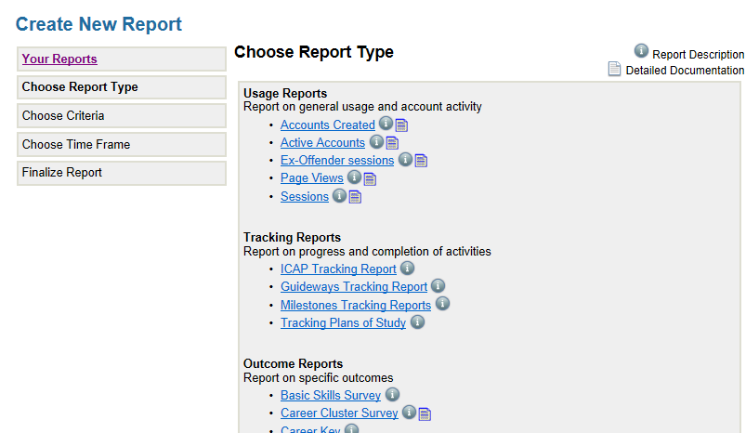

Note that you may roll over the icons next to the report name to receive a description and, if available, detailed documentation about the report
Choose criteria for your report as well as time frame and graphic display elements as applicable

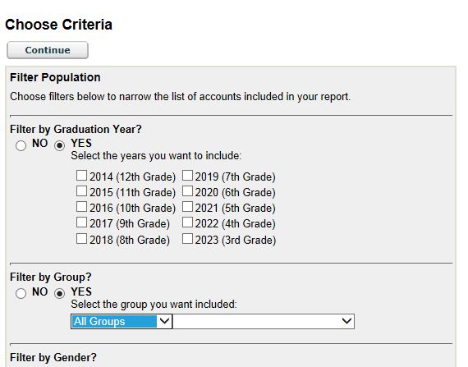

Note that in many cases, a graduation year or group filter will be most effective to really understand report results sets. This is why it is critical to ensure your groups are accurate.

Be sure to explore output options fully

Many reports will allow you to select a timeline
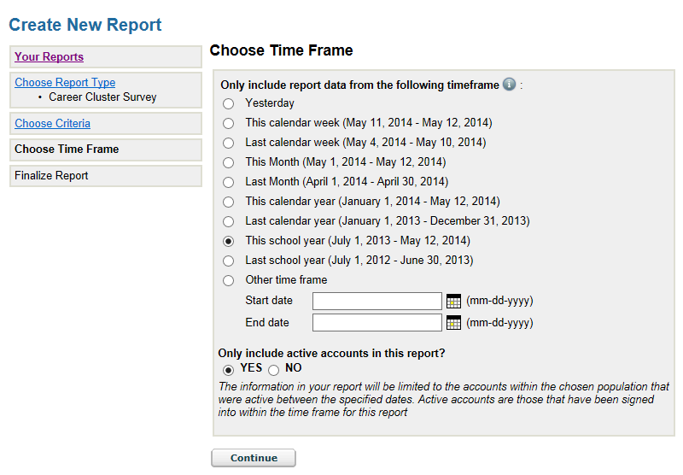

And many have a Display Graphs option
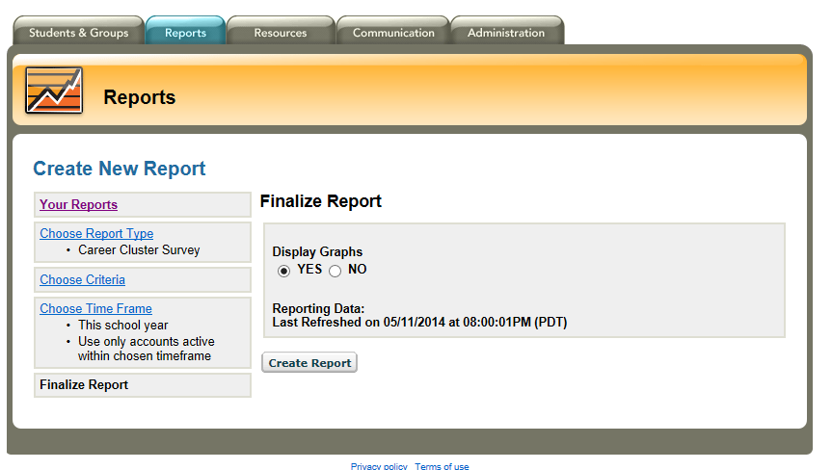

Be sure to print, save or export your report results.
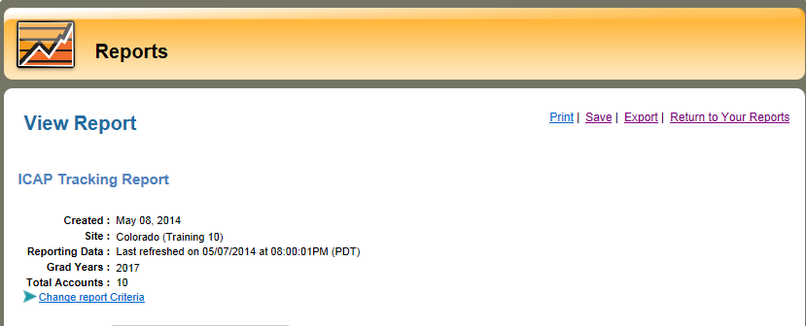

Note: The Export to Excel feature includes a data sheet that displays student ID information with detailed data for sorting, matching, analyzing and saving at the record level. This will allow you to add data as necessary for each student as they move through each grade.

For Example, the ICAP Tracking Report has three levels of summary and detailed student data…

First Level for 9th graders in my Colorado Training School summary for the whole ICAP:

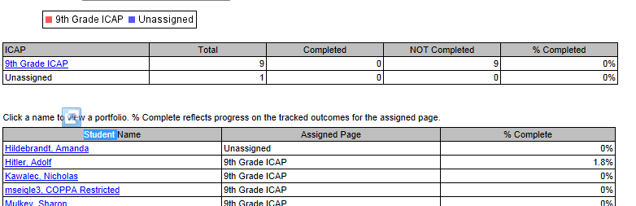

Click the ICAP name to navigate to the Second Level of detail.

Click the section name to navigate to the Third Level of detail.
Second Level for 9th graders for each section of their ICAP:

Third Level for 9th graders for each activity in the selected section of their ICAP:
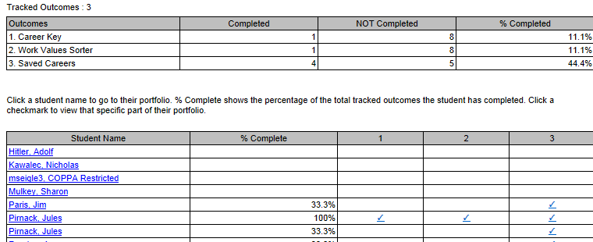

And the export to Excel presents this information in several worksheets to give you the most flexibility.

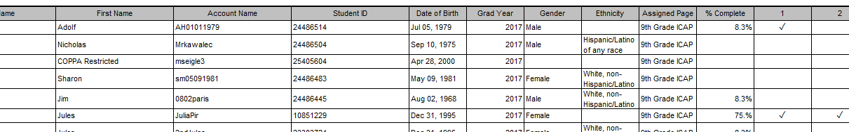

For further questions and clarification please contact an Outreach and Access Coordinator in your region or access the assistance order form.

