Sign in to the Professional Center
May is the time to capture the progress that your students have made on CollegeInColorado.org by running your end of the year reports. Each student’s grade level will be updated in the system on July 1st.

- Reports are created and run from the Professional Center Reports tab [http://procenter.collegeincolorado.org]
- If you do not have a professional center account, please click on Create a Professional Center Account. To obtain a Professional Account Access Key (PAAK) or Administrator Code, contact Twyla Esquibel at Twyla.Esquibel@cic.state.co.us
Ensure Report Accuracy
- To ensure report accuracy, check students associated with your school. Use the tools on the Students & Groups tab
- Update Your Groups by adding or removing students
- Review system-defined student groups (by Class) by using Browse by Class. You may release students incorrectly associated with your school or students may correct their graduation year
Determine the Reports Most Suited to your School
- Determine which reports to run based upon how you have set up CollegeInColorado.org for your students (see next page)
- Choose from four tracking reports (ICAP Tracking Report, Milestone Tracking Report, Tracking Plans of Study, Guideways Tracking Report)
- Choose from dozens of single activity usage and outcome pre-formatted reports
Create and Run Reports
- Click on the Reports tab
- Click on Create a New Report. Follow the wizard to Choose Report Type and Criteria
- Choose Time Frame and Finalize Report to select your output option (print, save, and export to excel)
For further questions and clarification please review the Running Reports Step-by-Step document, contact an Outreach and Access Coordinator in your region or access the assistance order form.

IMPLEMENTED SITE SET UP | REPORT TO RUN
Individual Career and Academic Planning Page (ICAP)  You set up the system so that students see an ICAP in their portfolio  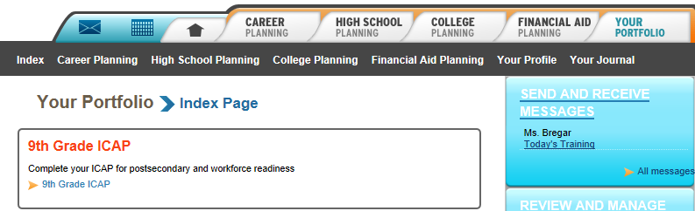 | ICAP Tracking Report
Milestones  You set up the system so that students see milestones in their portfolio  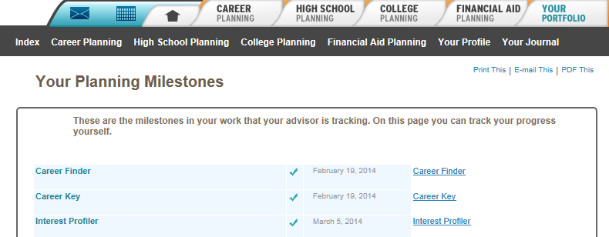 | Milestone Tracking Reports
Online Coursework Planning  Students complete their coursework plan online  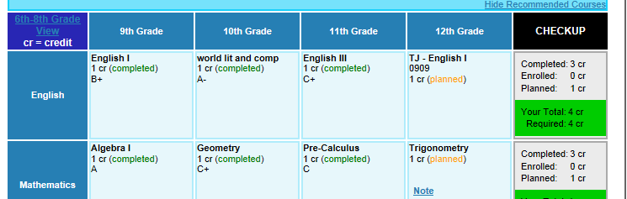 | Tracking Plans of Study
Guideways  You have students using grade level or ICAP Guideways  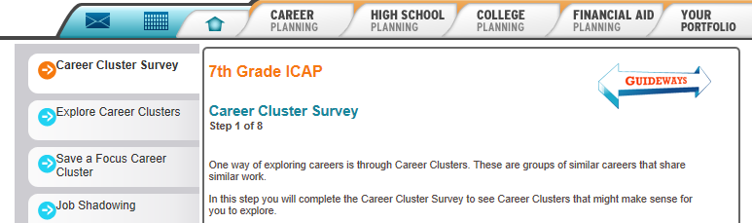 | Guideways Tracking Report
Single Activity  You expect student to complete specific activities but may not have set up the system with an ICAP page, Milestones or Guideways | Dozens of single activity usage and outcome pre-formatted reports

