ENHANCED interest profiler

The Interest Profiler helps students and adults identify their work-related interests, learn about their vocational personality type and develop a greater awareness of how those interests can match to careers.
In April, the Interest Profiler in RUReadyND.com, FLChoices.org, GAcollege411.org and PlantoSucceedNYC.org was upgraded to O*NET’s 60-question short form. This new version will take less classroom time for individual assessment, leaving more time for reviewing results and matching careers.
Key enhancements to the Interest Profiler:
- Only 60 work task questions
- Updated graphics and improved user interface
- More efficient operation
- Improved results display
- New career matching algorithm based on the full interest profile.
- Enhanced reflection area

- Only 60 Work Task Questions
The number of work task questions has been reduced from 180 to 60. The revised assessment was extensively researched and tested by the U.S. Department of Labor to ensure it provides the same reliable results as the original. For consistency with the approved assessment, the number of possible responses for the work task questions has been revised from three to five.
- Updated Graphics and Improved User Interface
New graphics create a more contemporary experience. Guidance text has been changed when necessary to provide clear, relevant instructions.
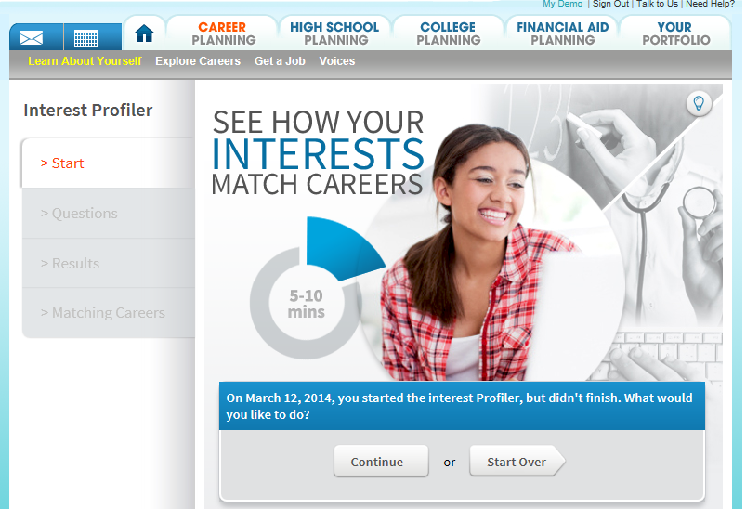
Starting page of the enhanced Interest Profiler

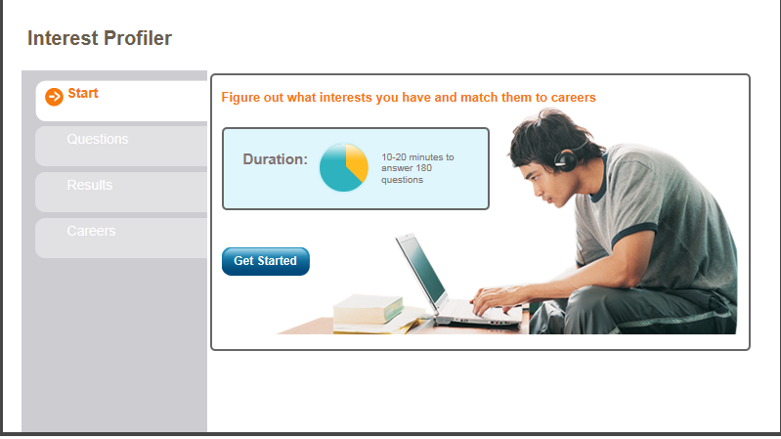
Starting page of the previous Interest Profiler

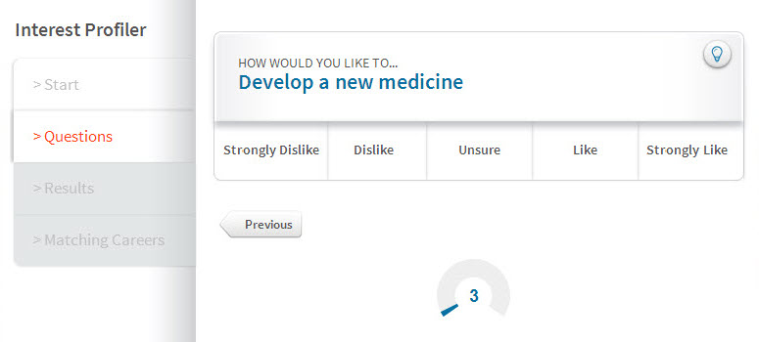
  - A work task question from the enhanced Interest Profiler with five options for responding

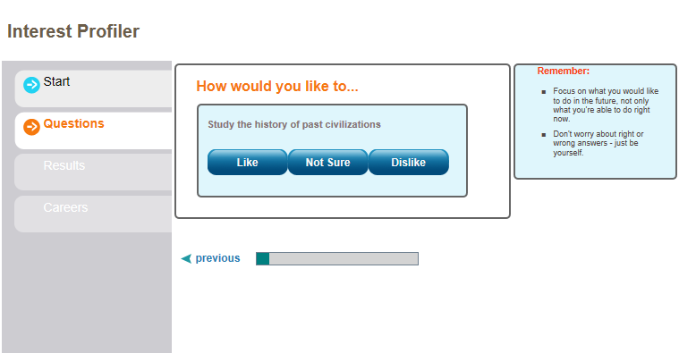
A work task question from the previous Interest Profiler with three options for responding

- More Efficient Operation

Every 10 questions, a user’s responses are sent to the XAP server and saved to their account. This provides an option to restart the Interest Profiler assessment if the user has to stop before reaching the end. The new Interest Profiler is more efficient, as previously the end user’s responses were sent to the server question by question.

If a user doesn’t finish all of the questions, they are given the option to start over or continue where they left off when they return to the Interest Profiler. (They will restart at the last question saved.)

  - Option to restart the Interest Profiler after stopping during the assessment

- Improved Results Display

The new Interest Profiler features an enhanced results page providing additional, integrated information on the end user’s interest profile.

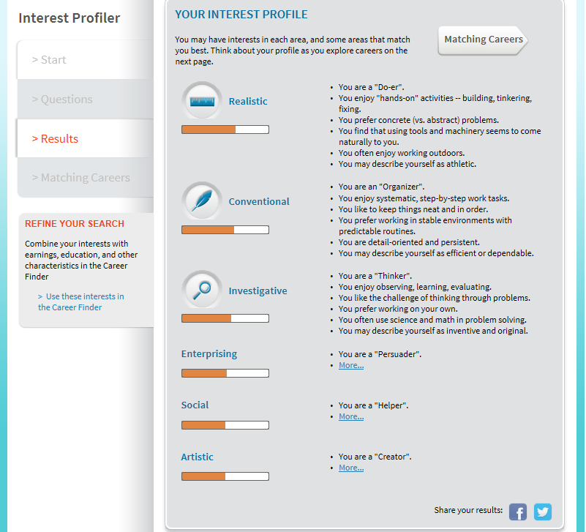
  - Results page from the enhanced Interest Profiler

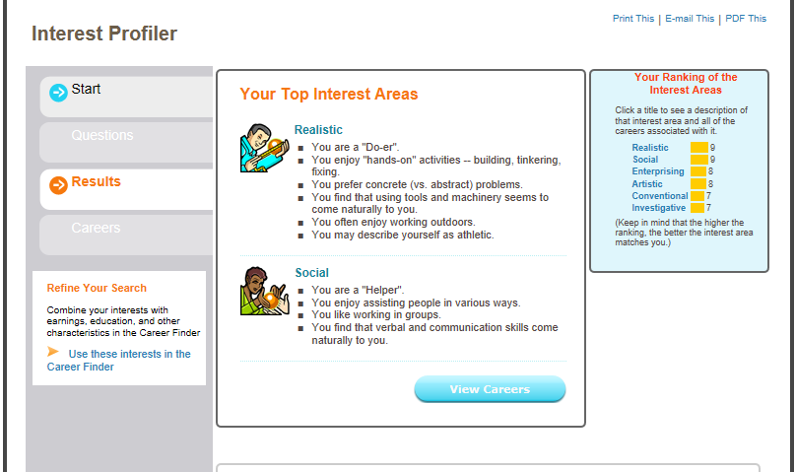
  - Results page from the previous Interest Profiler

- New Career Matching Algorithm Based on the Full Interest Profile
A new career matching algorithm is used in the new Interest Profiler to match the user to career suggestions using the full interest profile with all interest areas. In the past, matches were based on just the top interest areas.
The Best Match tab displays a table of careers ranked by how much they fit the user’s interest profile. The stars in the Your Match column provide a graphic display of the interests match between the user and the careers. Clicking the stars in a career’s row in the table displays a pop-up window comparing the user’s interest profile and the interest profile for the selected career.
As in the past, the table includes each career’s education level and average annual salary. Clicking the career name still displays the career profile.
Clicking the new Education Level tab provides a new alternate way to view matching careers. The table is redisplayed showing the education level categories. Each level can be expanded to show the top matching careers in the selected education level. This new option provides a quick list of suggested careers for end users with an achieved level of education or a defined future education goal.
Comparing careers in different education levels can be an effective classroom activity to conclude an Interest Profiler lesson.

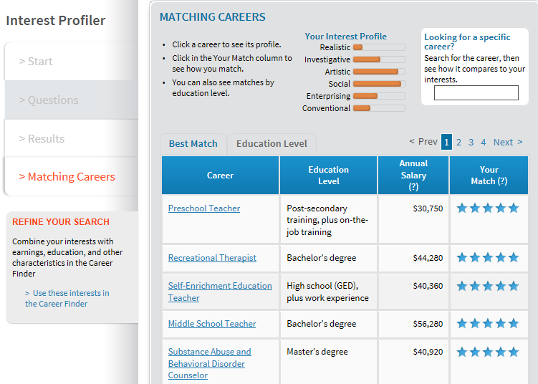
Matching careers page of enhanced Interest Profiler

  - 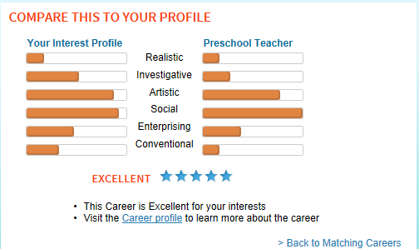
Comparison of the user’s interest profile and the interest profile of a selected career

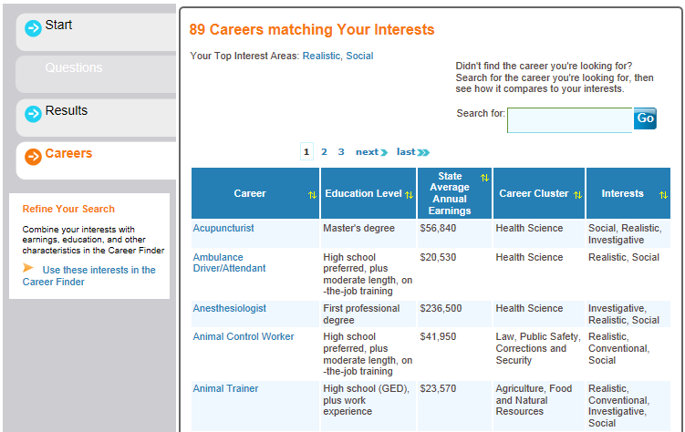
Matching careers page on the previous Interest Profiler

- Enhanced Reflection Panel
Greater guidance is given when it’s time for students to reflect on their Interest Profiler results. New selectable options are available to help prompt students. A text field is still available to enter further thoughts.
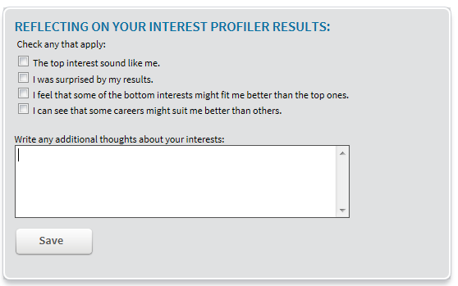
  - Reflection panel for the enhanced Interest Profiler

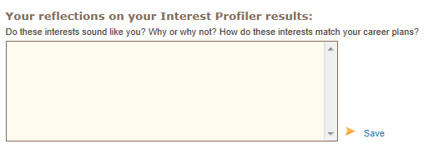
  - Reflection area on previous Interest Profiler

Note: Migration From Old to New Interest Profiler
Results from using the old Interest Profiler saved in users’ portfolios will automatically be migrated over to the new Interest Profiler.
In-progress Interest Profiler sessions that were started in the old Interest Profiler but not finished cannot be migrated and will be lost. In that case,users can start the new shorter assessment again from the beginning.

USage reporting

While the flow of the enhanced Interest Profiler is much the same as the existing Interest Profiler, the technical structure and design are all new. So what is the impact of the new technical structure on Page Views as a measurement of Interest Profiler use, particularly when comparing time periods with both old and new Interest Profiler usage?
XAP conducted usage measurement studies between the previous Interest Profiler and the short-form Interest Profiler. With the same number of end users performing the same tasks in the two versions, Google Analytics showed only a 9 percent increase in Page Views for the new, enhanced Interest Profiler. Therefore the impact of the new Interest Profiler on overall system usage measured by Page Views is minimal and can be ignored. XAP’s recommendation would be to account for the 9 percent increase only if doing comparison reporting on usage for the Interest Profiler assessment alone.
When using Google Analytics for reporting on the usage of the new Interest Profiler, XAP has simplified the report to show usage of the primary sections of the assessment without the “noise” of seeing specific pages related to individual end user sessions.
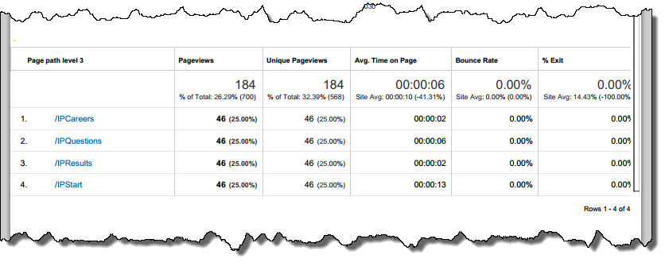
In the report sample above, the Content Drilldown report for the /InterestProfiler/ path shows overall Page Views for the assessment and Page Views details for the Start, Questions, Results and Careers sections.

