What’s New for April 2016

Updated Milestone Report in the Professional Center and Report Central
Better reporting means better analysis and implementation of college and career readiness programs. Educators and administrators will now be able to generate more in-depth information on Milestone completion with the updated Milestone Report in the Professional Center. Additionally, the new Milestone report will be available within Report Central.
The enhanced Milestone report in the Professional Center includes these updates:
- Educators can choose a timeframe for the Milestone report, or run the report without timeframes.

- Educators can select the set of Milestones defined for a school or site, or they can choose individual Milestones.

- Filtering options will be available including:

  - Graduation year
  - Group
  - Gender
  - Race/Ethnicity
  - Role

- Educators can opt to report on all accounts or only active accounts.
- Milestone reports can be saved to the Your Reports page so that the report can be easily rerun using the same criteria.
The new Milestone report in Report Central includes these features:
- Administrators can choose a timeframe for the Milestone report, or run the report without timeframes.

- The report can be filtered by:

  - Graduation year
  - Group
  - Gender
  - Race/Ethnicity
  - Role

- Administrators can select the set of Milestones defined for their system, or they can choose individual milestones.

The Milestone Report in the Professional Center
Educators and administrators will be able to filter the Milestone Tracking Report so it better meets their needs. The filter criteria include: by Milestone (or Milestone set), gender, ethnicity, graduation year, graduation year, group, and time frame.
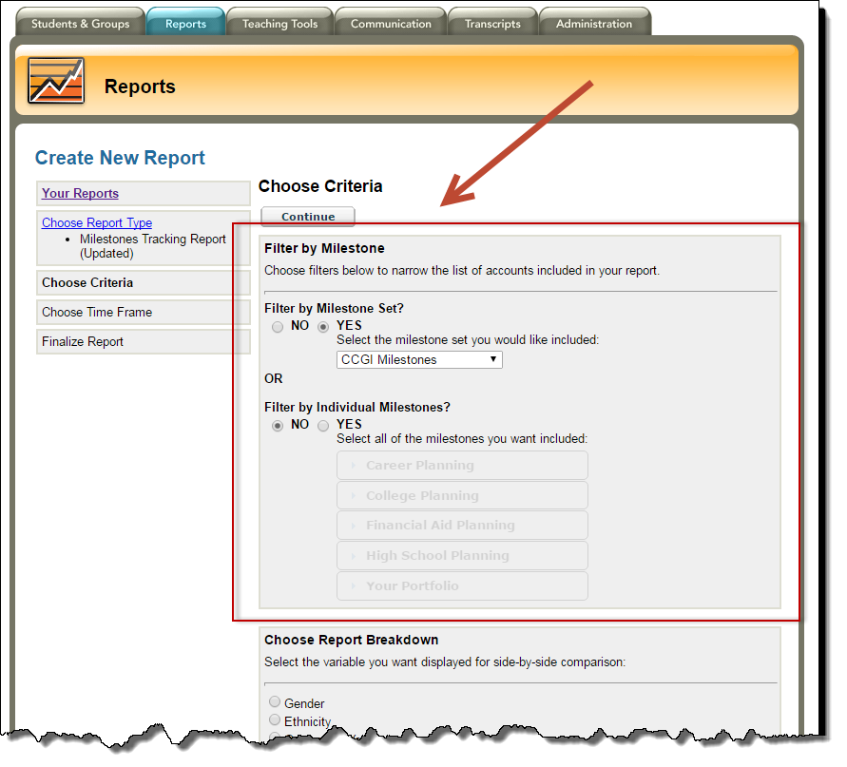
Screenshot of Milestone Tracking Report showing option to choose Milestone or Milestone Set
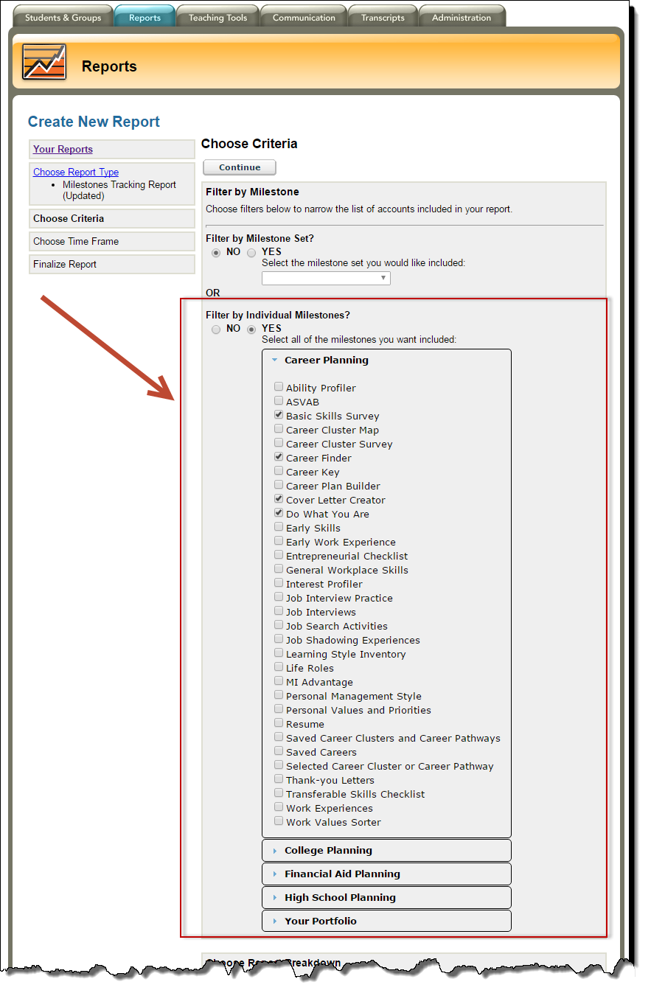
Educators can choose individual Milestones
In addition to choosing a Milestone or a set of Milestones, educators and administrators can choose a timeframe for the report.
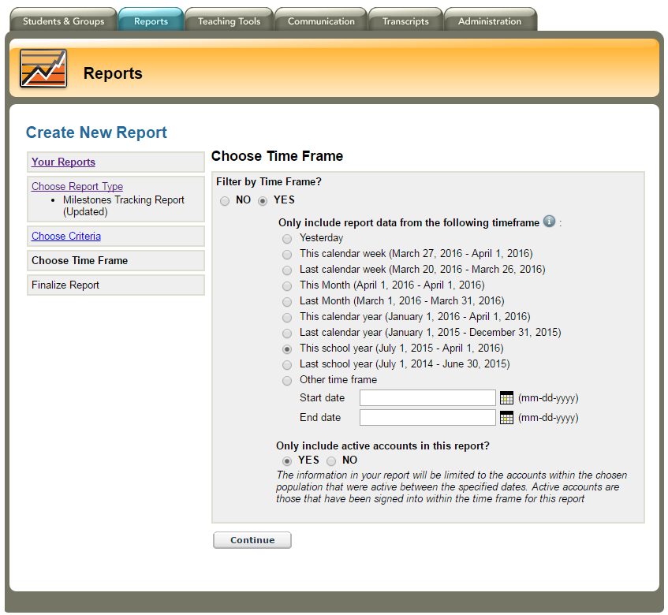
Screenshot of the timeframe options within the Milestone Tracking Report
The final report shows completion rates for each Milestone (both total and percentage) and gives educators in the Professional Center the opportunity to drill down to individual student’s Portfolios. Administrators using Report Central will see a similar report but without the ability to see students’ names and Portfolios.
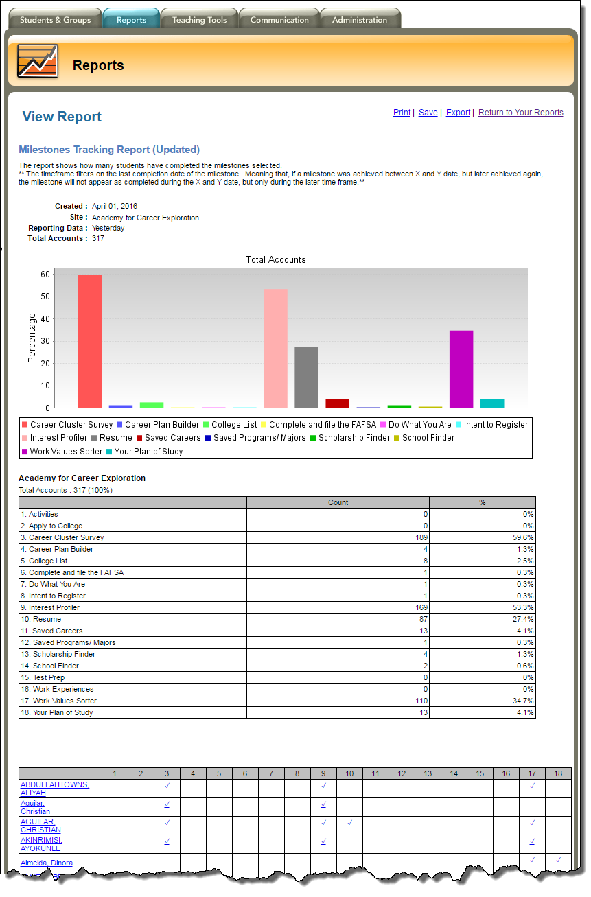
Screenshot of the Milestone Tracking Report in the Professional Center

