Using My Goals and Action Plans as a Milestone
A new “My Goals and Action Plans” activity will be available as a Milestone in the August 8th release. This activity replaces all of the activities listed below which will be retired in September, and which will no longer be available as Milestones after the August release.

If your Milestone set has included any of the activities listed below, each of these Milestone items will be adjusted by August 8th to automatically show the My Goals and Action Plans activity instead.

Important: If you wish to retain information about Milestone achievement for your students on the retired activities, be sure to run a milestone tracking report for your student groups prior to August 8th.

  - Ultimate Goals
  - Long-Term Goals
  - Intermediate Goals
  - Short-Term Goals
  - Goals Into Action
  - Postsecondary and Workforce Goals

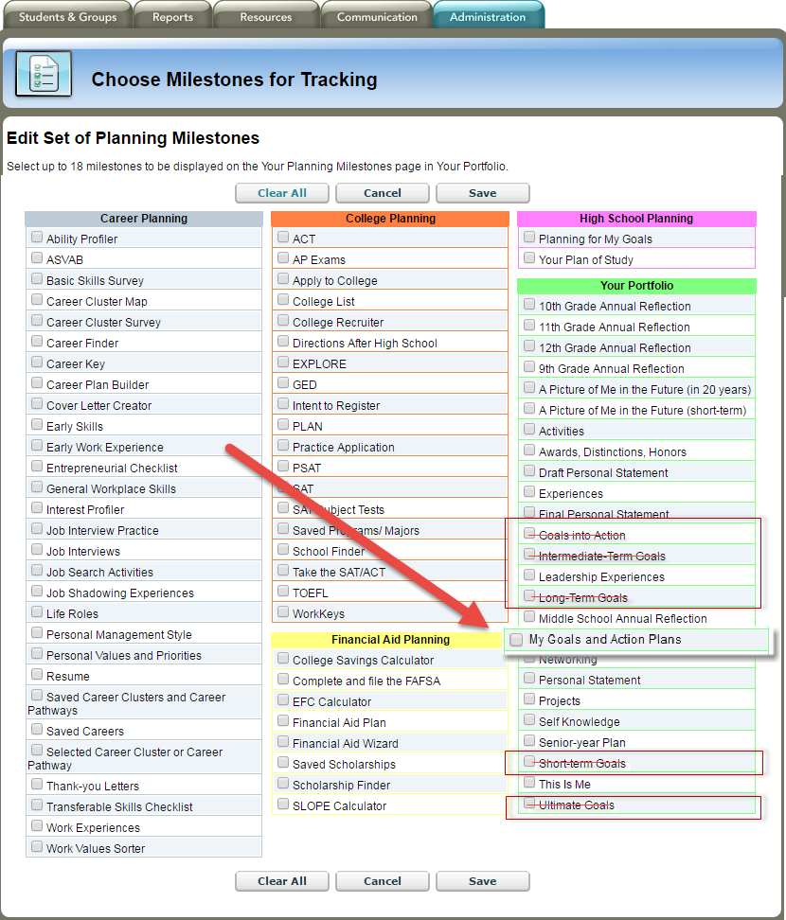

Screenshot of the changes to the Edit Milestone Set in the Professional Center

