What’s New for September 2016

New “My Goals and Action Plans” Activity
“Setting a goal is not the main thing. It is deciding how you will go about achieving it and staying with that plan.” Tom Landry

In August a new goal activity is being released. Called “Postsecondary and Workforce Goals” from the student view and simply “Goals” in the Professional Center, the new goal activity aligns with SMART (Specific, Measurable, Attainable, Relevant, Time-Bound) goal-setting guidelines. The activity is simple and easy to use. Students are led through the process of goal setting through a series of questions including type of goal, priority, timing and tasks to complete the goal.

Seen from a student’s ICAP (two goals completed):
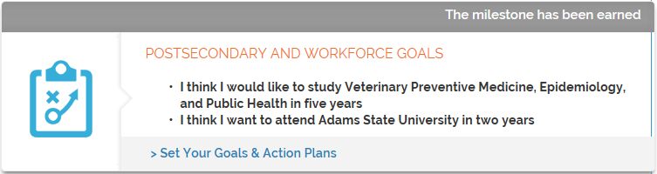

Selectable for ICAP in the Professional Center ICAP add activities tool:
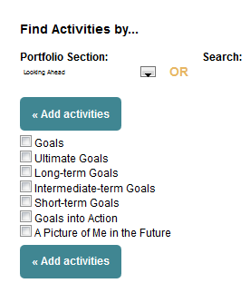

My Goals and Action Plan has built-in reporting and accountability functionality so educators and administrators can easily track students’ completion.
As part of the rollout of the new goal, we will be retiring these goal-setting activities in September:

  - Ultimate Goals
  - Long-Term Goals
  - Intermediate Goals
  - Short-Term Goals
  - Goals Into Action
  - Career Goals
  - Academic Goals
  - Personal/Social Goals
  - Postsecondary and Workforce Goals

The content previously recorded by students within these activities will be visible in the new Goals activity, but will not be able to be edited or adjusted after the September release.

Introducing the New My Goals and Action Plans Activity
- How Does It Work?
- Using My Goals and Action Plan as a Milestone
- Adding My Goals and Action Plans to Your IEP, ICAP or ILP
- Reporting on My Goals and Action Plans
- Archiving Old Goal Activities

How Does It Work?
The new My Goals and Action Plans activity is located in the Looking Ahead section of Your Profile in Your Portfolio.
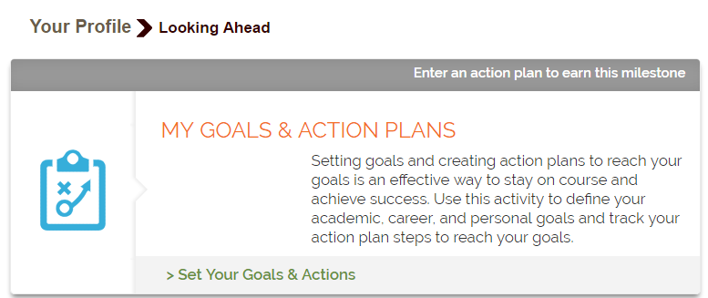
Screenshot of the new My Goals and Action Plans activity in Your Profile Looking Ahead

Students start the activity by selecting “Set Your Goals & Actions” and then filling out the questions: Type of Goal, Level of Interest, Timeframe and Priority.

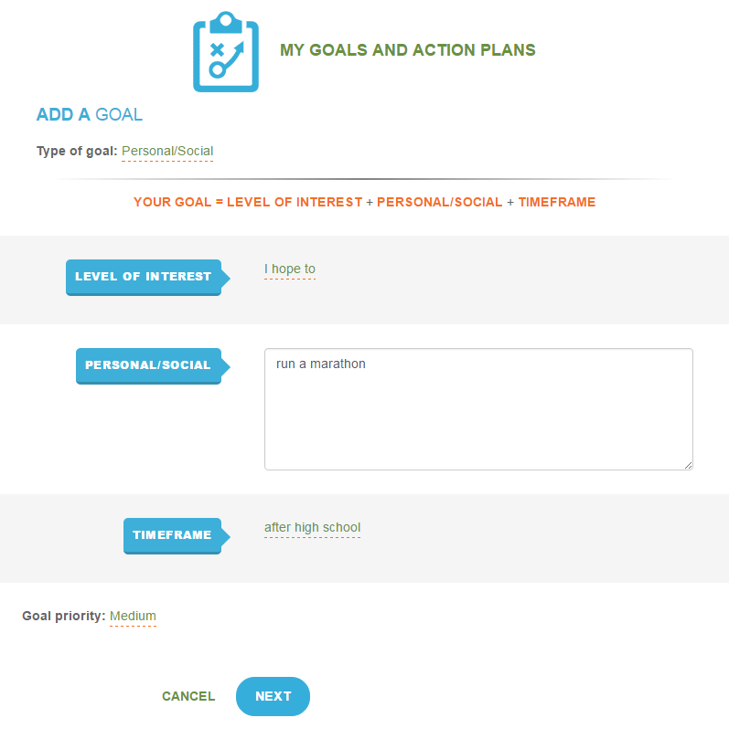
Screenshot of the Add a Goal page in My Goals and Action Plans

Once the goal is set, then students respond to the question “How is This a SMART Goal?” by answering questions for each of the SMART characteristics (Specific, Measurable, Achievable, Relevant and Timely).

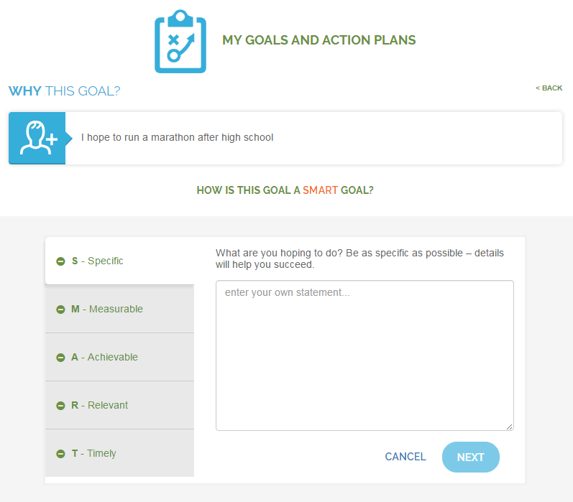
Screenshot of the SMART goal questions

Once a student identifies the Specific, Measurable, Achievable, Relevant and Timely aspects of their goal, they can then, if they choose, enter an Action Plan where they list the individual tasks they need to accomplish to achieve their goal. Each task is associated with a due date and a status.

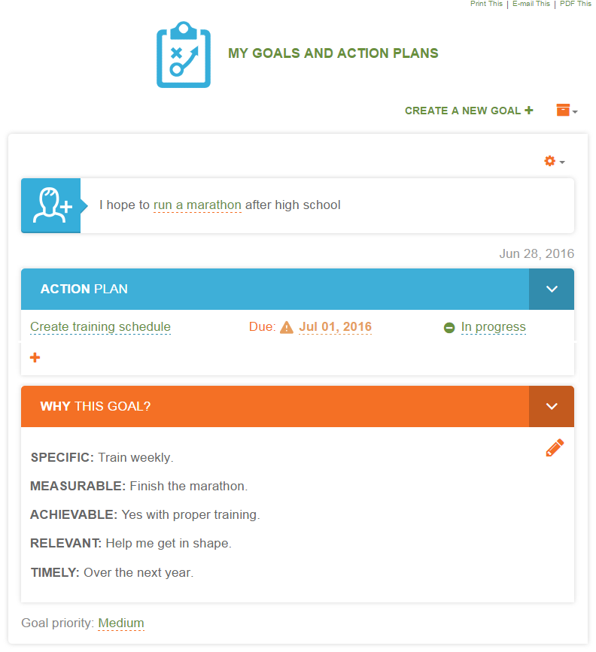
Screenshot of an Action Plan

Using My Goals and Action Plans as a Milestone
“Goals” will be available as a Milestone by August 8, 2016. The activities listed below that will be retired in September. If your Milestone set has included any of the activities listed below, your Milestone set will be adjusted to automatically include Goals activity in place of the retired activities.

  - Ultimate Goals
  - Long-Term Goals
  - Intermediate Goals
  - Short-Term Goals
  - Goals Into Action
  - Postsecondary and Workforce Goals (For Colorado)

Important Note: If you wish to record Milestone completion by your students for the retired activities and you did not run the Milestone Tracking report for your student groups prior to August 8th, contact support at 1-800-281-1168
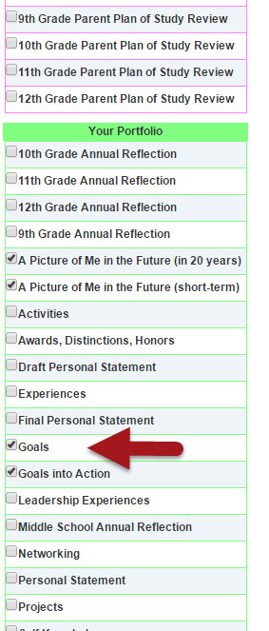
Goals Milestone in the Professional Center

Adding My Goals and Action Plans to Your ICAP
It is important to note that any local or district ICAP will need to be updated if it includes any of the goal-setting activities that will be retired in September.

  - Ultimate Goals
  - Long-Term Goals
  - Intermediate Goals
  - Short-Term Goals
  - Goals Into Action
  - Career Goals
  - Academic Goals
  - Personal/Social Goals
  - Postsecondary and Workforce Goals (For Colorado)

Local and district administrators will be able to replace the above activities with My Goals and Action Plans options in their ICAP. If their ICAP is a grade-based set, then three variations of the My Goals and Action Plans activity will be available. The variations are:

- Early Goal Setting
- Mid-Year Goal Setting
- End-of-Year Goal Setting

Reporting on My Goals and Action Plans
The new activity, My Goals and Action Plans, will be available in Milestone and ICAP tracking reports in both Report Central and the Professional Center.
CIC recommends running Milestone reports for the 2015-2016 school year prior to August 8th.
CIC also recommends running ICAP tracking reports for the 2015-2016 school year prior to updating district or local ICAPs.

Retiring Old Goal Activities
In the September release, these goal activities will be retired:
  - Ultimate Goals
  - Long-Term Goals
  - Intermediate Goals
  - Short-Term Goals
  - Goals Into Action
  - Career Goals
  - Academic Goals
  - Personal/Social Goals
  - Postsecondary and Workforce Goals (For Colorado)

What does this mean for students?
After the September release, students will still be able to see their old goals – however, they will appear in My Goals and Action Plans under the label “Previous Goals.” The content from these retired goals will not be available for editing or updating.

Suggested Checklist for New My Goals and Action Plans Activity
The checklist below covers the tasks that CIC recommends district and local educators complete if they are using any of the nine retiring goal activities.
- Run Milestone report for 2015-2016 school year prior to the August 8th release if your current Milestone set uses any one of the retiring goal activities. If you did not run reports prior to August 8th, contact support at 1-800-281-1168.
- Review your ICAP to see if any of the retiring goal activities are used. If so, run ILP, ICAP or IEP tracking reports for 2015-2016 school year if you had not already done so at school year end.
- Update your ICAP sets with new My Goals and Action Plans activity as desired. Review instructional text and flow to ensure references to the activities are correct.

