COLLEGE ADMISSIONS TOOL ACTIVITY

Instructions:
- Follow link below:
  - http://www.CoAdmissionsTool.org
  - Click on the green “BUILD OPTIONS WIZARD” button

The screen will look something like this:

Click on the Four-year Colleges circle then complete the information requested in the Wizard until you arrive at the Matching Colleges List.

Important note: Experts recommend that you apply to more than one college. You should select at least one school that it will be easy for you to be admitted and one “stretch” school – that is, one that it will be more difficult to get into. So, you may want to keep two-year schools on your list since they offer open enrollment (you will be admitted regardless of GPA or test scores). You can do this by selecting all both two- and four-year alternatives on the “Confirm Two- or Four-Year Options” step (screen 3 of 13), of the wizard.

- Once you arrive at the Matching College List, experiment! Ensure you have entered your GPA, ACT score (and SAT if you sat for that test) and My Coursework information. It will look something like:

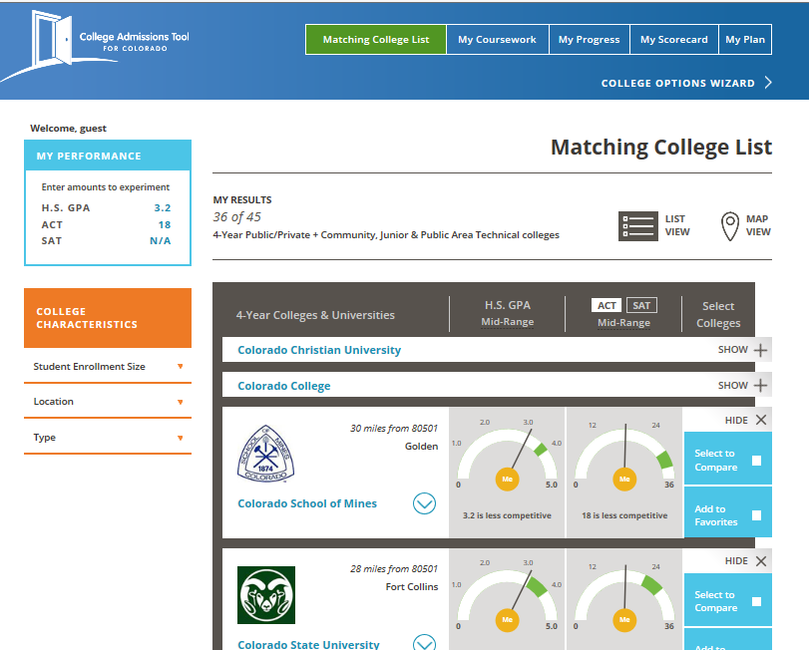
How many schools are left on your list?
If you aren’t interested in a school, hide it.
If you‘re really interested, Add to Favorites and/or compare side by side.
Green is the score range of students the college admits on average. Does your dial read below (less competitive), in the green (competitive) or above?
Adjust your scores to see what happens to your dials.
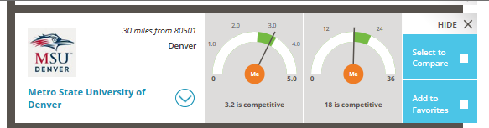
Get more detail about each college.

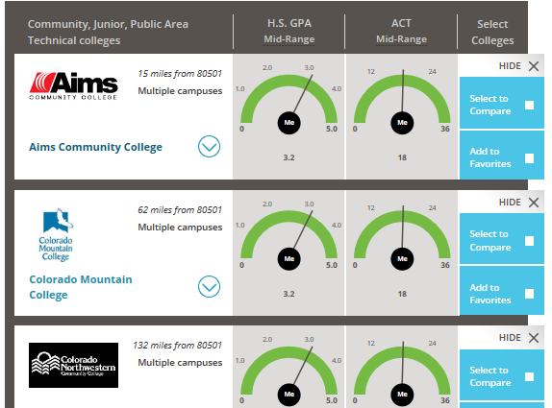
Two-year schools/community colleges are all green because they are open enrollment.

- Now, put in the test scores and GPA that you already have or honestly think you can achieve in the upper left blue box in the Tool. Pick and Add to Favorites at least two colleges where one of the two dial indicators is in or above the green (you are competitive). Then add a couple of schools where the indicator is close to the green but below it (you are less competitive).

Enter the school names below and how competitive you are based on GPA and Test score (first two columns).

School Name | Competitive or Less from GPA/test? | What else does the school want that could help your chances? | How competitive overall are you?

- Click on the “My Progress” tab at the top of the Tool.

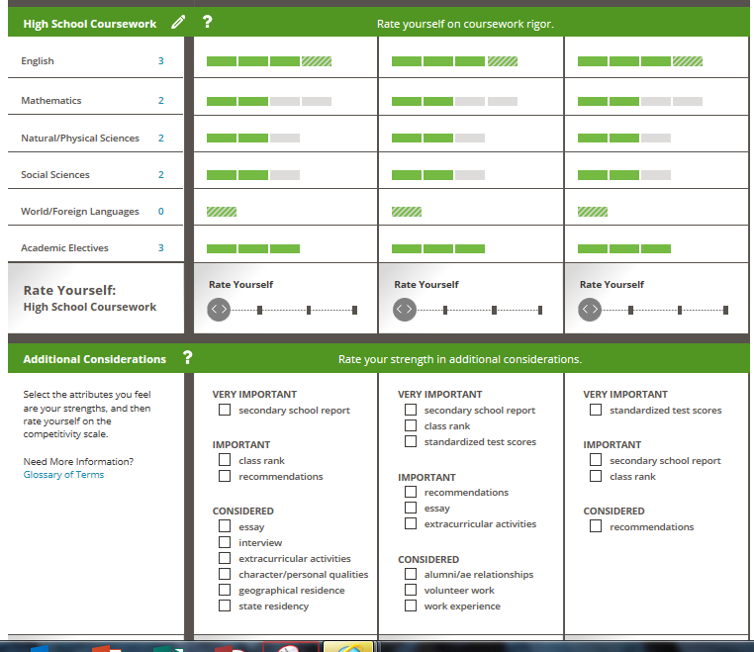
You can review the GPA and test score dials here, but you can also review and rate how you are doing on coursework requirements and “Other Considerations” such as writing a great essay, community service you have completed and so forth.

Be sure you honestly rate yourself on how you have done or will do in each area. After you read the “Other Considerations” that each college values, in the chart above, record those areas you intend to really focus on during the application process.

- Click on the My Scorecard tab at the top of the page.

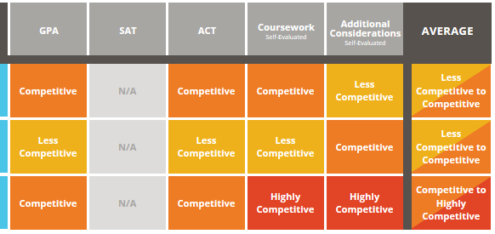
In the Average column, you can see whether your honest ranking of coursework and additional considerations important to each college made a difference in your competitiveness.

You should also be able decide those areas and for which schools you should really focus your efforts during the application process.

- Now go back to the chart and page 3 and complete how competitive you feel overall for your favorite schools.

- Do you need to change your application approach? Do you have at least a couple of schools at which you are fairly confident you will be admitted? Jot down your thoughts here.

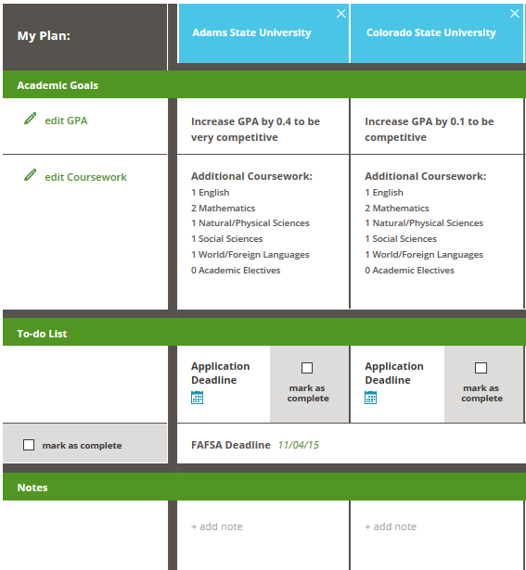

- Last step! Click on the My Plan tab at the top of the page. For each favorite school, make a plan! We have given you a start in the coursework area, but you can also add items to the to-do list and notes.

Remember that this Tool just gives you some estimates of how competitive you are for admissions, however, each school is a bit different and they all evaluate students on many things – not just GPA, test scores or even courses taken in high school. Be sure to visit the colleges’ websites to get more information.

And, be sure to save this worksheet as “Admissions Tool 12th Grade” and upload it into your Evidence Documents area in your ICAP!

