DETAILED INSTRUCTIONAL SHEET, HB 17-1041

Summary: Inform Students and Parents of Education Leading to Jobs
In August 2017, a law went into effect regarding educational opportunities that lead to jobs. The law mandates that in developing and maintaining a student’s individual career and academic plan (ICAP), each public school district (PSD), including charter schools, must ensure that the benefits of concurrently enrolling, the types of certificates and jobs to which specific career pathways lead, and the educational opportunities available through military enlistment, are explained to students and parents.

College In Colorado has many activities and features that schools may use with students and add to their customized ICAP that will help the school meet the law’s requirements. Detailed information about these activities and features may be found at the College In Colorado Professional Center (Procenter.CollegeInColorado.org) Resources tab.

Bill Requirements
- Charter schools shall assist students/parents in developing and maintaining individual career and academic plans (ICAP) no later than the beginning of 9th-grade including the items below and consistent with section 22-2-136
- During ICAP development, PSDs must explain to students/parents the requirements for and benefits of concurrently enrolling in courses with an institution of higher education
- During ICAP development PSDs must explain to each student/parent the various career pathways created pursuant to section 24-46.3-104 and the types of certificates and jobs to which each pathway leads
- During ICAP development, PSDs must explain to each student/parent the skills and educational opportunities available through military enlistment and information concerning the military enlistment test

CIC Resources Overview, details to follow
- Charter school ICAP
Charter schools have access, at no charge, to College In Colorado’s ICAP features and tools as well as outreach support and regional trainings. Online features and tools include:
- Nearly 150 online activities
- Tool to help professionals build student ICAPs by specifying activities to display, with navigation, on grade-based pages for student completion
- Data aggregation and tracking reports to monitor student ICAP progress
- Functionality for students to invite parents to view their online ICAP and portfolio

- Concurrent enrollment (CE)
CIC provides an overview of CE benefits, requirements and other information for use by professionals, parents and students including:
- A student worksheet to help explore and document CE understanding and requirements step-by-step
- Online ICAP template that includes CE activities and instruction, enabling easy duplication at a school
- Portfolio activity in which students record their CE activities also enabled for ICAP
- Reminders to talk with counselors about CE, along with links to CE documents, incorporated into the College Planning Timelines
- High school role-based home page links to CE Options document

- Career Pathways
To date, three top job career pathway interactive modules are available on CareersInColorado.org: information technology, healthcare and construction. Two more pathways, business services and cyber security, will be added in 2018.
- Each industry has multiple pathways that sequence and align the progression for top careers in the pathway
- Both a flowchart look at a pathway map and a “walk-along” the pathway are available
- As the user “walks” (scrolls) along a pathway, information is displayed that is pertinent to the pathway link, the career/job itself and tidbits of information about the industry
- Schools and programs are populated by the Eligible Training Providers List which includes programs available within each region, their cost and duration, and whether funding eligible through WIOA
- The CareersInColorado.org pathway modules may be included as activities for students to complete on their ICAP. Students may save industry, selected pathway, academic options and reflections in their CIC portfolio
- Students may click to navigate to the full career profile in CollegeInColorado.org. The Employment tab search tool locates jobs currently listed in ZipRecruiter for that career
- Wages, outlook, estimated job openings, employment levels and job requirements are also included

- Military Enlistment Opportunities and Test
Information about military options and the ASVAB achievement test are available on CollegeInColorado.org and the College Admissions Tool.
- The College Admissions Tool’s Build Options Wizard includes the military as one of six postsecondary options to explore
- College In Colorado hosts articles about the military option, users can view a list of careers that are available in the military, with links to the full career profile and a resource center
- Applicable career profiles have a tab dedicated to opportunities in the military
- Information about the ASVAB military aptitude test is provided on the Test Prep page

Additional School/District Assistance
CIC will provide this document, along with a legislative issue brief, to help schools identify how they may use CollegeInColorado.org and related sites to meet the requirements of the law. In addition, this information is included in CIC’s two-day regional workshops being conducted throughout the state this school year.

CIC Resources Details and Screen Shots

- Charter schools ICAP

Charter schools have access, at no charge, to all of the College In Colorado’s ICAP features and tools as well as outreach support and regional trainings. Online features and tools include:
- Nearly 150 online activities from which to choose in career and postsecondary exploration and planning areas including interest and skills assessments, comprehensive career and postsecondary institutional and program profiles, financial aid calculators and planners, middle and high school coursework planner, goal setting, self-evaluation and reflection activities as well as document upload and storage capacity;
- School-level selection and build interface for school professionals to select, display and require completion of specific activities to suit student needs and resources available in their building;
- Data aggregation and tracking reports to monitor student ICAP progress;
- Students may invite parents to view their ICAP and online portfolio.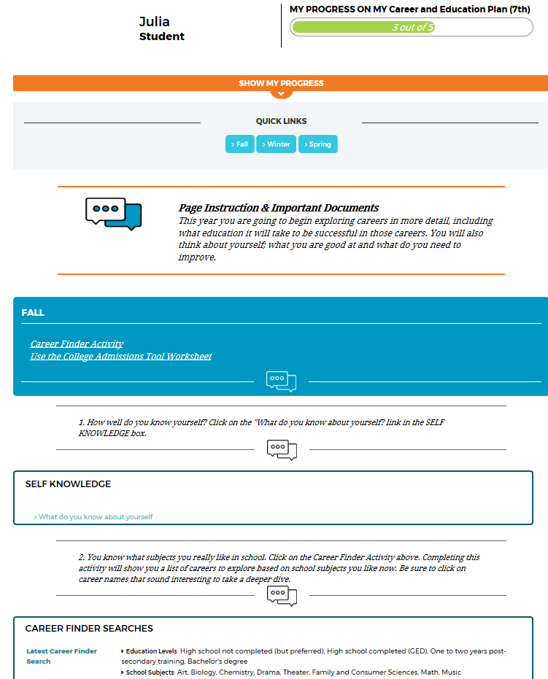

- Concurrent enrollment (CE)

- CIC provides an overview of CE benefits, requirements and other information for use by professionals, parents and students.
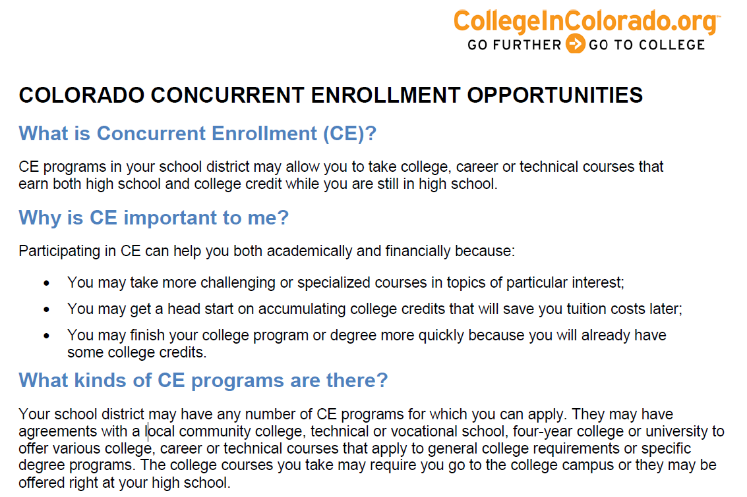

Figure 1: CE Overview Document (partial)

- CIC provides a student worksheet to help users explore and document CE understanding and requirements step-by-step.

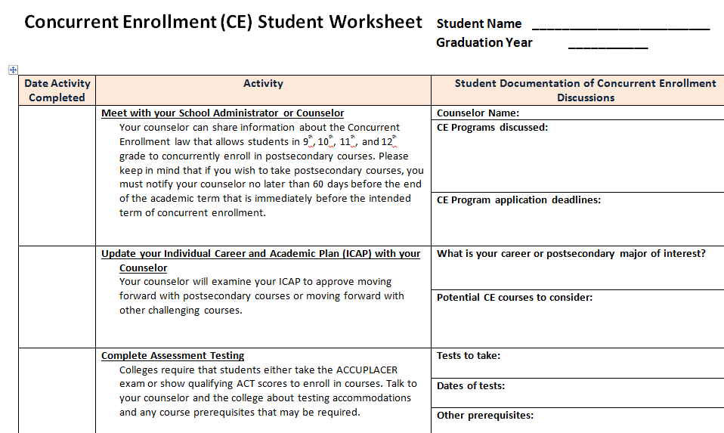

Figure 2: CE Student Worksheet (partial)

- The ICAP template is set up for easy duplication at a school and includes the CE activities and instruction.
- The Portfolio activity in which students record their CE activities (Early College Access Programs) may be added to an ICAP

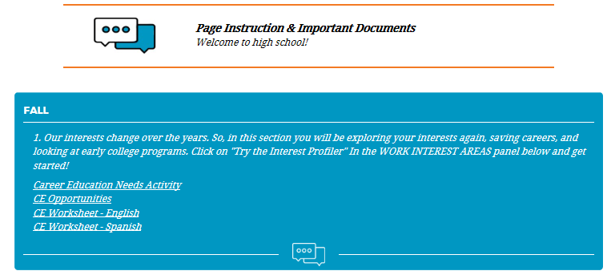
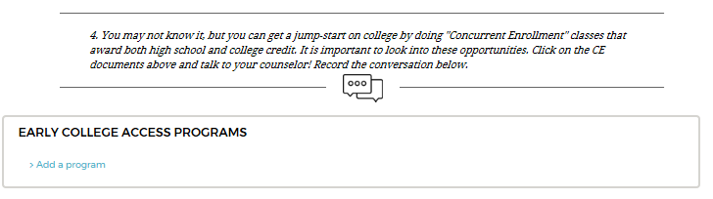

Figure 3: ICAP Template 9th grade page segments for CE

- Reminder to talk with Counselor about CE along with links to documents are incorporated into the College Planning Timelines.

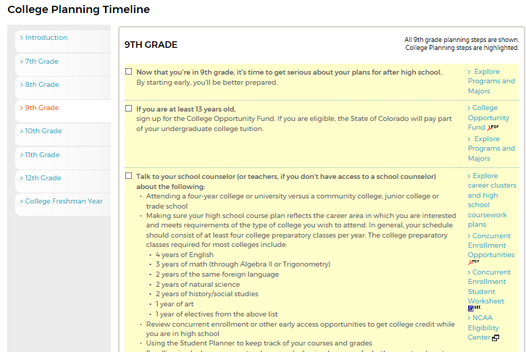

Figure 4: 9th grade Planning Timeline segment

- The high school role-based home page links to CE Options document.
Figure 5: Home page quick links for high school role

- Career Pathways

- To date, three top job career pathway interactive modules have been developed on CareersInColorado.org: information technology, healthcare and construction. Two more pathways, business services and cyber security, will be added in FY2018.
Figure 6: Pathways in IT introductory screen
- Each industry has multiple pathways that sequence and align progression for top careers in the pathway.
- Both an flowchart look at a pathway map and a “walk-along” the pathway are available.

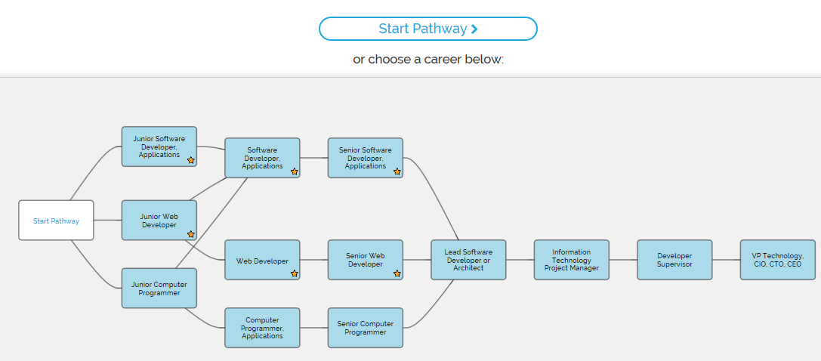

Figure 7: IT Developer Pathway Map

- As the user walks (scrolls) along a pathway, information is displayed that is pertinent to the pathway link (“How to advance to…” which includes programs and schools, credentials, work experience and typical education), the career/job itself (“about” which includes recommended competencies, knowledge required, skills required, abilities required, pathways into and from this job family, wages and outlook) and tidbits of information about the industry.

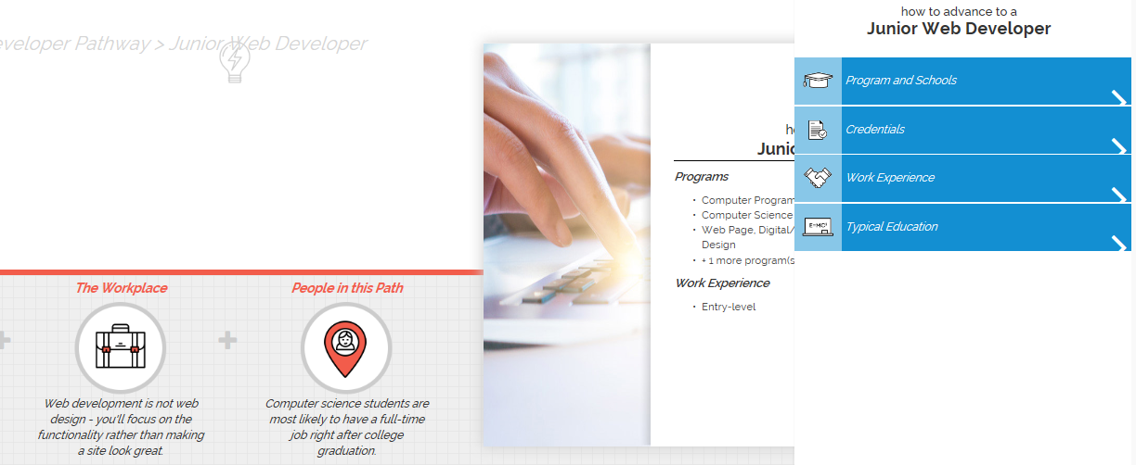

Figure 8 "Walking along" the pathway
- Schools and programs are populated by the Eligible Training Providers List which includes programs available within each region, their cost and duration.
- Careers In Colorado is available to specify as an ICAP activity. From their CIC portfolio, a student may select any pathway or industry available to explore.

Figure 9: Pathway selection in CIC portfolio

- Students may save industry, their selected pathway, academic options and reflections.
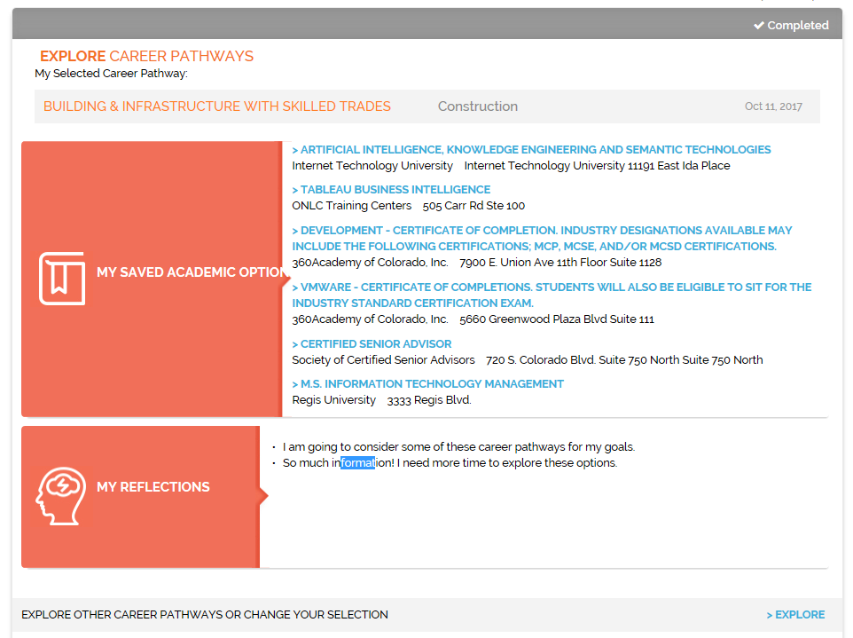

Figure 10: Saved training possibilities

- Students may click to navigate to the full career profile in CollegeInColorado.org. The Employment tab search tool finds jobs currently listed in ZipRecruiter.

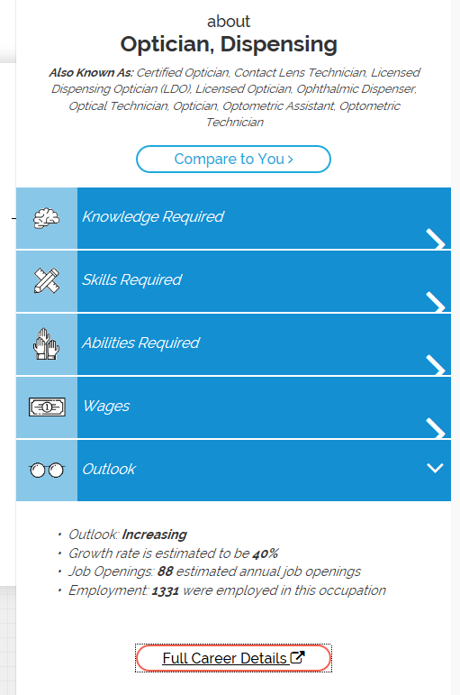
- Wages, outlook, estimated job openings, employment levels, job requirements are also included.

Figure 11: Career/job profile "about"

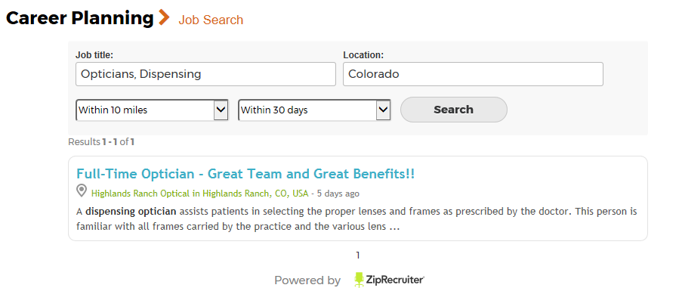
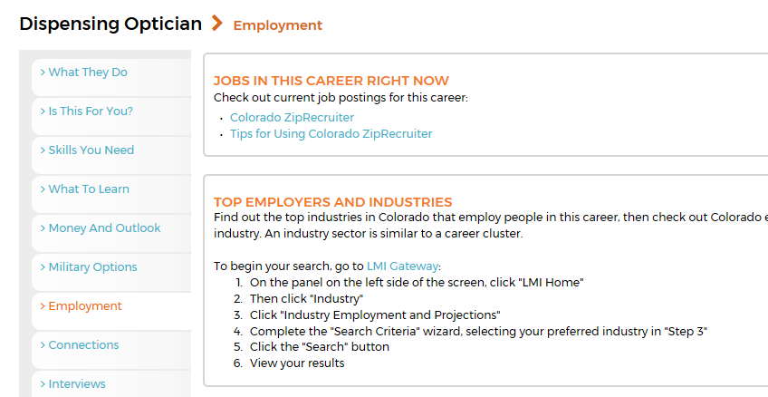
Figure 12: Employment tab and ZipRecruiter interface
- Military Enlistment Opportunities and Test

- The College Admissions Tool Build Options Wizard includes the military as one of six postsecondary options to explore. Information includes requirements to enter (including link to ASVAB information), credentials offered, benefits, trade-offs and “Did You Know?” information. The “Learn More” links directly to www.Military.com.

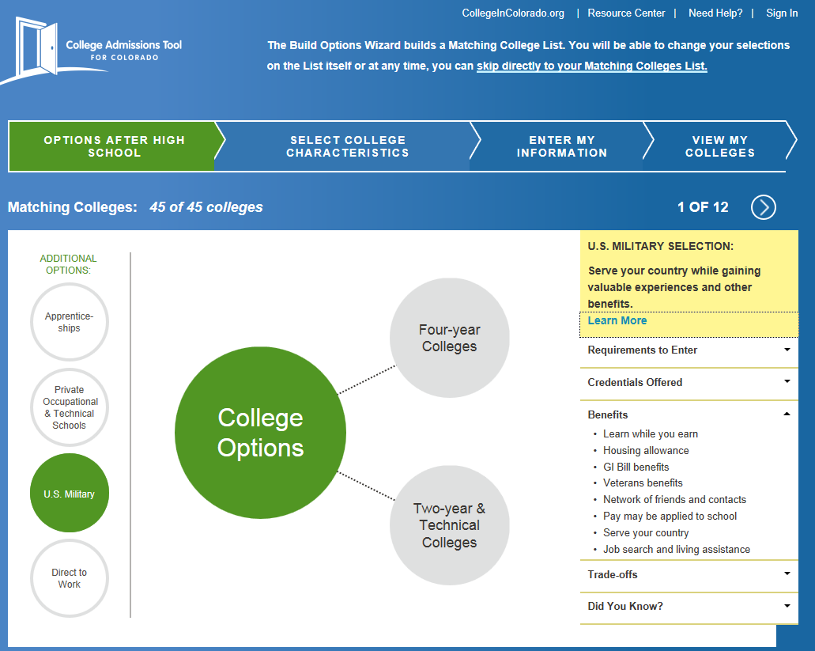

Figure 13: Military option page in the CAT

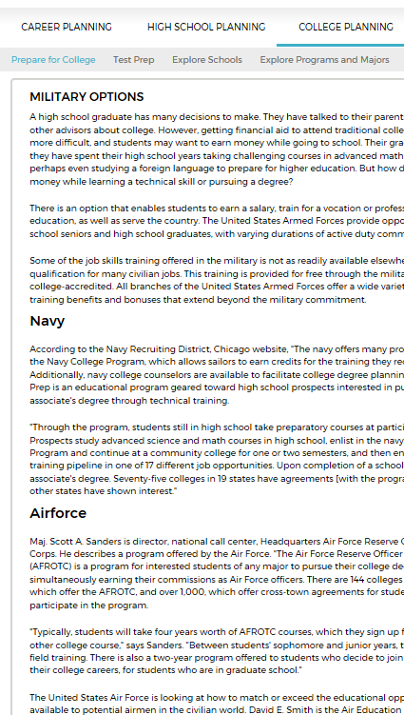
- College In Colorado hosts articles about the military option, a browse to view a list of careers that are available in the military, with links to the full career profile and resource center.

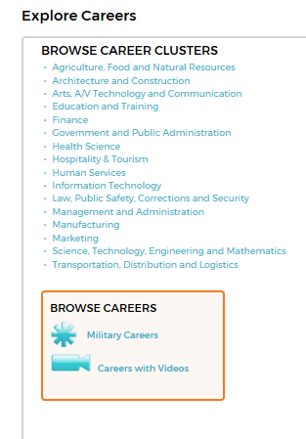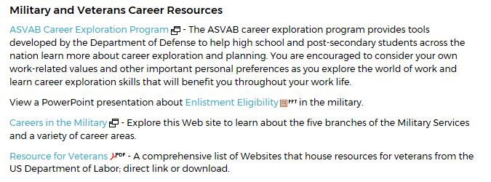
Figure 14: Articles, browse and resources areas

- Applicable career profiles have a tab dedicated to opportunities in the military.

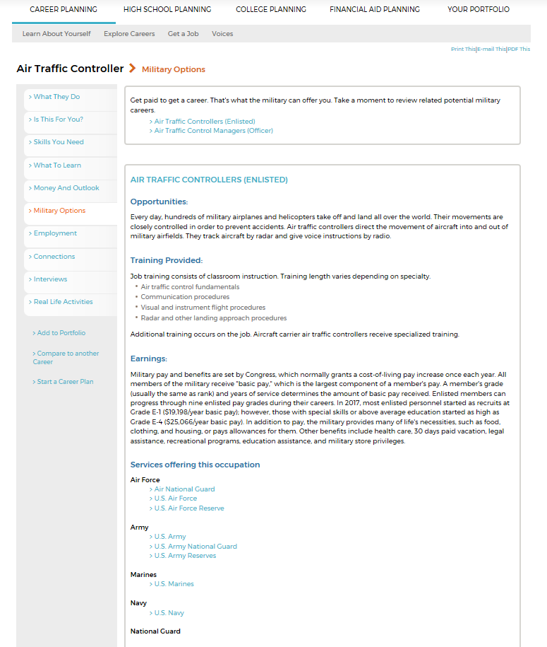
Figure 15: Military tab, career profile
For more information, please contact Julia Pirnack, director of College In Colorado, at (303) 974-2669 or via email Julia.Pirnack@cic.state.co.us

