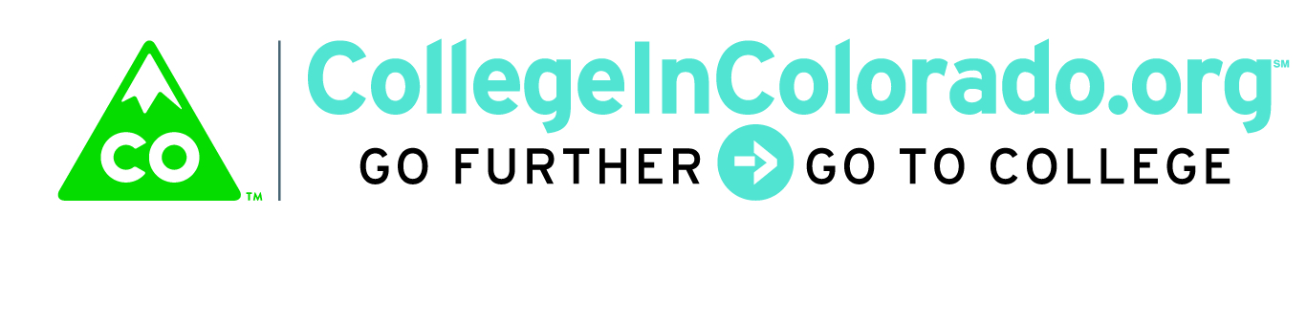

Cross Agency Partnership: Product/Services Group

Meeting Minutes

November 20, 2017
Present: | Lee Wheeler-Berliner, Matt Cornett, Mark Duey, Trevor Williams, Brian Pool, Julia Pirnack
Next meeting: | TBD

Introduction
The product/services group is tasked with reviewing existing tools currently in use by stakeholders as well as determining gaps and qualitative information on products and services that relate to education, training, career and workforce pathways exploration and planning. The larger taskforce recommended action items for this group including documenting user workflows, gathering product information as well as exploring how products and services are currently funded.

The group focused this initial discussion on what seems to be missing from the current extensive menu of product and tool options that agencies currently offer and, from a user perspective, what would provide the most utility to the extensive and varied list of targeted users that we collectively serve. While the activities offered in career exploration, job preparation, postsecondary exploration and so forth are multi-use and readily available, the individual’s circumstances and characteristics are what dictate their best path forward. What has not been done well is a system that delivers what each specific user needs at the correct time and in the correct sequence based on their characteristics. The most compelling need is to assist users with transitional periods; the transition from secondary to postsecondary/work/military, career changing or finding for adults, opportunity youth (or adults) – times in which users need extra guidance rather than an overwhelming number of choices from which they are expected to make sense.

Discussion
Keeping the concepts above in mind, the group agreed that from a product design standpoint, there are several features that should be non-negotiable. The underlying structure/platform should provide:
- Individual online portfolio visible to supporting agency professionals at user invitation.
Each user must have their own highly secure online portfolio that acts as a repository of the users’ work and documentation on the platform. Users may invite multiple professionals to view their portfolio and all invited professionals can see the work done by the user regardless to which agency the professional belongs.

- Primary key
In order to avoid duplication and monitor effectiveness of the system, a unique primary key must be available to the user profile. For K-12 public school users this should be the SASID; however, ultimately and for other users, the SSN must be available. How to meet security and privacy requirements will be researched.

- Common authentication
Users should not have to maintain more than one username and password gain access and use any software component selected for inclusion in the system.

- Visual and functional integration
While the system may be a conglomeration of disparate pieces of software housed in multiple locations or by varying agencies, the user should not be aware that this is the case.

- Data integrity and use
The system must structure and store data so that it may be accessed and analyzed by all agency partners

The group discussed several design concepts that would move the platform from its current state in which the user either navigates to tools of interest with little guidance or necessitates professional to build navigation for groups of users to a state in which the system would use key profile characteristics to map out appropriate activities to individual users. This would enable participating agencies to serve users in many different stages of their planning process, with different requirements or needs and different use cases. One size fits all and excessive set up time for staff would be avoided. In addition, multiple platforms, tools and vendors could be used, updated or added over time, as long as they were able to meet the integration and data sharing requirements. This would keep the items relevant, technology and content fresh.

- User profile elements dictate pathway activities
Each user profile will contain basic information about that user that allows the system to propose an individualized pathway of activities and work that will best suit that user. As information is added to the profile by the user or by supporting professionals, additional features, options, and tools may be recommended to the pathway.

- Professional case management
If a user has the benefit of professional consultation and/or assistance, those professionals must be able to add notes and comments to the user’s portfolio and profile, enabling the system to suggest activities and resources to the user based on those notes as well. In addition, the professional may make notes over time regarding their interactions and recommendations to the user within that user’s portfolio, visible to the user and other agency professionals the user has attached to their portfolio

Action Items
To test whether these design concepts seem viable, Matt and Julia will discuss and develop several basic “personas” that can be described through key profile elements, the resulting stereotypical pathway including decision points and suggested activities and resources to deliver associated with those elements. In addition, Trevor will assist us to find a person that may help with drafting a persona elated to TANF recipients. These personal pathways will suggest features and tools that are available today within CIC, CC or other platforms, to demonstrate the basic design concepts.

Future verification of workflow and statutory requirements will be conducted with professional and end users to substantiate the preliminary design concepts once drafted.

Mark will look into the work currently being done at OIT regarding storing SSN with access by multiple agencies, specifically to discover what the security, privacy and legal requirements for storage of this data would be from an AG or OIT perspective.

Preliminary persona types include:
- Traditional secondary school student, post-secondary or military bound
- Opportunity youth aged 16 - 24 (w/o diploma, not working, not in school)
- Adult in career transition
- Head of household, un- or under-employed

