This Quick Reference Guide is designed to help you begin using CollegeinColorado.org quickly and easily. Share this guide with the rest of your staff to get the most of this free college and career planning resource.

Quick Reference Guide for Professionals

Which Code Should I Use?

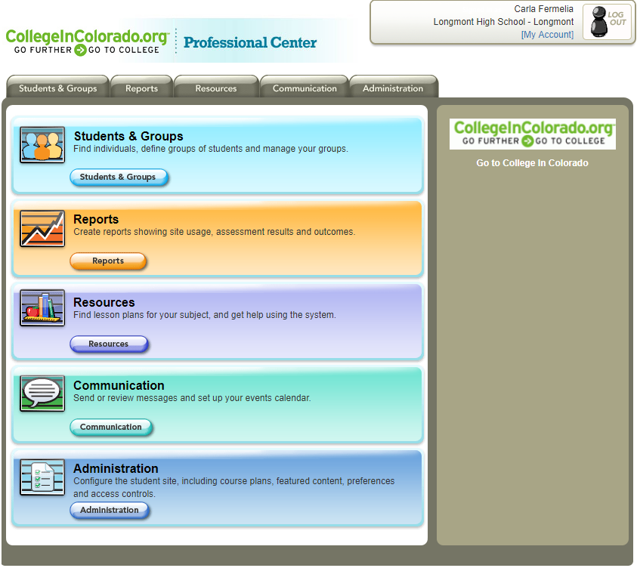
Get Started – For Professionals

1. Go to www.CollegeInColorado.org and click the FOR PROFESSIONALS link at the bottom of the page or navigate directly to: http://procenter.collegeincolorado.org
2. In the right panel of the page, click GO in the Professional Center box.
3. When you arrive at the Professional Center (http://procenter.collegeincolorado.org), click Create a Professional Center Account.
4. Choose your role and click Go.
5. Click Find to choose your school or organization*, then enter the Professional Account Access Key (PAAK) or Administrator Code (AC) and click Next.
Don’t know which code to use? See the Which Code Should I Use? topic at right.
6. Enter your information, read the privacy policy and terms of use, and check the box if you agree. Make sure you remember or record your username and password in a safe place.
7. Click Create Your Account.
*In addition to their primary connection to a school or institution, users may now invite professionals at other organizations to view their portfolio. These agencies appear on the “Other” list found at the top of the “Find” school page.
Your professional account will give you access to tools in CollegeInColorado.org and the Professional Center. When you return for another session, just sign in with your account name and password.

The Professional Center gives you all the tools you need to manage your Individual Career and Academic Plans, college and career planning activities, administration, reporting, and communication. The Center provides for two levels of secured access: professional level, through a Professional Account Access Key (PAAK), and administrator level, through an Administrator Code (AC).

The PAAK gives you access to:
• Students & Groups - Find and view individual portfolios, define groups of students, and manage your groups.
• Reporting - Create reports that show website usage, assessment results, and planning outcomes for groups of students at your school.
• Resources - Find curriculum, lesson plans, and activities for your content area and the guidance office while using the system.
• Communication - Send or review your messages to students, and post and manage events that appear on student calendars.

The AC gives you access to all of the above, plus:
• Administration: Customize the student website views for your school, including course plans, graduation requirements, Individual Career and Academic Plan (ICAP) activities, milestones, local scholarships, preferences, and access controls.
Use of this code is normally restricted to one “power user” to do system-level set up for their school on CollegeinColorado.org.
Customer Support

Can’t find what you’re looking for? Have a question? Want to hear a friendly voice? Contact the XAP Customer Support team:
Toll free: 1-800-468-6927
Email: support@collegeincolorado.org
Monday to Friday from 6 a.m. to 5 p.m. Mountain Time.
Effective Use of Your Professional Center

Your Professional Center account provides access to tools that organize, track, and review your students’ work. (Follow the paths shown in parentheses; you will need AC access if the path indicates “Administration.”)

Look Up Student Account Names and Reset Passwords
• If students forget their account names or passwords, you can look up their usernames and reset their passwords.
• In the Professional Center, find and click a student name (Students & Groups) to see that student’s portfolio. In the Account and Password panel on the right sidebar, click View account name or reset password.
Create Your Advisory Group or Careers Class
• Use the Group Builder (Students & Groups > Group Builder) to create a group and add the appropriate students. Add and remove students from any student list.
• Using your group, you can review student portfolios (Students & Groups > Groups), send messages (Communication > Compose Message), add events to student event calendars (Communication > Add Event), and view reports on student outcomes (Report Builder).
Customize ICAP Activities, including Plans of Study
• Modify the default ICAP settings for your school or create your own (Administration > Edit Individual Career and Academic Plan).
• Update course titles and information, graduation requirements, and plans of study to suit your school (Administration > Update Master Course List, Edit High School Graduation Requirements, Customize High School Programs of Study).
Create and Track Milestones
• Set up student milestones you would like to track (Administration > Customize Planning Milestones).
• In the Professional Center, you can track individual (Students & Groups, click a student name), class or advisory group progress (Reports > Milestones Tracking Report).
Effective High School Course Planning
• The recommended courses for each cluster or pathway can be edited in the Professional Center to match your course offerings (Administration > High School Courses).
Find Lesson Plans and Curriculum
• Use the wealth of resources developed for use with
CollegeInColorado.org (Resources).
• The student portal is packed full of features to help you optimize student learning and your time.

Ensure That Every Student Has a Plan
• Use the CollegeinColorado.org sample ICAP template or your school’s customized version (Your Portfolio > Individual Career and Academic Plan).
• Use the Career Plan Builder to follow step-by-step connections from careers to programs to postsecondary schools, and build an action plan (Career Planning > Explore Careers > Career Plan Builder).
• Use Milestones for additional activities that students can see, act on, and complete (Your Portfolio > Your Planning Milestones).
Explore and Plan for Career Success
• Take interest and skills surveys to discover Colorado career clusters and careers of interest (Career Planning > Learn About Yourself.)
• Use compare/contrast and query tools to review detailed career information, including skills and education needed, salary levels, and job expectations (Career Planning > Explore Careers).
• Practice interviews and create a resume, cover letter, and thank-you notes in preparation for a job or internship (Career Planning > Get a Job).
Effective High School Course Planning
• Students can build and maintain their course plans for high school, and track their progress to graduation and college admission (High School Planning > Your Plan of Study). The process starts with recommended courses based upon a Career Cluster/Pathway that displays courses for the student to take.
Create and Maintain College Lists
• Have students explore postsecondary schools using the browsing and searching tools (College Planning > Explore Postsecondary Schools).
• Save to Your Portfolio to start or add to the list of Saved Schools (College Planning > Explore Schools > school profiles).
• In Your Portfolio, students can review and sort their college list. Comments and campus visit notes can be added to each school and application steps can be tracked (Your Portfolio > College Planning > Postsecondary Plans > Saved Colleges and Postsecondary Schools).
Assistance with Financial Aid
• Students can use the Financial Aid Planning Timeline to make sure they follow the steps toward getting assistance with paying for college (Financial Aid Planning > Build Your Financial Aid Plan > Financial Aid Planning Timeline).
• Calculators can help estimate Expected Family Contributions and College Savings, and review Student Loan scenarios (Financial Aid Planning > Financial Aid Calculators).
• The Scholarship Finder lets students build a list of scholarships for which they might qualify based on their profile data. Plus, sign up for email notifications when new scholarships that match their profile are posted (Financial Aid Planning > Find Scholarships > Scholarship Finder).

