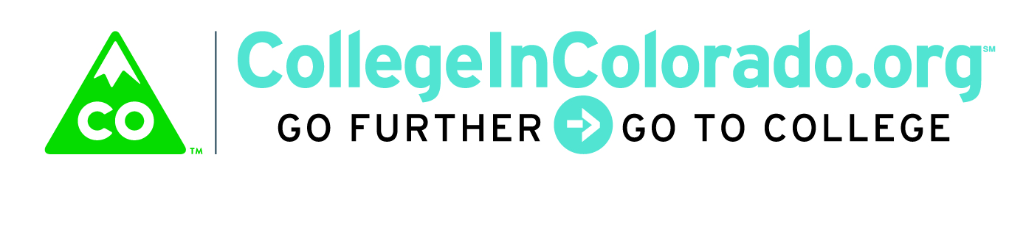
Cross Agency Partnership: Full Task Force

Meeting Minutes

December 4, 2017
Present: | Stephanie Veck, Matt Cornett, Misti Ruthven (via phone)  Mark Duey, Elise Lowe-Vaughn, Trevor Williams, Derek Blake, Brian Pool, Inta Morris, Diane Duffy, Julia Pirnack, Twyla Esquibel
Next meeting: | Doodle poll for second or third week in January
 | Location: 1560 Broadway, Suite 1700 & conference line

Introduction
An overview of the agenda for the meeting was provided including:
- review the messages developed for distribution to professional stakeholders;
- discuss the draft design principles for the product;
- check in on status of other efforts and timeline including charter and funding

Discussion
The task force reviewed the messages developed for distribution to professional stakeholders (messages for end users will be considered at a future date). In general, feedback was received that the messages should be reordered somewhat to clarify the current state of CIC and its duration versus the goals and planning for the future state. In addition, the potential need for direct funding from organization and the value proposition to those organizations was not clear. . The notion that decommissioning is still a possibility is not covered in the messages. DHS and Workforce representatives indicated additional targeting, as was done with the K-12 messages, would be helpful.

The task force reviewed the meeting minutes from the product/services sub-group to discuss the design principles suggested by that group:
- Individual Online Portfolio
- Primary Key
- Common Authentication
- Visual and functional integration
- Data integrity and use
- User profile dictates pathway activities
- Professional case management
There was general agreement that all of these elements are desirable for and important to the product. The vision that user profile elements should drive which pathway activities the system would suggest to an individual was favorably received. Most of the discussion revolved around user privacy concerns, particularly for minors and with sensitive data. Suggestions and issues for handling these concerns were brainstormed, with emphasis that the technology used must be very responsive to this issue. Additional discussions related to modifications for specific groups of users must be conducted as we move forward. The design should set a high bar for what is best with respect to data integrity and functionality, but it may have to be amended as review takes place by legal staff or each agency.

The task force also briefly discussed whether an RFI was appropriate. The product sub-group intends to do workflow analysis, current product inventory as well as research into other products on the market in the career, education and training arena. In addition, the hope is to use the rich content and tools that currently exist and build in interoperable framework on which those tools may be housed. Because of the timeline involved, an RFI may not be feasible to conduct prior to an RFP.
In the context of the charter development as well as the current federal budget environment, potential difficulties with locking in funding were also discussed. Getting other entities, such as vocational rehabilitation and individual school districts, to participate will likely be a necessity.

Brian ran through the timeline commitments for the various sub-group efforts and updated deadlines. He encouraged the group to respond quickly to the Doodle Poll that will be sent out to schedule the next meeting and to think of names for the product before the next meeting.

Action Items
Inta will update the messages within the next two days for distribution and review by the group.

Stephanie will send a template for a one-pager that discuss the how, when, where; this will be used to design a piece to accompany the messages to detail the work going forward, including the value proposition.

Julia will meet with DHS and Workforce representatives individually to modify or augment the messages for their audiences. Trevor will reach out to Melinda Cox to discuss communication to counties.

Mark will continue to explore the work OIT is doing on a common portal for individual state records.

Julia, Matt/Elise and Trevor/Derek will meet to define “personas” and related profile elements that could contribute to individualized pathways. In addition, work to continue documenting existing workflows and product features inventory (begun by CDLE with the assessments that workforce uses), as well as how products are budgeted within agencies, will continue.

Diane will draft a charter for review by the governance sub-group by December 8 and for signature from agency participants by year end.

All will respond to the Doodle Poll ASAP and for the next meeting, please think of names for the task force in general as well as specific product names.

Vision
Colorado delivers a sustainable, modern and personalized web-based service that securely stores and organizes education, training and career planning information.

We enable students, families, job seekers, professionals and other stakeholders to explore and navigate relevant education, training and career pathway options.

Our team demonstrates multi-agency collaboration using career pathway web-based services and data integration to holistically support stakeholders.

