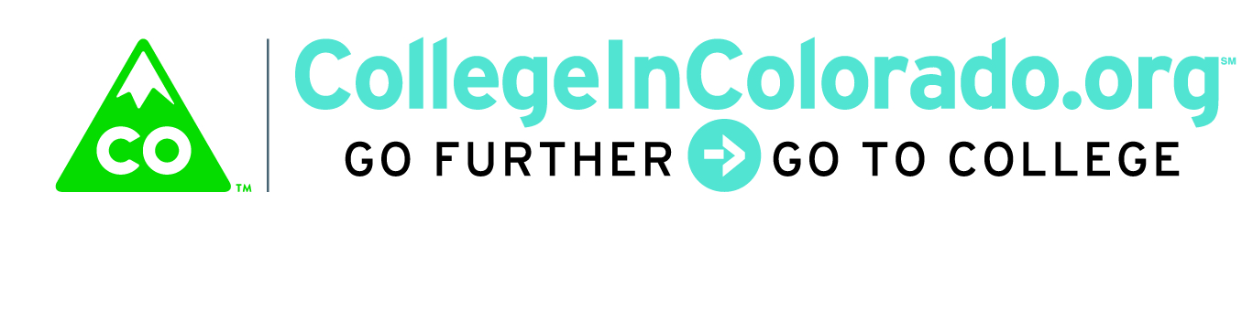
Cross Agency Partnership: Full Task Force

Meeting Minutes

January 17, 2018
Present: | Inta Morris, Diane Duffy, Julia Pirnack, Brian Pool, Mark Duey, Bill Dowling, Fred Franko, Trevor Williams, Derek Blake, Lee Wheeler-Berliner, Sarah Leopold, Misti Ruthven, Andy Tucker, Twyla Esquibel, Elise Lowe-Vaughn, Andrew Galloway and Katie Griego
Next meeting: | Doodle poll for second or third week in February
 | Location: 1560 Broadway, Suite 1700 & conference line

Introduction
An overview of the proposed agenda for the meeting was provided including:
- Approve minutes from the December 4, 2017 meeting (approved)
- Discuss and approve Dan Streeter/Elevate USA to task force (approved)
- Website and communications update
- Implementation Plan updates
  - Charter
  - Feedback from recent communications
  - Funding status
  - Business requirements process
  - Survey of Assessments
  - Naming (if time)

Discussion
Communications
Julia reviewed recent work on communications including showing the CollegeInColorado.org About page (https://secure.collegeincolorado.org/Home/About/_default.aspx) “CIC - Future Planning” section that contains all of the minutes and work to date for the task force along with the Transition Timeline that was developed to help simplify the decommission or move forward timelines. As approved at the December meeting, mass e-mail blasts regarding CIC status and timeline were sent out to school district superintendents, BOCES and all professionals that have a CIC professional center account which include K-12, workforce, non-profit organizations and other professional users.
The task force discussed other targeted correspondence including workforce center directors and corrections. Bill agreed that an update of the CIC status and task force work could be provided to the workforce directors the next day at their meeting. Julia indicated that she would be meeting with members of the CCCS career services roundtable to discuss the situation and encourage a participant to the task force.
Charter
The Task force discussed the draft Charter language including amending the “soft” funding placeholders to firmed up funding. Funding agencies reaffirmed commitments to one-time funding amount and requested that we move forward rapidly with transferring funding to the DHE. In the case of CDLE and CWDC, monies would need to be expended by June 30, 2019. Sarah Leopold of DHS indicated that they would not yet be able to commit to a specific amount, although the DHS Child Welfare/Pathways division has confirmed their committed amount.

Feedback from recent communications
Julia provided several examples of feedback that has come in from stakeholders in K-12 districts throughout the state including the primary concern regarding what to use for ICAP if the free CIC product is decommissioned and the costs associated with other private sector products. While there was discussion that there may be other free methods, such as Google docs or “on paper” to do some ICAP work, as recommended by CDE CIC will continue to contact K-12 superintendents, counselors and teachers and engaged with them directly in order to determine their needs and preferences for ICAP product and services.

Business requirements process
A mockup of a “Journey Map” was shared. This type of map is an illustration of our key design concept showing how the system could present an activity itinerary using multiple agencies’ tools based upon known user profile elements. This illustration appears to help people more readily grasp the task force vision for the product.

As work has proceeded on defining product requirements, it has become apparent that full workflow documentation for each agency user type will not be possible within the desired timeline. Julia proposed and the task force agreed on the following process:
- Continue documenting, by agency, key statutory or business requirements and preferred end user activities in the various focus areas to be vetted by agency subject matter experts;
- Develop “Journey Maps” for key archetypes that represent large user groups for each agency to be vetted by agency subject matter experts;
- Create a document that outlines the objectives for the product/services and core and accessory functionality that will accomplish the objectives to be approved by the task force;
- Convene focus groups to verify the requirements and journey maps, including itemizing favorite products and current gaps in products used now;
- Continue developing a design package, including the items above, which will be used to build the RFP.

Mark shared an update regarding the My Colorado portal being built by OIT and indicated that the likelihood we would be able to use that portal for user ID handling and authentication, at least initially, is small. Work on the realities around which agency portals or software will be capable of doing the desired data sharing envisioned for the product will be ongoing.

Assessment inventory
Fred shared results from the recent survey work done among regional workforce centers to document assessments in use at each of those centers. The survey illustrates the sheer number and also the duplication of offerings in the assessment area, although the vast majority of centers use CIC or My Next Move in the interest/career exploration area. Bill pointed out that some of the other assessments used are driven locally by what businesses wish to use and others are not self-reported interest assessments or the like; rather they document bona fide skills or academic attainment. It was agreed that some rationale will need to be developed to categorize assessments to help determine when and whether they are included in the common product.

The task force returned to the question of requirements for the RFP, price, data elements and scope as well as how to list the voting/funding members of the task force vs. the non-voting/non-funding members on the Charter.

The task force updated the timeline associated with work on the Implementation Plan. The group also reiterated the desire to reduce overlap in work by various agencies, keep the product cost as low as possible and that it could grow over time as more features are desired or agencies provide additional funding.

Action Items

Diane and Inta will work with the DHE accounting staff and the various agencies to accomplish moving the funding commitments to the DHE.

Diane and Inta will take a look at the Charter again and how the signing executive directors are presented on it.

Julia will continue to meet with the sub-committees as necessary and work to finalize business requirement matrix, journey maps and design package.

Mark will continue to explore the work OIT is doing on a common portal for individual state records and/or discuss the project with other vendors that may have applicable product(s).

Product/Services sub-committee will discuss how to categorize assessments and which are important to include as part of the product mix.

Communications sub-committee will continue to work on informing stakeholders about CIC status and work by the task force.

All will respond to the Doodle Poll ASAP and for the next meeting, [from last time] please think of names for the task force in general as well as specific product names.

Vision
Colorado delivers a sustainable, modern and personalized web-based service that securely stores and organizes education, training and career planning information.

We enable students, families, job seekers, professionals and other stakeholders to explore and navigate relevant education, training and career pathway options.

Our team demonstrates multi-agency collaboration using career pathway web-based services and data integration to holistically support stakeholders.

