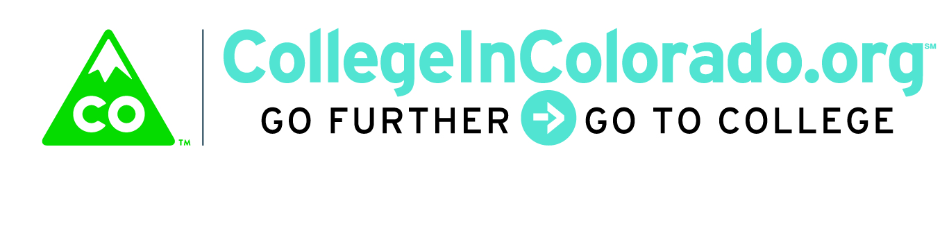

Cross Agency Partnership: Product/Services Group

Meeting Minutes

February 14, 2018
Present: | Lee Wheeler-Berliner, Sarah , Mark Duey, Trevor Williams, Brian Pool, Julia Pirnack
Next meeting: | TBD

Introduction
The product/services group is tasked with reviewing existing tools currently in use by stakeholders as well as determining gaps and qualitative information on products and services that relate to education, training, career and workforce pathways exploration and planning. In support of that, an Activity Matrix was developed that itemizes existing functionality and content along with other activities that have been proposed by various people and organizations.

The purpose of the Matrix will be to gather information from subject matter experts and practitioners in the field on whether each activity is a high or medium priority for their work with their clients. Each program/funding stream will be ranked by individuals that work with that program.

Once the Activity Matrices have been gathered and focus group work completed, the results will be tallied and will help us determine the “core” product elements that should be proposed in an RFP/RFI.

Discussion
Subject matter experts attending the meeting were asked to complete the matrix for the programs that pertained to them. In addition, the next step of identifying activities pertinent to archetypes to illustrate the design concepts, was discussed.

Action Items
Mark and Lee indicated that they would need to request that others at their respective agencies work through the Activity Matrix and provide feedback. DHS representatives at the meeting completed some of the work and will send in information for additional programs/funding streams not currently shown on the Matrix.

