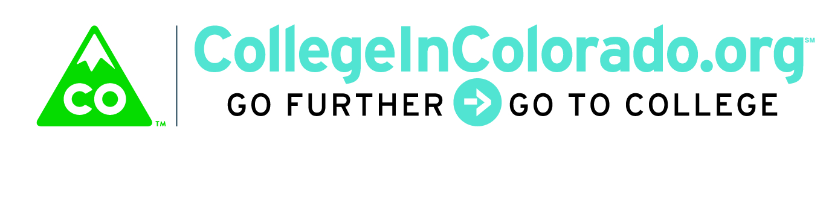

Cross Agency Partnership: Product/Services Group

Meeting Minutes

March 19, 2018
Present: | Lee Wheeler-Berliner, Megan Rymski , Mark Duey, Brian Pool, Julia Pirnack; Freddy Burciaga
Next meeting: | TBD

Introduction
On March 13, the full task force approved issuing a Request for Information (RFI) as a preliminary step to a formal Request for Proposal. An RFI will be useful to help the task force gather architectural and functional suggestions from multiple vendors regarding how the product envisioned could be developed and for what cost.

In addition, the full task force was briefed on the outreach being done with stakeholders statewide to solicit input through one-on-one discussions as well as focus groups and gathering completed Matrix prioritizations. The product/services group has multiple items to complete in preparation for the RFI.

Discussion
The proposed RFI including informational elements were discussed. Julia requested that several important tasks be completed by agency SMEs or their staff.

The proposed RFI schedule was discussed as well (note dates have since slipped due to potential CORE downtime on April 2):
Release - April 3
Acknowledge receipt deadline for vendors – April 6
Questions from vendors deadline – April 13
Our response to questions deadline – April 18
RFI submittal from vendors deadline – April 30

Action Items
Agency representatives were asked to complete the following by March 23rd in preparation for the RFI release:

- Review and redline RFP draft
- Send in additional vendor suggestions
- Continue to encourage stakeholders to complete the Activity Matrix
- Review and suggest itinerary steps for agency archetypes (conceptual) for the journey map samples
- Complete the chart of platforms/activities that each agency wishes to be considered for the final product (attached)
- Notify appropriate technical staff to be on standby for questions as necessary the week of April 9

Systems/Platforms to be connected to multi-agency partnership portal

Including Tools/Features

AGENCY ______________________________________________________________________

Platform Name and URL | Specific Tool/Feature | Tool/Feature URL | Data Exchange Desired?

For each of the platforms itemized above, please answer the following:

- Does the agency platform include user authentication? If yes, then:
  - Can the agency platform work with another calling system (the new platform) as the identity provider?
  - What types of single sign on (SSO) are supported?
  - What are the SSO capabilities of the agency platform?
- What APIs exist in the agency platform?
  - Provide user data back to the calling system?
  - Accept data from the calling system?
- Would the existing APIs support agency platform integration with the calling system or is new API development required?
- Do you have the capacity (in-house resources/funds) to build API capability to facilitate data exchanges if not currently available?

IT/MIS Division contract name and information for additional technical questions:

Name ____________________________________________

Title ____________________________________________

E-Mail ___________________________________________

Product/Services subcommittee member: ____________________________________

