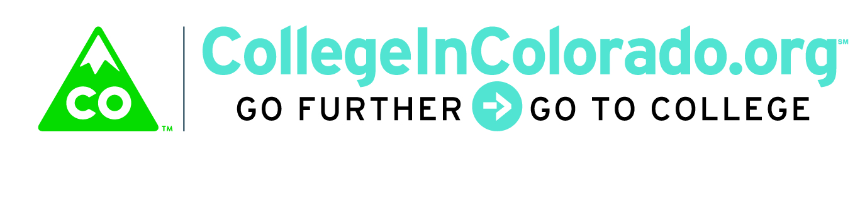
Cross Agency Partnership: Full Task Force

Meeting Minutes

April 10, 2018
Present: | Lee Wheeler-Berliner, Andrew Galloway, Megan Rymski, Inta Morris, Julia Pirnack, Brian Pool, Twyla Esquibel, Alfredo Burciaga
Next meeting: | May 8, 2018, 12:00 – 3:30 Lunch Provided Note time change!
Note location change! | Location: Colorado State Bank and Trust Building, 1600 Broadway, Suite 2200

Introduction

The proposed agenda for the meeting was reviewed:
- Approve minutes from the March 13, 2018 meeting (not introduced; add to next meeting)
- Updates on Charter status and funding efforts
- Implementation Plan updates
  - Recent communications
  - Activity Matrix summary
  - RFI Status
  - Focus group wrap up
  - Vendors committed to submitting RFI response
- Wrap up and next steps

Discussion
Charter, Funding

A quick recap of the charter signature round and funding status was given by Inta. CWDC has signed the Charter (with minor revisions made by Procurement Division) and it is currently awaiting CDLE signature. The Charter will then be returned to DHE, then routed to DHS and then to other advisory member executive directors.

Inta shared the good news that additional funds have been made available through CIC’s traditional funding stream. Once the budget has been reviewed and updated, more information will be available on exact funding status. While we still need additional funding from partners, the gap to maintain CIC base operation through June of 2019 has lessened.
Implementation Plan Updates

Communications

One-on-one conversations with superintendents and others in K-12, along with focus groups have been completed. Julia shared a summary of the focus group main ideas; see “Focus Group Wrap Up” document.

Activity Matrix
The activity matrix results were also shared. Refer to the “CIC Info and Data” spreadsheet, “Matrix Summary by Agency” worksheet. Detailed responses may be viewed in the “Activity Matrix All Detail” worksheet. It was noted that there was little input from workforce arena and that people may continue to send these in as they complete them.
RFI
The RFI was posted and e-mailed to vendors on April 3. The task force discussed the need to have staff at the ready to answer questions that may be posed by vendors during the April 16 – 18 period of time. Our answers to vendor questions are due on the 18th. We anticipate the bulk of the questions to be around the technology used by various partner sites. Julia requested again that task force members suggest which activities on their portals may be of interest to link in to the product as well as provide technical information on those sites.
Vendor Respondents
The list of vendors that have responded positively to the RFI with their intention to submit was discussed; we have an incredible group of vendors that are interested in working on this project. View the current list at https://secure.collegeincolorado.org/Home/About/_default.aspx.
The taskforce briefly discussed some of the elements that may be decision criteria during RFI vendor submittal review. These items included how well the proposal met the five functional requirements, ballpark cost and delivery and familiarity with Colorado and education in general.

Action Items Outstanding

Inta will continue to work with the various agencies to accomplish moving the funding commitments to the DHE and signature round of the Charter.

Agencies committed to provide:
- Have technical staff at the ready to answer questions from the RFI April 16 - 18
- Obtain status and/or send the matrix to their stakeholders
- Identify agency website/portal and activities, including basic data sharing information, that may be included in the product

Vision
Colorado delivers a sustainable, modern and personalized web-based service that securely stores and organizes education, training and career planning information.

We enable students, families, job seekers, professionals and other stakeholders to explore and navigate relevant education, training and career pathway options.

Our team demonstrates multi-agency collaboration using career pathway web-based services and data integration to holistically support stakeholders.

