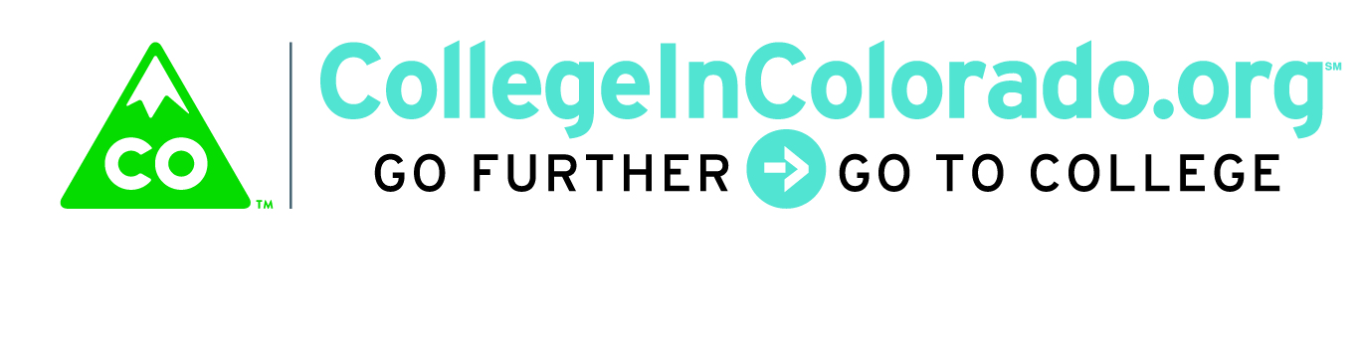
Cross Agency Partnership: Full Task Force

Meeting Minutes

June 12, 2018
Present: | Lee Wheeler-Berliner, Megan Rymski, Derek Blake, Andy Tucker, Megan McDermott Inta Morris, Julia Pirnack, Brian Pool, Twyla Esquibel, Alfredo Burciaga,
Next meeting: | July 10, 2018; 2:30 – 4:00
 | Location: 1600 Broadway, Suite 2200, Training Room

Introduction
A quick overview of the Vision and Governance principals was given and the proposed agenda for the meeting:
- Updated RFP and Project Timeline
- Essential Activities from Matrix
- Demonstrate Connectivity

Discussion
RFP and Project Timeline
As requested from the last meeting, the potential Request for Proposal (RFP) timeline was discussed, including both the activities during the upcoming fiscal year (July 1, 2018 through June 30, 2019) for the RFP and product build, as well as the decommission timeline if the task force elects not to continue the build process.

Items that are scheduled in the timeline include:
- Identification of phase I requirements
- 6 month (January 1, 2019 through June 30, 2019) initial build period while CIC.org is still available
- Ensure basic ICAP tools are available at deployment
- Conduct Webinar for vendors for Q & A during August
- September for vendor response evaluation

It was confirmed that the RFP will require vendors to bring funding and/or funding partners or other strategies to the table for their initial build and potentially a portion of ongoing operations and maintenance since the timing of the project does not allow agencies the opportunity to find funding within their own budgets.

The task force discussed timing to begin work with the legislature on funding should this be required. The draft timeline was adjusted to allow for additional lead time for this effort.

Additional aspects of the project were also discussed including the outreach and training portions of supporting a new product. Creating a plan for these services would take place in early 2019. The timeline also suggests that in the next two months an informational packet for potential funders should be created and finalized after RFP responses are received.

The task force discussed several ways to incentivize other organizations to take a look at the product concepts and funding. The timeline was updated to reflect additional research taking place during the next few months, such as identifying duplicative functionality and repurposable funds as potential funding sources.

Finally, the task force reviewed the decommission timeline as well, should they decide not to pursue the product or in case no vendors come back with a viable proposal. It was reiterated that CIC.org will be available through June 30, 2019. During March, April and May of 2019, remaining College In Colorado staff would work with schools that are still using CIC.org to transfer, if desired, to the XAP Choices360 product (for a per-student charge) which would be most similar to the current platform and would allow their data to transfer seamlessly. Further research would be required to determine if it is necessary or desired by the remaining CIC.org users to deliver data in a format that would transfer easily to other applications as well.

Essential Activities
The matrix results from focus groups and vendor input was reorganized into five major categories of work that should be present in phase I in competitive proposals:
- Assessments and Surveys
- Career profiles data and exploration tools
- Understanding postsecondary options
- Pulling it together and making decisions
- Create Individual Plan
Julia discussed the suggested components in these five areas that will be itemized in the RFP.

Demonstrate Connectivity
One of the key concepts for the project to demonstrate – and one of its biggest selling points -- is to connect users to the correct agency and then use activities from those sites within the user Journey; all with assistance from agency professionals. Julia reminded the task force she would be reaching out again to obtain answers to basic technical questions about the web services available and include those activities each agency would like to have on Phase I build of the product.
Derek mentioned updates to TRAILS that DHS is doing and some likely points of intersection with the new product. He also mentioned that heavy Money101 use (financial literacy courses) is common among those working with foster youth. Megan also mentioned that their organization is publishing an RFI for a case management system and discussed the type of data that is essential for their purposes as they work with clients.
For the purposes of the RFP, identifying the agencies that wish to participate and the associated general activities is a first step. Once the project is in the design stage, it will be essential to understand the details of what functionality down to which data elements may be exchanged and integrated into the system for both user and professional support along with reporting requirements.

Action Items Outstanding
Brian asked the taskforce to start thinking about individuals on their teams, both technical and program experts, that should participate on the RFP response review committee. Depending on the number of responses, a review of the submittals along with a likely interview of two or three of the best submittals will be scheduled.

Julia will continue to draft the RFP and send it out for review by the 21st. The RFP is slated to be posted on June 27th. Please note that Julia will be out of the country from June 28th returning on July 23rd.

Vision
Colorado delivers a sustainable, modern and personalized web-based service that securely stores and organizes education, training and career planning information.

We enable students, families, job seekers, professionals and other stakeholders to explore and navigate relevant education, training and career pathway options.

Our team demonstrates multi-agency collaboration using career pathway web-based services and data integration to holistically support stakeholders.

