

Educator Guide

Table of Contents

Welcome to College Application Month PAGE 3

Before CAM: Getting Ready PAGE 5

**CAM Lesson Plans**

**WEEK 1:** Explore Higher Education Pathways PAGE 6

**WEEK 2:** Identify Careers of Interest PAGE 7

**WEEK 3:** Select Higher Education Pathways PAGE 8

**WEEK 4:** Prepare Your Applications PAGE 9

**WEEK 5:** Get Familiar with FAFSA and Financial Aid PAGE 10

**WEEK 6:** Apply! PAGE 11

**Using the CAM ICAP**

Step-by-Step Instructions PAGE 12  
CAM ICAP at a Glance PAGE 19

**EVENTS AND OUTREACH**

Hosting FAFSA Completion Events PAGE 20  
More Ways to Celebrate CAM PAGE 22

Promoting in your School and Community PAGE 23

**COMMUNITY OUTREACH**

Sample Press Release PAGE 25

Student/Family Informative Letter PAGE 26

Volunteer Resource Guide PAGE 27

Volunteer Recruitment Letter PAGE 28

Welcome to College Application Month

College Application Month would not be possible without dedicated professionals, so we are thrilled to have your support! We've created a toolkit of resources that can help you deliver high-quality education and career planning during this campaign and beyond.

**What is College Application Month?**

College Application Month (CAM) is a six-week boot camp to get students and adult learners to identify career goals, research matching education programs and apply successfully. We hope this guide of lesson plans will be a convenient way to get participants thinking deeply about their future.

**How does it work?**

Participants will work through a series of College In Colorado (CIC) activities to plan and apply to higher education programs. To deliver the content, you may either use the online CAM ICAP template, available through CIC's Professional Center, or have students [download and print their CAM Passport](http://www.ciccollegeappmonth.org/resources/educators/42-cam-passport-2018/file) and follow step-by-step directions posted on the [CAM website](http://www.ciccollegeappmonth.org/students-mainmenu/getting-started) (www.ciccollegeappmonth.org).

Each week, students will tackle a major step in the application process. You can embed these lessons in your regular planning, or you can assign the tasks as homework:

**Week 1:** Explore your education pathway.

**Week 2:** Choose four careers of interest.

**Week 3:** Find an education program that matches your careers of interest.

**Week 4:** Narrow down your schools and prepare your applications.

**Week 5:** Get Familiar with the FAFSA and File Your FAFSA.

**Week 6:** Apply!

*As a CAM Ambassador, you will stamp the student's CAM Passport when they   
successfully complete each week's task.*

**CAM Contests**

**Student Scholarship Giveaway**

Once participants complete the CAM tasks, they will be eligible to enter a drawing for a $1,000 scholarship by:

* Filling out the [College Application Month completion survey](https://forms.zohopublic.com/twylaesquibel/form/CollegeApplicationMonthExitSurvey/formperma/oGF7D6bLivRFPFC6gA74PvmbugDP6TNIUZldjr2fNsQ), where they record their tasks from the last six weeks; and
* Submitting their [FAFSA application](https://fafsa.ed.gov/), which you may track using [Colorado's FAFSA Completion Tool.](http://www.ciccollegeappmonth.org/educators-mainmenu/144-uncategorised/94-fafsa-resources#Completion)

*The exit survey will not ask for any sensitive or personal information—just their first and last names, their high school and their workbook answers.*

For additional prizes, [students can take a selfie with this **#IApplied** template](http://www.ciccollegeappmonth.org/resources/educators/43-cam-selfie-template/file) and tag CIC on Twitter ([@CollegeInCo](https://twitter.com/CollegeInCo)) or Facebook ([CollegeInColorado.org](https://www.facebook.com/cohighered/)) or send them to info@cic.state.co.us.

Finally, we encourage you to have the students sign the **College Application Month** poster and write the program of their choice. Send us pictures of your school's poster using the email and social media handles above!

**Educator Prizes**

The educators/administrators who have the highest percentage of students who filled out the educator survey will enter our drawing for exciting prizes! The contest officially ends Nov. 9, 2018 for both educators and students.

**Helping us erase the belief gap**

Studies show that by 2020, nearly three in four jobs in Colorado will require some kind of higher education or training. To continue our momentum as a state, we need more students and adult learners to find a postsecondary path that suits their unique talents and interests.

Higher education is not just good for individuals—it’s good for our state too! Graduates of postsecondary programs are more likely to be employed, earn more money over their lifetimes and lead healthier lives. As a CAM Ambassador, you are helping us erase our equity gaps and ensure every Coloradan has the opportunity to reach their potential.

**BEFORE CAM:**

Getting Ready

**Before CAM officially begins, we recommend working through the following considerations:**

* Will you include CAM activities as part of your lesson planning? If so, we recommend reserving computer lab time early.
* Will you use CAM as part of your Individual Career and Academic Planning (ICAP) requirements? If so, be sure to [review our resources](https://secure.collegeincolorado.org/Home/For_Professionals/Materials.aspx#icap) and learn how to set it up.
* Set up participants’ CIC accounts:
  + Have participants used CIC before? If so, make sure their accounts are ready to go. [Learn how to reset passwords here](https://secure.collegeincolorado.org/images/cic/pdfs/Resources/publications/updating_your_account.pdf).
  + Do participants need to create CIC accounts? Have them work through this step-by-step guide for [students](https://secure.collegeincolorado.org/images/cic/pdfs/account_creation.pdf) and/or [adults.](https://secure.collegeincolorado.org/images/cic/pdfs/quick_reference_guide_adults.pdf)
  + Have participants write down their passwords in a safe spot, or keep track of them yourself. *This has been a major snag for educators in the past!*
* If you are not using the CAM ICAP, print out a [CAM workbook (*called the CAM Passport)*](http://www.ciccollegeappmonth.org/resources/educators/42-cam-passport-2018/file) for each participant.
* Familiarize yourself with the following tool and websites:
  + [College Admissions Tool](https://www.coadmissionstool.org/)
  + [Career Cluster Survey](https://secure.collegeincolorado.org/Career_Planning/Learn_About_Yourself/Career_Cluster_Survey/Career_Cluster_Survey.aspx)
  + [Explore Careers tool](https://secure.collegeincolorado.org/Career_Planning/Explore_Careers/Explore_Careers.aspx)
  + [FAFSA website](https://fafsa.ed.gov/)
  + [College and University Checklist and Application](http://www.ciccollegeappmonth.org/students-mainmenu/64-public-college-listing-2)

**WEEK 1:**Explore Higher Education Pathways

During Week 1, participants will explore the many education pathways, including four-year degrees, two-year degrees, certificates, apprenticeships and the military.

**Learning Objective:** Using the College Admissions Tool, participants will understand the many pathways available to them and compare personal advantages and disadvantages.

**CIC Tools:** [College Admissions Tool](https://www.coadmissionstool.org/)

**CAM Passport Task:** Participants will fill out a **Pathways Benefits/Trade-Offs** list for higher education pathways.

**Tips for Success:**

* Be sure to encourage participants to consider pathways outside their preconceptions. A student set on attending a four-year university may be interested in attending a two-year institution first to save money.
* Avoid using words like **traditional, nontraditional** or **other** and opt for words like **additional.** This helps create a positive environment for all students.

**What the research says:**

It’s important for participants to explore the many education pathways so they can make informed decisions. A 2017 Gallup survey found that about half of all U.S. adults would change at least one of the decisions they made along their education path, whether that be choosing a different major or field of study, a different institution or another degree type. What’s more, people who completed a trade or technical program were more positive about their education decisions than are individuals with an associate or bachelor’s degree. The activities in Week 1 will help students think deeply about their options so they enroll in the right program.

**WEEK 2:**

Identify Careers of Interest

During Week 2, students/adult learners will identify their unique talents and interests   
and start thinking of ideal career fields.

**Learning Objective:** Using the Career Cluster Survey, participants will identify their unique aptitudes and interests and match them to a suggested career field.

**CIC Tools:** Career Cluster Survey

**Workbook Task:** Participants will reflect on their survey results and write down four career possibilities *(two for their top two clusters).*

**Tips for Success:**

* If participants do not like their Career Cluster results, encourage them to explore options on the [Careers In Colorado website](https://www.careersincolorado.org/#/home).
* If students have a particular career in mind, they can explore independently by using the [Browse Careers](https://secure.collegeincolorado.org/Career_Planning/Explore_Careers/Explore_Careers.aspx) tool.

**What the research says:**

Studies show that students who specify a degree in their first year of college are more likely to complete it. By researching their talents and interests, students will enter their program with their strengths and future career in mind.

**WEEK 3:**

Select Higher Education Programs

During Week 3, students/adult learners will put it all together. They will find out what kind   
of education they’ll need for their career(s) of interest and identify a pathway that works   
for them.

**Learning Objective:** Using the **Explore Careers** tool, participants will match their career of interest to an education pathway that complements their goals and situation.

**CIC Tools:** Explore Careers tool

**CAM Passport Task:** Participants will write down three possible careers and the education required for each. Then they’ll identify majors/programs and matching schools.

**Tips for Success:**

* Encourage participants to think back to the pathways they explored in Week 1. Many good-paying jobs require a two-year degree or short-term certificate.
* Encourage participants to think big! Help them chart their next steps and remind them that career arcs are long and winding. Share your own story as an example.

**What the research says:**

Finding the right fit is important for students, especially those from underrepresented groups. Studies show that more than half of high-achieving students from low-income families end up at a college beneath their academic level, [a phenomenon called *undermatching*](https://www.insidehighered.com/admissions/article/2018/04/16/study-finds-undermatching-remains-major-problem-especially-black). More troubling, those who are under-matched are less likely to graduate on time. By exploring multiple pathways and options, we hope students land at an institution where they’ll thrive.

**WEEK 4:**

Prepare Your Applications

If they haven’t already done so, student will identify their top career-education pathways and matching schools. This week, they’ll also start thinking about the application process and what materials they will need.

**Learning Objective:** Using the **Colorado Training Provider** website and/or the **School Finder** tool, participants will narrow down the programs to which they want to apply. You will notice that there are specific application steps for each major pathway: **Four-Year**, **Two-Year**, **Certificate**, **Apprenticeship** and **Military**.

**CIC Tools:** [Colorado Training Provider](https://www.cotrainingproviders.org/#/) website and School Finder tool

**CAM Passport Task:** Participants will copy pathway work from Week 3 fill out an application checklist for an institution at which they intend to apply.

**Tips for Success:**

* The Colorado Training Provider site and School Finder tools provide a lot of information! We recommend familiarizing yourself with these tools to help guide participants.
* Participants pursuing the four-year path will have additional steps, including submitting high school transcripts, asking for letters of recommendation and writing a personal essay. We have resources available for each of these steps.
* Check in with students to see if they’re on track to apply on time. Identify any roadblocks and report them to [info@cic.state.co.us](mailto:info@cic.state.co.us). This will help us design better resources going forward.

**WEEK 5:**

Get familiar with FAFSA and Financial Aid

No matter participants’ education path, most will need to fill out the Free Application for Federal Student Aid, also known as FAFSA. This is the ticket to earning grants, work study, loans and other financial aid that can help make programs more affordable.

**Learning Objective:** Using the FAFSA website, participants will learn about financial aid, create a FSA ID and learn what documents are necessary for filing.

**Tools:** FAFSA website

**CAM Passport Task:** Participants will fill a FAFSA checklist and note any items of confusion.

**Tips for Success:**

* Use the [Colorado FAFSA Completion Tool](http://www.ciccollegeappmonth.org/students-mainmenu/94-fafsa-resources#Completion) to track which students have filed.
* FAFSA is a notoriously difficult process. Be patient and empathetic with participants and remind them that earning grants and scholarships are well worth the tedium!
* Students who are undocumented may feel concerned about filing a FAFSA. Let them know that their data are secure and remind them that they are entitled to state tuition at Colorado institutions under the ASSET law.
* [Consider hosting a FAFSA night in your community](http://www.ciccollegeappmonth.org/students-mainmenu/94-fafsa-resources#Nights). Reach out to local institutions and invite financial aid representatives to be on hand to answer questions and work with families.

**What the research says:**

Completing the FAFSA significantly increases the odds that students will continue their education—especially among low-income and minority students. In Colorado, 85 percent of high school graduates who complete a FAFSA enroll in college within 12 months. Boosting our FAFSA completion rates will boost our college-going rates, too.

**WEEK 6:**

Apply!

This is when it all comes together! Use this time to review participants’ checklists,   
answer any last minute questions and celebrate everyone’s hard work!

**Learning Objective:** Using the **College and University Checklist and Application** webpage, help students get ready to apply.

**Tools:** College and University Checklist and Application webpage

**Workbook Task:** Participants will write down at least one institution where they applied to or plan to apply.

**Tips for Success:**

* Students may have trouble applying within the six-week timeframe. Keep track of their progress and continue to cheer them on!
* Ask fellow educators and community members to get involved! They can proofread essays, share their higher education experience and help explain the process.

Using the CAM ICAP Template

Using the pre-defined College Application Month template will save you a lot of time and effort while still allowing you to customize activities for your students.

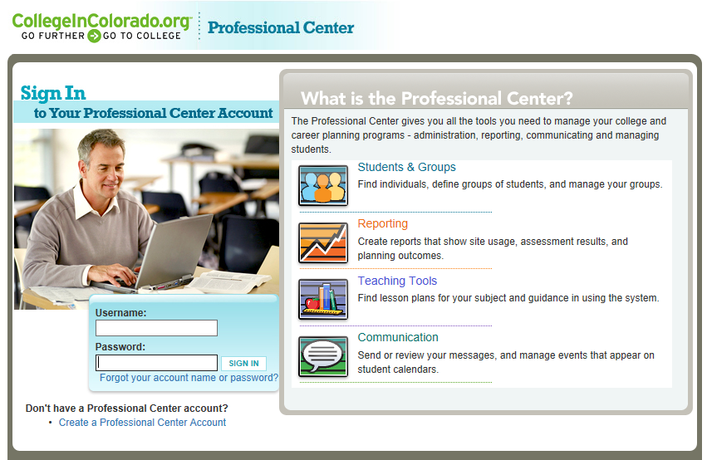

**Step 1:** **Log in**

**Log in:** Enter your username and password at Procenter.CollegeInColorado.org

or create an account. Email [Twyla.Esquibel@cic.state.co.us](mailto:Twyla.Esquibel@cic.state.co.us) if you don’t have your codes.

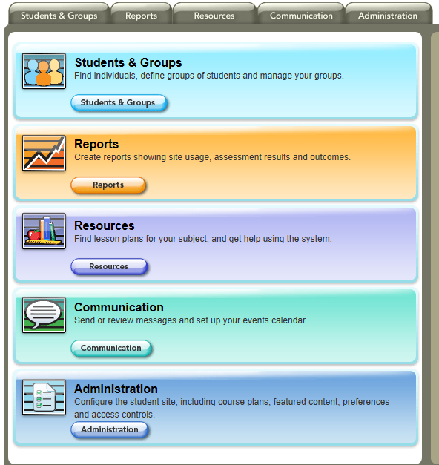

You MUST be an Administration user to work with the template. If you do not see the Administration tab when you log in, contact your school’s CIC administrator or [Twyla.Esquibel@cic.state.co.us](mailto:Twyla.Esquibel@cic.state.co.us).

This Administration panel must be present in your account to work with ICAPs.

**Step 2:** Create a Group of 12th grade students

Do your 12th graders already have an ICAP in the CIC website assigned to them? If so, you will need to create a special group of your 12th graders that will work on the College Application Month ICAP. This will keep your other ICAP intact.

*If you don’t currently use an ICAP on CIC.org with your students, skip to step 4b.*

Click on the **Students and Groups** tab then **Group Builder**.

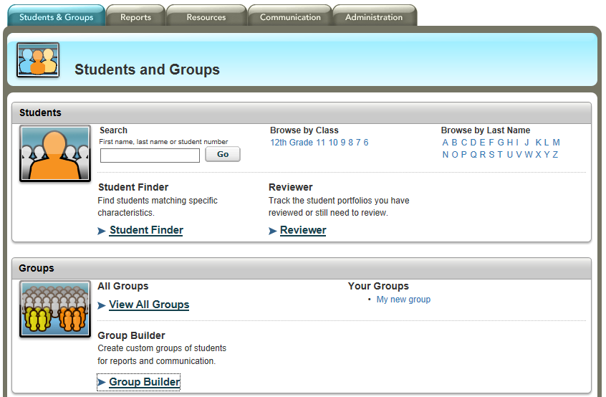

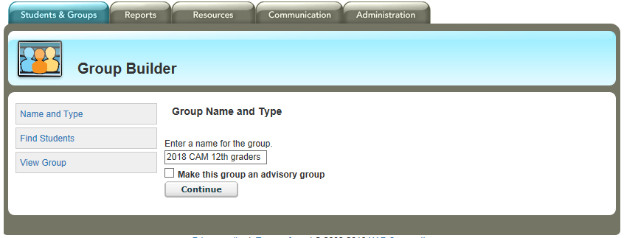Enter the name you want for your group. Click **Continue**.

1. Under **Browse by Class**, click **12th Grade** to view a list of your 12th grade students.
2. Click **Select All**.
3. Click the **Add** button in the upper right next to your new group name.

Once you click the **Add** button, you should get a red message indicating how many students were added to the group.

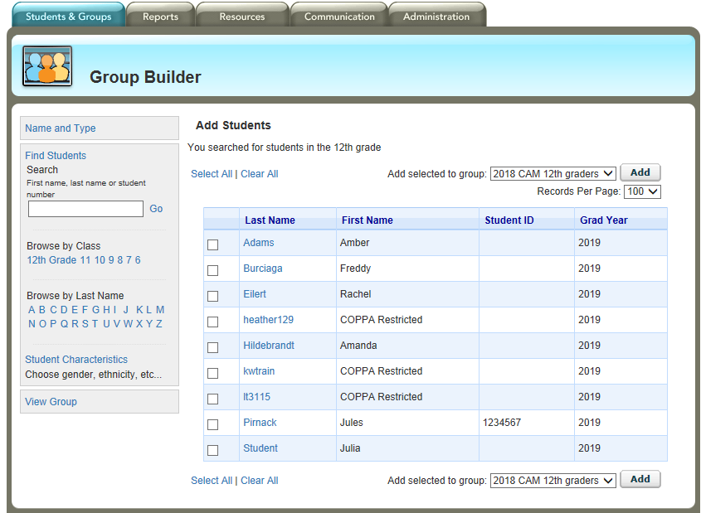

Click on the **Students** and **Groups** tab again to verify your new group is available.

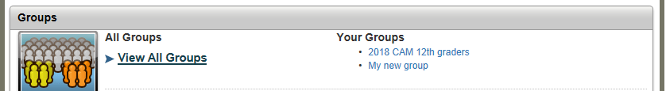

**Step 3**

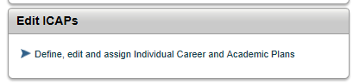

Click on the **Administration** tab > **Edit ICAPs**

Your ICAP Sets page will look something like this. Click the hamburger menu in the upper right corner of the 2018 College Application Month ICAP to see the dropdown choices. Click **Duplicate**.

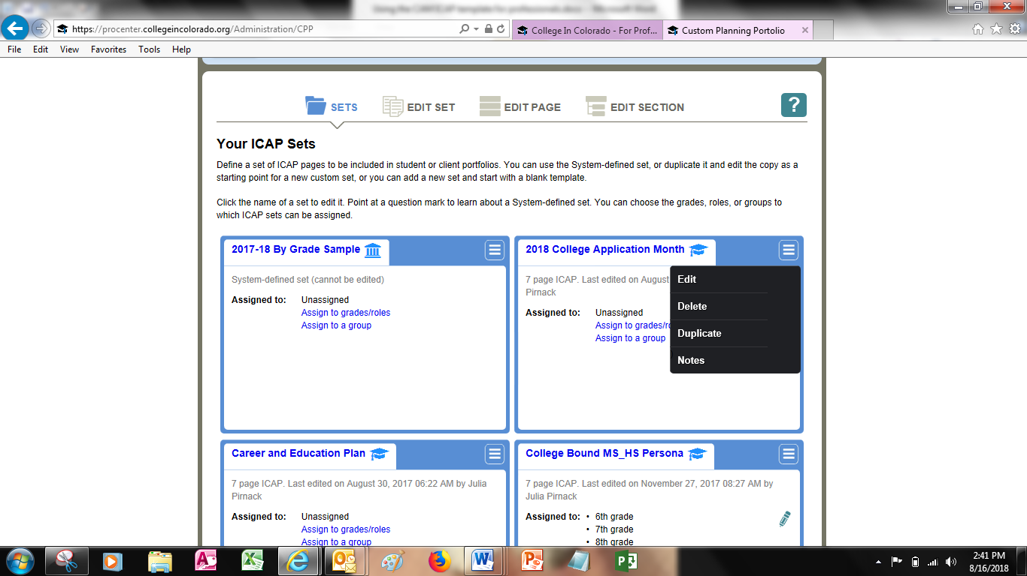

A copied ICAP will now be in your ICAP Sets list under the name “Copy of 2018 College Application Month”

**Step 4a** – Assign the CAM ICAP to a GROUP

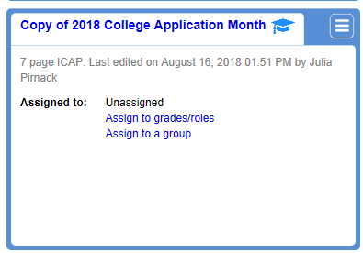

Assign this ICAP to your 12th grade student CAM group by clicking **Assign to a Group**.

Click the checkbox next to your group name and click **Save**. 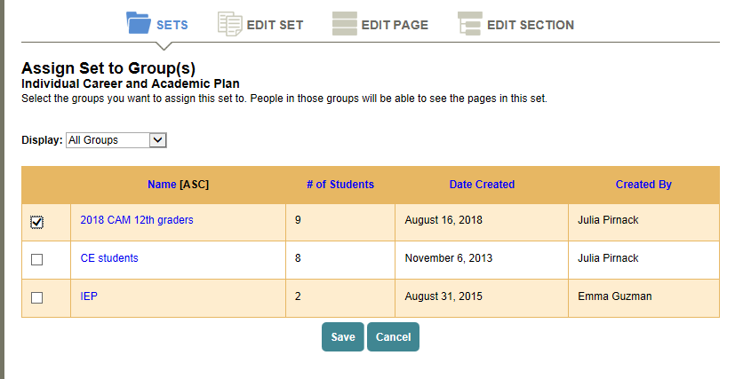

**Step 4b** – Assign the CAM ICAP to a grade level



If you don’t currently use an ICAP with your 12th grade students, assign the CAM ICAP to all your 12th graders by clicking **Assign to grades/roles.**

Click the 12th grade circle to assign this ICAP to your 12th graders. Click **Save**.

**Note**: If you had other ICAPs assigned to 12th graders, you have now *unassigned* them. If that happens, use the Step 4a instructions (page 16) to create a group.

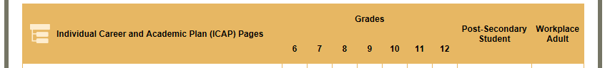

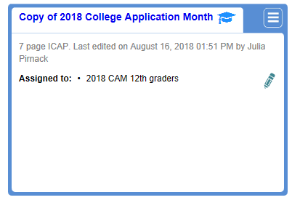

Now that your CAM ICAP is assigned to your 12th graders, rename your CAM ICAP however you wish by clicking on the name of the ICAP.

Then click the pencil next to the name…

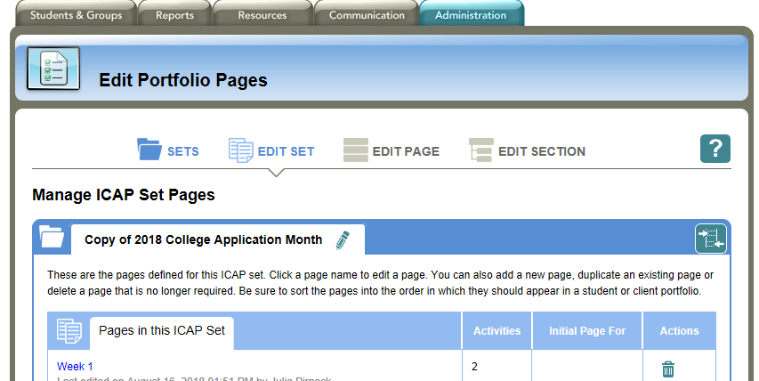

Click **Save**.

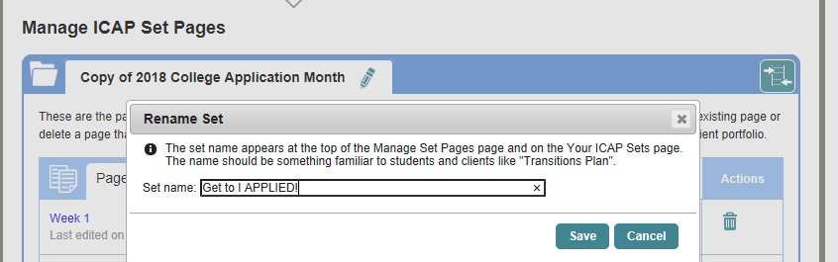

*That’s it!   
All of your 12th grade students should now be able to see the CAM ICAP in their portfolio.*

CAM ICAP at a Glance:

|  |  |  |  |  |
| --- | --- | --- | --- | --- |
| **Template** | **Pages** | **Sections** | **No. of Activities** | **Comments** |
| **2018**  **College Application Month template** | **Week 1** | Explore after high school options  Optional: Set your goal | 2 | *This CAM ICAP will help students complete many of the required elements for a complete ICAP including career, pathway and education exploration during a guided 6-week period in the fall.* |
| **Week 2** | Explore career clusters  Explore careers  Optional: Explore top Colorado industries | 4 |
| **Week 3** | My skills  Education for my career  Schools for my program | 4 |
| **Week 4** | Get Ready – Apprenticeship  Get Ready – Military  Get Ready – Certificate  Get Ready – Associate’s Degree  Get Ready – Bachelor’s Degree | 12 total among 5 sections; students do 1 section |
| **Week 5** | Aid applications | 2 |
| **Week 6** | Info for my applications  Apply  Scholarships | 10 |
| **Up Next** | Scholarships  Review correspondence  Decide | 1 |

*If students want a written record of their work in addition to their digital portfolio, have them print out the* [*CAM Passport*](http://www.ciccollegeappmonth.org/resources/educators/42-cam-passport-2018/file)*.*

Email [Alfredo.Burciaga@cic.state.co.us](mailto:Alfredo.Burciaga@cic.state.co.us) with questions or for assistance.

Hosting FAFSA Completion Events

Hosting your own financial aid, college preparation, or FAFSA completion event is a good way to share information with a number of students at once.

**Set Goals for the Event**

What message do you want to convey to students and parents? What actions do you want them to take? What outcomes do you want for them? The answers to these questions can determine the agenda, structure, and length of your event.

For instance, if you simply want your students to be aware of the many options in postsecondary education in your area, you might want to host a college fair at which schools can set up information tables. You might not want to line up any speakers but instead allow students to show up when they like, visit the information tables, and then leave.

On the other hand, if your goal is for students to file a FAFSA® form, you will need to decide whether you will lead the entire group of attendees through the application one question at a time or allow them to start as they arrive, work through the form at their own pace, and get the help of experts standing by. How you arrange your event depends on what you want to get from it and what you think would best suit the needs and characteristics of your audience.

The most important thing to keep in mind is to have a clear goal for your event so that you can plan event timing, agenda,expert speakers, handouts, and advertising around that goal.

**Choose Location, Date, and Time**

Think about your audience—but also about your own needs and resources—as you plan the time and place for your event.

Is the location convenient (and inexpensive) for the audience to get to? Will you have to pay a fee to access the location? If so, can you pool funds with another school or organization to save money? Or can you find an alternate location free of charge? Ask local colleges and churches whether they have space available for your event.

Is there a date when many of your audience members would be unable to attend due to a competing event? Is there a time of day that is particularly ideal for your audience? Will you be serving substantial refreshments? If not, don't hold your event too close to lunch or dinnertime, or your attendance will drop.

As you consider the pros and cons of different locations and times, talk to colleagues; they might think of obstacles or opportunities that you haven't.

**Choose Presenters**

If you want to have one or more presentations at your event, you'll need presenters. Try the following:

* Depending on your level of comfort with the topic and with public speaking, you can be the presenter. [Get tips on making a presentation about financial aid](https://financialaidtoolkit.ed.gov/resources/how-to-host-a-financial-aid-event-in-your-community.pdf) or use this [CIC Financial 101 PowerPoint template](https://highered.colorado.gov/Publications/CIC-Financial-Aid-2018.ppt).
* Ask the admissions or financial aid staff at a local college if someone is available to speak.
* Find out if there's a college access organization near you that can provide an expert in the topic you want to feature. (Invite them to bring their students to your event so they can benefit as well.)
* Email [FSAOutreach@ed.gov](mailto:FSAOutreach@ed.gov) to see whether someone from the Federal Student Aid Outreach Team will be in your area around the time of your event and can speak to your audience about financial aid. Please note that the Outreach Team is small, with a limited budget, and cannot fulfill all requests for speakers. In order to respond to your email, the Outreach Team will require the following information:  
  + Contact name
  + Phone number
  + Email address
  + Organization name
  + Date of event
  + Name of event
  + Complete event location address
  + Audience size expected
  + Audience type: high school students, adult learners, counselors, etc.
  + Type of request: panel participant, presenter, exhibit booth, etc.

**Spread the Word**

Start advertising your event as early as possible, and advertise it in a variety of ways to reach the largest number of people. Remember the old adage that someone has to see or hear a message seven times before they take action? Here are seven ways you can advertise your event:

* Email students and parents.
* Put up posters around the community.
* Share the details on your school's or organization's website.
* Put ads in your local paper and school paper.
* Tweet about it.
* Put an ad on local radio.
* Spread the word via your Facebook page.

**Gather Handouts**

At your event, you print out this CIC handout in [English](http://www.ciccollegeappmonth.org/resources/educators/38-paying-for-college-english/file) and [Spanish](http://www.ciccollegeappmonth.org/resources/educators/39-paying-for-college-spanish/file) and use [videos, tools and resources from the U.S. Department of Education collection](mailto:https://financialaidtoolkit.ed.gov/tk/resources.jsp).

A number of publications are available to [order in bulk from the Federal Student Aid Publications Ordering System](mailto:https://financialaidtoolkit.ed.gov/resources/order-federal-student-aid-publications.pdf).

**Get Help Carrying Out the Event**

Besides starting your planning early, one of the best things you can do to ensure the success of your event is to get help. Ask colleagues to collaborate in the organization and preparation. Ask subject experts to share their knowledge in mini-workshops. Ask students to serve as the set-up and clean-up crews, welcome people at the door, hand out materials, and serve refreshments. Don't go it alone**!**

**Assess the Event's Success**

If appropriate, provide an evaluation form for your event, and review any feedback you get. Hold a “lessons learned” meeting after the event, and take notes so you'll have a record of what worked and what didn't work. That way, you'll be even better prepared when it's time to organize your next event.

*Adapted from* *financialaidtoolkit.ed.gov/tk/outreach/host-event.jsp*

More Ways to Celebrate CAM

* **Create a “Higher Education Wall.”** Participants write the names of the institutions to which they have applied on banners or strips of construction paper to hang in a main hallway. Highlight program names when they receive acceptances. Call on art teachers (if available) for additional promotional materials to decorate the walls of your school.
* **Coordinate writing workshops for personal statements or essays.** English teachers can use the [essay template documents created by College In Colorado](https://secure.collegeincolorado.org/Career_Planning/Get_a_Job/Prepare_Application_Documents.aspxx).
* **Provide application activities for all students in your school prior to and during your College Application Month event.** Use [CollegeInColorado.org](http://www.collegeincolorado.org/) curriculum materials to incorporate grade level appropriate activities for 9th-11th-grade students. Organize workshops during student/family evening events, homeroom with students or sport events.
* **Widely publicize students’ applications.** Interview students and adult learners about their plans and send the articles to local newspapers, public service announcements on local radio, intercom/homeroom announcements or ads in the newspaper. You can also create a special section in the school newspaper that gives the names of seniors and their prospective programs.
* Find templates for these activities and more on the [Resources webpage](http://www.ciccollegeappmonth.org/resources/educators) on the CAM website.

Promoting College Application Month   
in your School and Community

**Purpose**

To promote College Application Month events to the school community by:

* Disseminating information by phone, mail, e-mail, website, fliers, meetings, and word of mouth;
* Holding special events/meetings prior to applying;
* Recruiting volunteers from students’ families and community organizations;
* Hosting guest speakers during the events.

**Activities**

* *Bring together a planning committee* to decide on the options throughout the month and brainstorm additional activities, then make assignments and deadlines. This committee may include different groups such as faculty, staff, families, student groups and community members.
* *Set goals for the number of seniors participating*, *number of volunteers, etc.* Remind everyone of these goals and the importance of reaching as many people as possible in your school community.
* *Hold special event(s) such as a College Alumni Parent Night and “Ask Me About It!”* (see details included on p. 24). Schedule visits to your school prior to and during College Application Month by college admission professionals, first year college students and/or community and business leaders.
* *Send e-mail reminders to all parents, students, and school staff* in addition to the official student/ family letter (see p. 26). Also, include information in the school newsletter and post fliers around the school and community about your College Application Month events.
* *Invite a guest speaker* for College Application Month as part of a kick-off ceremony to elaborate from personal experience on the importance of applying to and completing college.
* *Recruit volunteers from students’ families and community organizations.* Be creative! Send the volunteer letter to volunteer groups, Boys and Girls Club, Pre-Collegiate Providers, YMCA, church groups, businesses in the community, banks, etc.

***“Ask Me About It!”***

**Activities**

* Have the entire faculty display an 8 ½ x 11-inch poster that lists their alma mater. Post signs and display them around the school.
* Announce the posting date to the school and set aside some time (i.e., during homeroom) and host a scavenger hunt for as many different schools as they can find, the school farthest away, the school with the most alumni, etc. Award small prizes.

**Preparation**

* E-mail a sample sign like the one included in this handbook to all faculty and staff and designate a posting date. Templates for the sign can be found online at [CICCollegeAppMonth.org](http://www.ciccollegeappmonth.org/).

**College Alumni Parent Night**

**Activities**

* Ask parents and staff to wear gear, display flags or bring other items of interest to represent their favorite institutions.
* Invite admission offices to send materials for display or invite admission staff to attend.

**Preparation**

* Schedule an evening, possibly in conjunction with a PTSA/PTA meeting. Reserve a space and make a promotion plan. Ask parents and the PTSA/PTA officers to provide refreshments and college paraphernalia door prizes.
* Invite parents and staff to represent institutions for your student body.
* Invite admission counselors from nearby colleges to setup information tables.
* Create a “Good Questions to Ask” sheet for students to use as they visit alumni and collect information on their selected schools of interest.

Community Outreach

**Communication is Key to Successful Outreach!** Capture stories from CAM event and send to local media outlets (i.e., newspapers, TV stations, community newsletters, etc.). Post banner images on you school/school district’s website.

**Sample Press Release**

**(City), CO DATE**– (Name of Your High School) will participate in the statewide College Application Month during the last two weeks of September through October.

As part of College In Colorado’s college access initiative, (Name of Your High School) will work with each senior on (Your School’s Event Date) to prepare, complete and submit at least one higher education application using the career and college planning website, [CollegeInColorado.org](http://www.collegeincolorado.org/).

Studies show that by 2020, nearly three in four jobs in Colorado will require some kind of postsecondary education or training. To put students on a path to success, it’s important they find a higher education path that suits their interests and aptitudes, whether they pursue a certificate, two-year or four-year degree or join the military.

(Name of Site Coordinator or School Principal), College Application Month event Site Coordinator/Principal for (Name of Your High School), expects more than (Insert Number) seniors to participate with the help of (Insert Number) volunteers from (Insert School Faculty, Administration, College, College In Colorado, Community Resources that will help).

For more information about (Name of Your High School), please contact (Name of Site Coordinator and contact info).

For more information about College Application Month, visit [CICCollegeAppMonth.org](http://www.ciccollegeappmonth.org/).

# # #

**Student / Family Informative Letter**

SCHOOL LOGO

SCHOOL ADDRESS

DATE

Dear Students and Families,

This fall, College In Colorado is sponsoring College Application Month (CAM). This campaign is possible thanks to the collaboration among HIGH SCHOOL administration, faculty, and staff at as well as students, their families and volunteers across the community.

The CAM campaign walks students through the key tasks in the application process over the last two weeks of September through October. Students who successfully complete each week’s challenge and file their FAFSA will be eligible for a $1,000 scholarship.

To get started, students should download the CAM workbook and step-by-step guide posted on [CICCollegeAppMonth.org](http://www.ciccollegeappmonth.org/). As they go through the process, students will likely need your help in gathering some of the information and completing application tasks.

Families are welcome to visit YOUR NAME High School on DATE(s) OF EVENT(S) to assist their student during the application process. If family members are interested in volunteering or guest speaking during the event, please let me know. Volunteers can greet and sign-in students or assist students with filling out college applications.

Studies show that by 2020, nearly three in four jobs in Colorado will require some kind of postsecondary education or training. To put students on a path to success, it’s important they find a higher education path that suits their interests and aptitudes, whether they pursue a certificate, two-year or four-year degree or join the military.

If you have any questions please call NAME, TITLE, at (000) 000-0000. Thank you for supporting exciting initiative to encourage Colorado students to reach higher.

Sincerely,

CAM AMBASSADOR

**Volunteer Resource Guide**

Reaching out to community groups and members during College Application Month is an effective way to promote CAM. Volunteers can donate food and supplies or help ensure events run smoothly. Use the templates and resources provided to help recruit and inform your volunteers.

**Managing Volunteers: Step-by-Step**

Recruiting Volunteers

1. Identify contacts in your community that may be interested in helping make your College Application Month event(s) a success by donating time and/or resources. Some examples may include:

* School alumni;
* Students who have already completed their application (i.e., college application ambassadors);
* Student families, PTA;
* Retired teachers;
* Volunteer, senior, or church groups;
* Community college and university representatives and faculty;
* Business, community, and political leaders;
* Representatives from youth programs (i.e., YMCA, Boys and Girls Club, 4H, Girl and Boy Scouts of America, etc).

1. Send potential volunteer groups a College Application Month Volunteer Recruitment Letter.
2. When promoting your College Application Month event(s), always mention the need for volunteers in your community.
3. Reach out to student leaders in your school. For example, students who have already completed their application could help other students during the event and be called the “CAM Ambassadors.”
4. Create a system for collecting volunteer information. Depending on your school district’s policy, you may need to conduct a background check.
5. Identify specific responsibilities and duties for your volunteers. For example, you may create shifts for greeting, sign-in, computer lab, other activities, etc. Create a short explanation of each responsibility for volunteers to follow throughout the day.   
   Finalize a volunteer list and, as a reminder, send information using the following template notifying volunteers of event details.
6. Provide nametags for volunteers on the day of the event.
7. Conduct a quick orientation, perhaps the morning of the event, to familiarize volunteers on the details of your event. Provide volunteers with a volunteer reference guide to College Application Month.

**Follow-Up**

1. Send a thank you letter to all volunteers for their dedication to College Application Month.

**Volunteer Recruitment Letter**

SCHOOL LOGO

SCHOOL ADDRESS

DATE

Dear (Name of Organization),

To encourage every student to reach higher, College In Colorado is sponsoring the annual College Application Month, held the last two weeks of September and the month of October.

The goal of College Application Month is to provide every graduating high school senior with the preparation and opportunity to apply to a higher education program with the help of the resources available on [CollegeInColorado.org](http://www.collegeincolorado.org/). A focus of College Application Month is to help first-generation students and students who may not otherwise continue their education.

We will be hosting our event(s) on (DATE(S) and would welcome representatives from (Name of Organization) to visit our school during this exciting and important time. Volunteers can (greet and sign-in students or assist students with the completion of higher education applications. CHANGE IF NEEDED).

Studies show that by 2020, nearly three in four jobs in Colorado will require some kind of postsecondary education or training. To put students on a path to success, it’s important they find a higher education path that suits their aptitudes, whether they pursue a certificate, two-year or four-year degree or join the military.

If you or any of your colleagues at (Name of Organization) are interested in working with (Name of Your High school) in any capacity, please contact (NAME, CONTACT INFO).

Thank you!

YOUR NAME YOUR TITLE