Using the CAM ICAP Template

Using the pre-defined College Application Month template will save you a lot of time and effort while still allowing you to customize activities for your students.
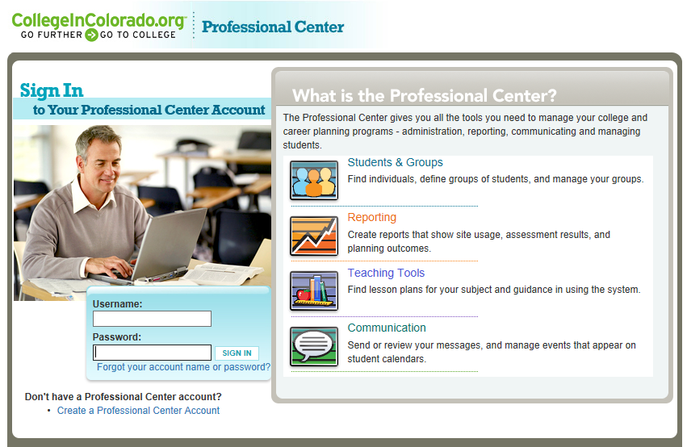
Step 1: Log in
Log in: Enter your username and password at Procenter.CollegeInColorado.org
or create an account. Email Twyla.Esquibel@cic.state.co.us if you don’t have your codes.

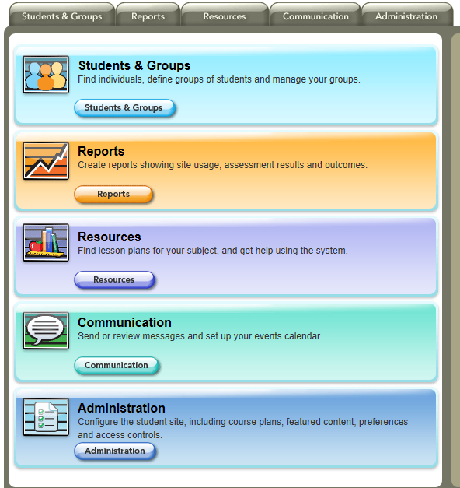
You MUST be an Administration-level user to work with the template. If you do not see the Administration tab when you log in, contact your school’s CIC administrator or Twyla.Esquibel@cic.state.co.us.

This Administration panel must be present in your account to set up ICAPs.

Step 2: Create a Group of 12th grade students
Do your 12th graders already have an ICAP set up and assigned to them on the CIC website? If so, you will need to create a special group of your 12th graders that will work on the College Application Month ICAP. This will keep your other ICAP intact.
If you don’t currently use an ICAP on CIC.org with your students, skip to step 4b.
Click on the Students and Groups tab then Group Builder.
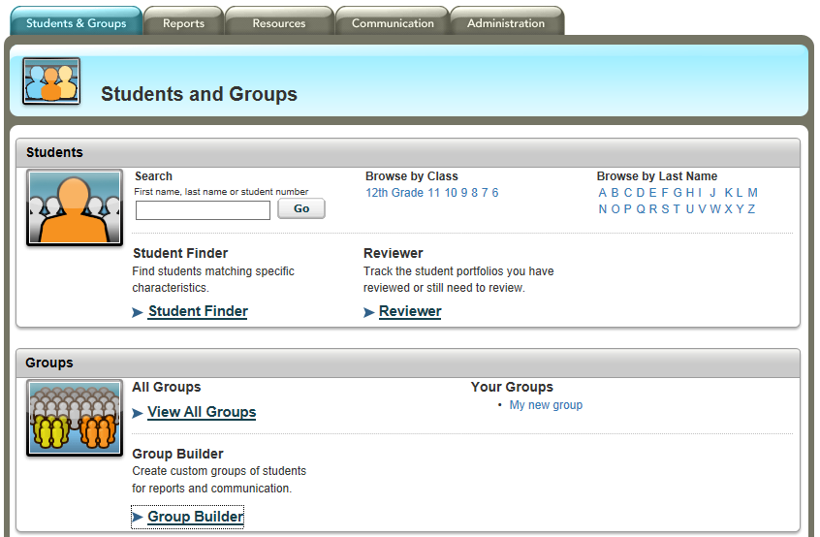
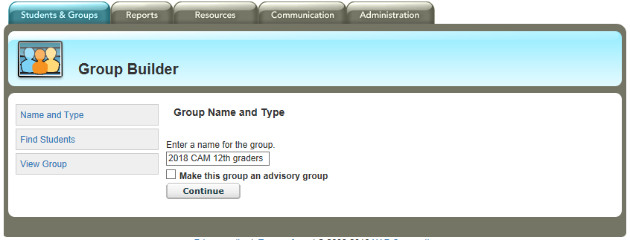
Enter the name you want for your group. Click Continue.

- Under Browse by Class, click 12th Grade to view a list of your 12th grade students.
- Click Select All (you can unclick any students that are no longer at your school).
- Click the Add button in the upper right next to your new group name.

Once you click the Add button, you should get a red message indicating how many students were added to the group.
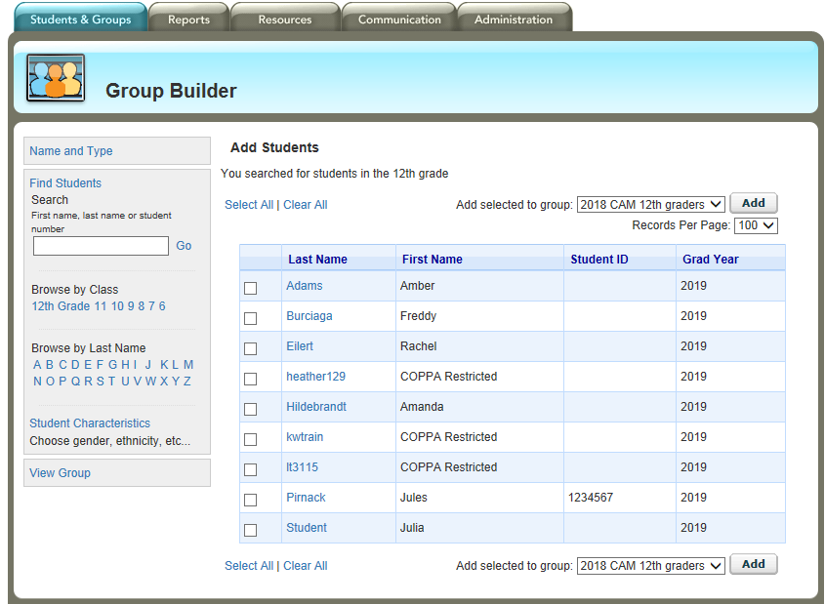

Click on the Students and Groups tab again to verify your new group is available.
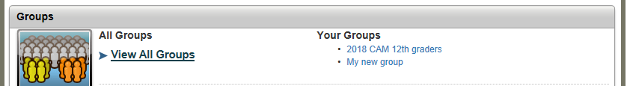
Step 3

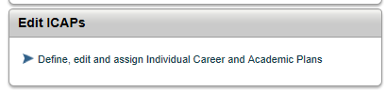
Click on the Administration tab > Edit ICAPs

Your ICAP Sets page will look something like this. Click the hamburger menu in the upper right corner of the 2018 College Application Month ICAP to see the dropdown choices. Click Duplicate.

A copied ICAP will now be in your ICAP Sets list under the name “Copy of 2018 College Application Month”
Step 4a – Assign the CAM ICAP to your GROUP

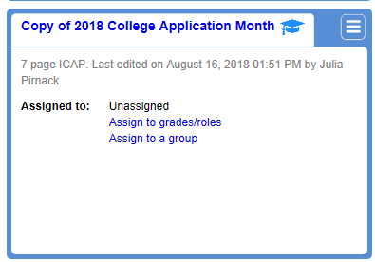

Assign this ICAP to your 12th grade student CAM group by clicking Assign to a Group.

Click the checkbox next to your group name and click Save. 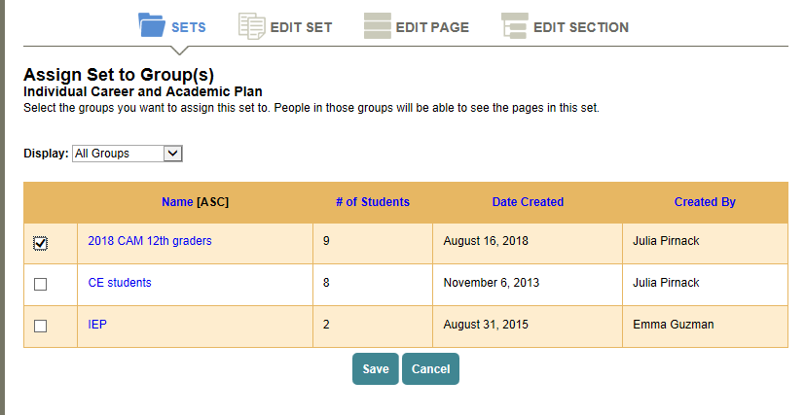

Step 4b – Assign the CAM ICAP to a grade level

If you don’t currently use an ICAP with your 12th grade students, assign the CAM ICAP to all your 12th graders by clicking Assign to grades/roles.

Click the 12th grade circle to assign this ICAP to your 12th graders. Click Save.
Note: If you had other ICAPs assigned to 12th graders, you have now unassigned them. If that happens, use the Step 4a instructions (page 16) to create a group.
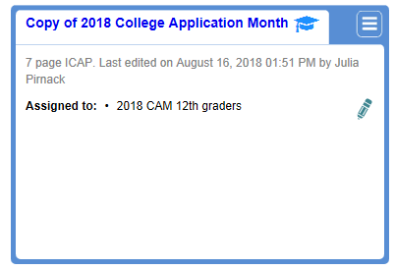

Now that your CAM ICAP is assigned to your 12th graders, rename your CAM ICAP however you wish by clicking on the name of the ICAP.
Then click the pencil next to the name…
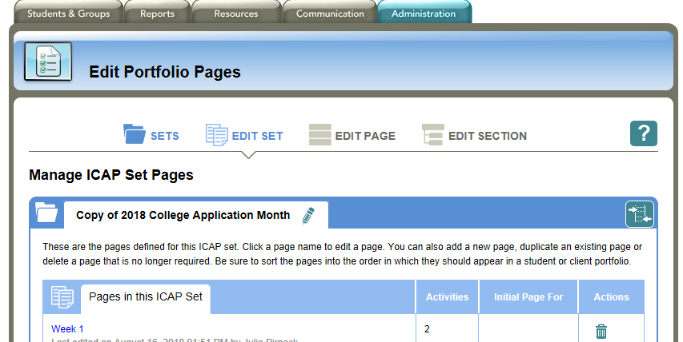

Click Save.

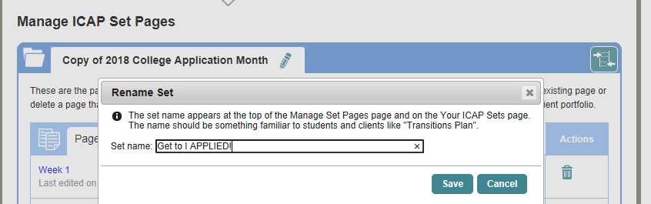

That’s it!
All of your 12th grade students should now be able to see the CAM ICAP in their portfolio.

CAM ICAP at a Glance:
Template | Pages | Sections | No. of Activities | Comments
2018  College Application Month template | Week 1 | Explore after high school pathway options  Optional: Set your goal | 2 | This CAM ICAP will help students complete many of the required elements for a complete ICAP including career, pathway and education exploration during a guided 6-week period in the fall.
 | Week 2 | Explore career clusters  Explore careers  Optional: Explore top Colorado industries | 4
 | Week 3 | My skills  Education for my career  Schools for my program | 4
 | Week 4 | Get Ready – Apprenticeship  Get Ready – Military  Get Ready – Certificate  Get Ready – Associate’s Degree  Get Ready – Bachelor’s Degree | 12 total among 5 sections; students do 1 section
 | Week 5 | Aid applications | 2
 | Week 6 | Info for my applications  Apply  Scholarships | 10
 | Up Next | FAFSA & Scholarships  Review correspondence  Decide | 1

If students want a written record of their work in addition to their digital portfolio, have them print out the CAM Passport.
Email Alfredo.Burciaga@cic.state.co.us with questions or for assistance.

