WEEK 1
EXPLORE AFTER HIGH SCHOOL PATHWAY OPTIONS

“Postsecondary (after high school) education” includes much more than colleges and universities. This week, you’ll explore all the education options available to you beyond high school, including four-year schools, community colleges, technical schools, apprenticeships and military service.

Your Task: Use the College Admissions Tool to research postsecondary pathways.

STEP 1: Open the College Admissions Tool. Click BUILD OPTIONS WIZARD.
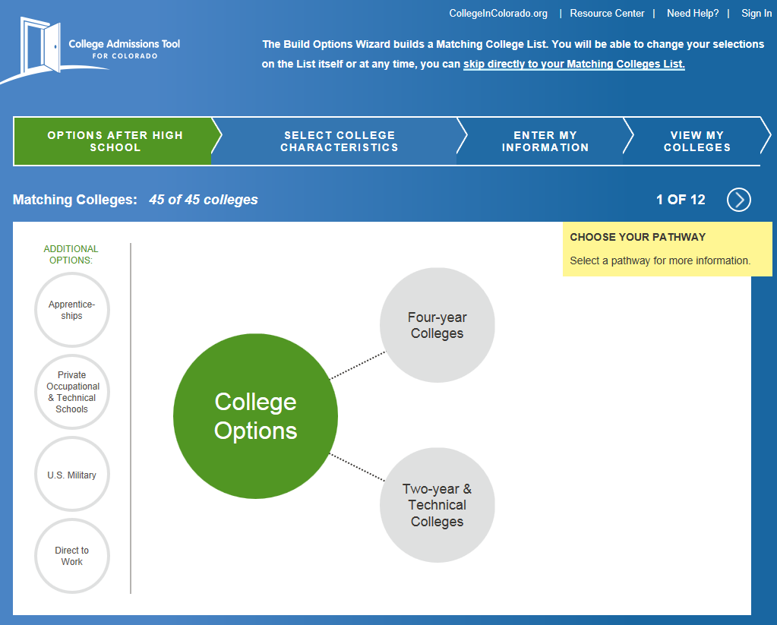

STEP 2: Click Four-year Colleges then select the Benefits and Trade-offs drop-down categories. Read through the items in these two categories.

STEP 3: Continue by clicking the other circles, including Two-Year and Technical Colleges, Apprenticeships, Private Occupational & Technical Schools, U.S. Military and Direct to Work. On each of these other after high school education options, look at their Benefits and Trade-offs.

STEP 4: Complete the chart below as you explore.

Option | Summarize Benefits | Summarize Trade-offs
Four-Year Colleges and Universities

Two-Year & Technical Colleges

Apprenticeships

Private Occupational & Technical Schools

U. S. Military

As you can see, each option has benefits and trade-offs. Which one or two options are most appealing to you?

Record your choices below and discuss your reasons.

