WEEK 2
MATCH YOUR TALENTS AND INTERESTS TO CAREERS
Choosing your career path can seem overwhelming, so we’ve developed tools to help! The Career Cluster Survey will help you identify your unique talents and interests and match them with a suggested career field.
Your Task: Use the Career Cluster Survey to identify three careers of interest.
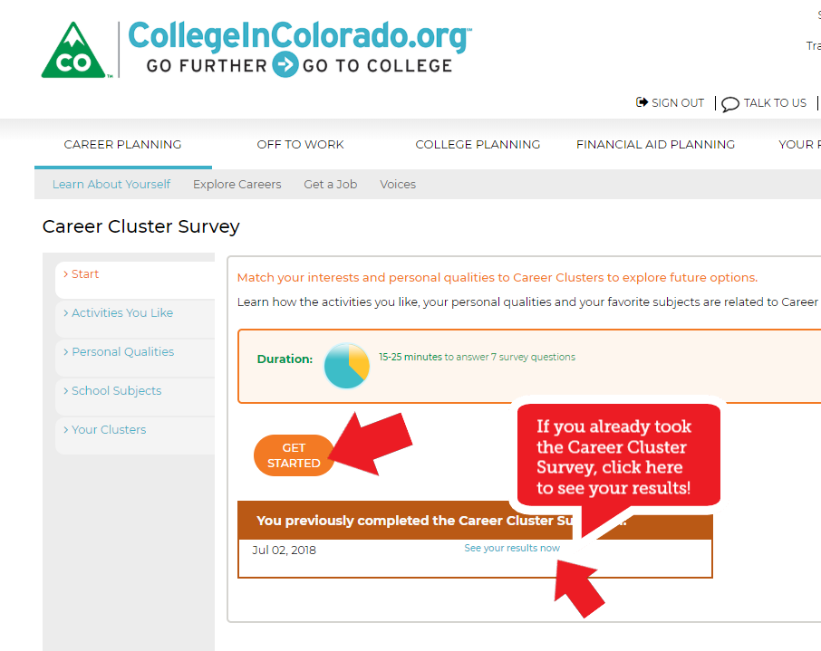
STEP 1: Take the Career Cluster Survey. As you explore, save your favorite clusters to your portfolio.
[To navigate directly: Career Planning > Learn About Yourself > Career Cluster Survey.] If you’ve already completed the Career Cluster Survey, click See your results now.

STEP 2: Explore the results of your survey. Click the bar next to your top two clusters or any that sound interesting to read about Employment Outlook, Trends and Opportunities in those clusters.
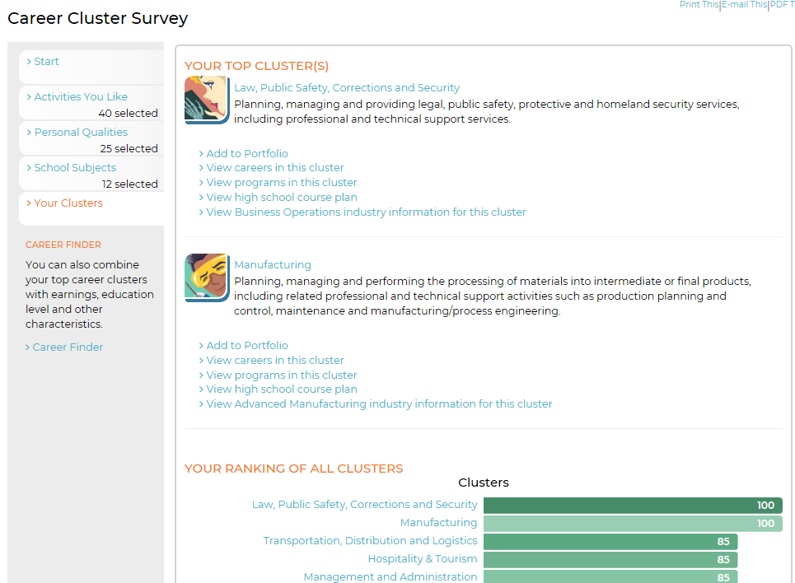
STEP 3: Write a paragraph below about your top cluster results. Were you surprised? Why or why not? Click Add to Portfolio to save your favorite clusters.

STEP 4: Next, click the Careers tab for a cluster. Click on a career name and read about it using the tabs to the left.

Step 5: Click What to Learn to read about majors and programs that will help you get the training and education needed to prepare for your career. University of Loyola Chicago has a major quiz that can help, too: https://www.luc.edu/undergrad/academiclife/whatsmymajorquiz/#
STEP 6: Identify your top two career choices in this cluster and write down one thing that surprised you about that career. Write down your career cluster and career below, and if you have ideas, possible majors and/or programs of study.

Career 1:_____________________________________________________________________________
_____________________________________________________________________________________
_____________________________________________________________________________________
_____________________________________________________________________________________
_____________________________________________________________________________________

Career 2:_____________________________________________________________________________
_____________________________________________________________________________________
_____________________________________________________________________________________
_____________________________________________________________________________________
_____________________________________________________________________________________

Want to explore more careers?
Colorado has plenty of training options in industries looking for talent.
Learn how to get started by choosing a career pathway that leads to an in-demand job with Careers In Colorado.

