WEEK 3
EXPLORE OPTIONS AFTER HIGH SCHOOL

This week, you’ll use online tools to come up with a list of matching schools and programs to which you might apply. Having this list prepared will give you a jumpstart on the application process during the fall of your senior year!

Your Task: Use online tools to identify possible options after high school.

STEP 1: Think back to your pathways and career exploration. In the table below, enter your two top careers in the first column and then list two programs for each career that sound interesting in the right column.
Career | Program of Study/Major | Level of Education*

*Bachelor’s degree, associate degree, certificate, military or apprenticeship

STEP 2: Now, it’s time to start exploring opportunities!
Click the links below and follow the directions to get acquainted with the kinds of education providers available.

- Colleges and universities (four-year bachelor’s degrees)
- Community colleges (two-year associate degrees and certificates)
- Private occupational schools (certificates)
- Military branches (Army, Navy, Air Force, Marines, Coast Guard)

STEP 3: As you explore these opportunities, jot down your favorites at the back of this packet. This will help you narrow down where you want to apply in the fall of your senior year.

Exploring Four-Year Colleges and Universities

There are more than a 30 four-year colleges and universities in Colorado and hundreds across the country! Be sure to apply to your “dream” school, but also select schools where you’ll sure you will be admitted.

STEP 1: Start the School Finder activity (College Planning > Explore Postsecondary Schools > School Finder).

STEP 2: Use the menu on the left side of your screen to filter by dozens of criteria. Click School Type and select Four-Year, then Programs/Majors Offered to select the postsecondary program(s) you identified earlier. When you finish inputting criteria, scroll down and click See Matching Schools. Hint: Pick only two or three criteria for best results.

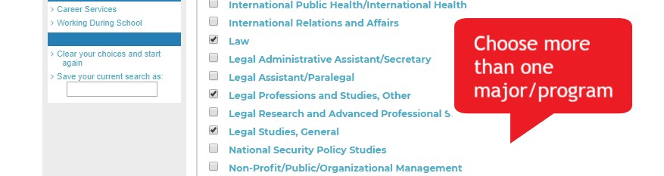

STEP 3: Your criteria will generate a list of matching schools. To learn more about each school, click on the institution’s name. Save four-year colleges of interest to your portfolio.

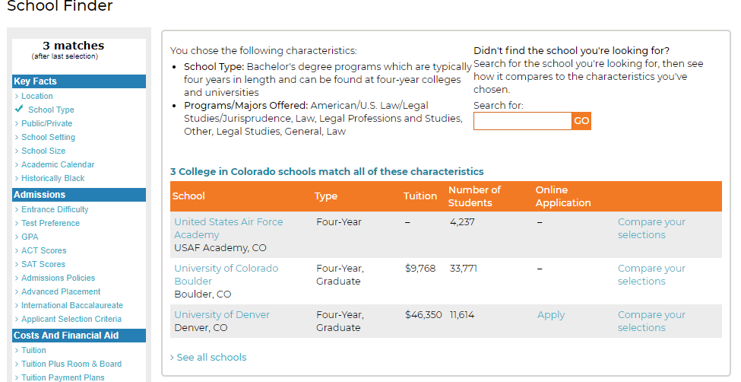

STEP 4: Revisit your SAT scores (and ACT if you took it).
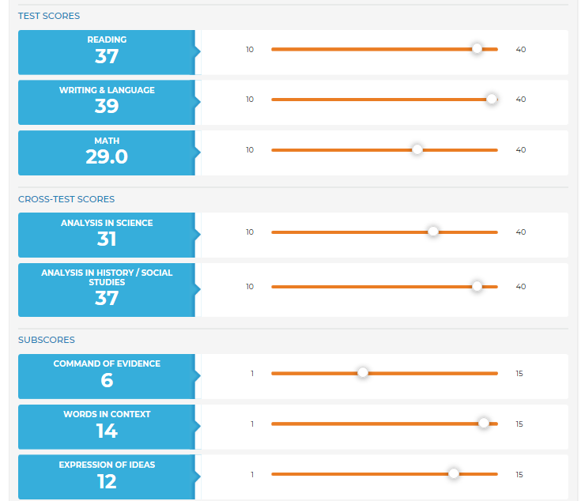
In your portfolio, (Your Portfolio > Your Profile > College Planning > Test Scores), enter your SAT or ACT scores or your predicted results.

After you record your scores, you will see on the summary page whether you are meeting or exceeding the “benchmark” score. The benchmark is a measure of whether you are fully prepared for college-level work in that subject.
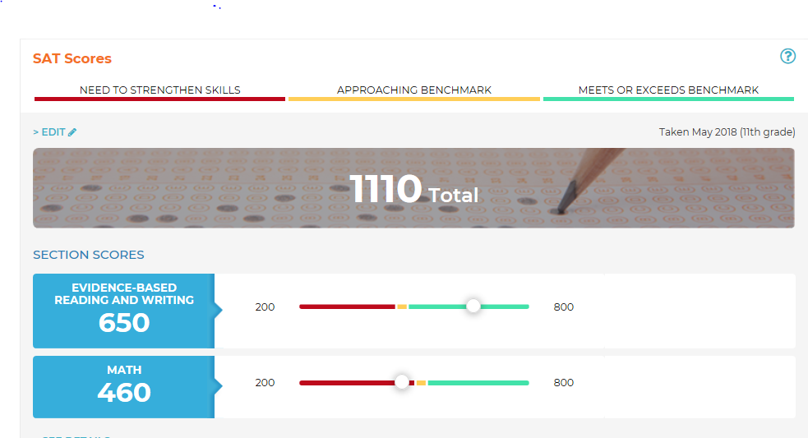
Consider Retake
Re
Great!

If you aren’t quite satisfied with your scores, your can do the following to improve:
- Take additional coursework during your senior year to increase your knowledge;
- Complete Kahn Academy test preparation for the SAT;
- Retake the test (you may have to pay for this).

STEP 5: If you are interested in any Colorado four-year schools, visit the College Admissions Tool Matching College List. Enter your high school GPA and test scores. How competitive are you at each school? If the dials indicate your score is within or above the green area, you are competitive or highly competitive among students who were admitted to that school. Select to Compare your favorites.

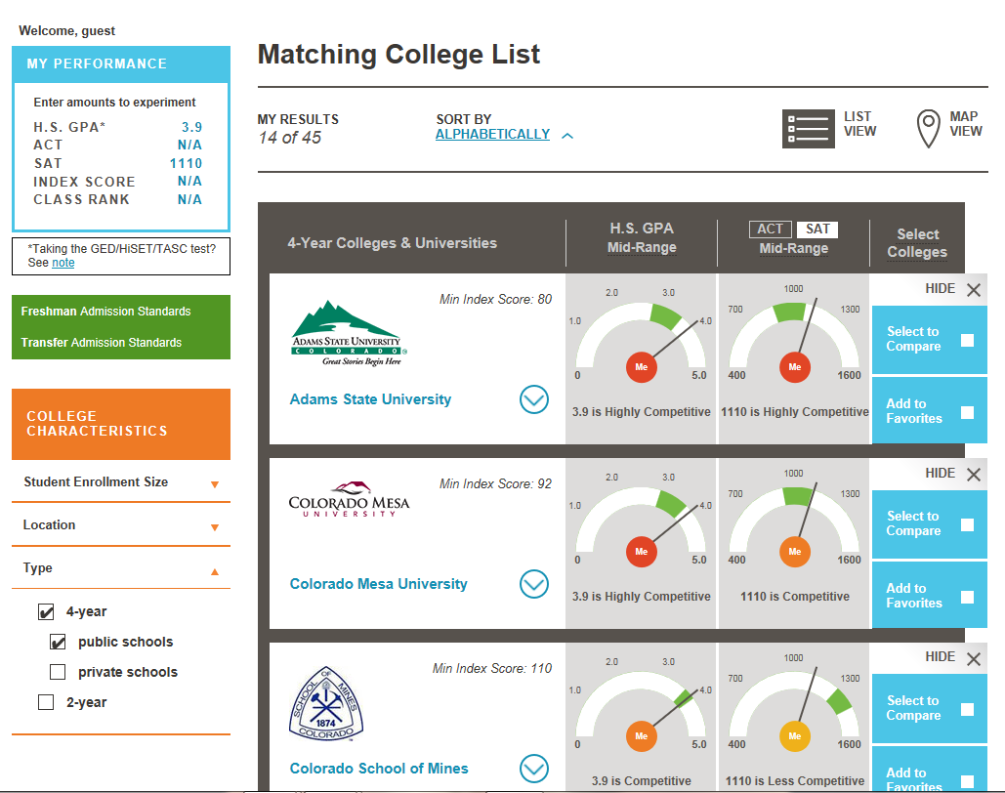
Apply filters

Exploring Community Colleges

STEP 1: From the CIC homepage, navigate to the College Planning > Explore Postsecondary Schools > School Finder.

STEP 2: Use the menu on the left side of your screen to filter by dozens of criteria. Click School Type and select Two-Year, then Programs/Majors Offered to select the postsecondary program(s) you identified earlier. When you finish inputting a couple of criteria, scroll down and click See Matching Schools. Hint: Pick only two or three criteria for best results.

STEP 3: Your criteria will generate a list of matching schools. To learn more, click on the two-year institution names.
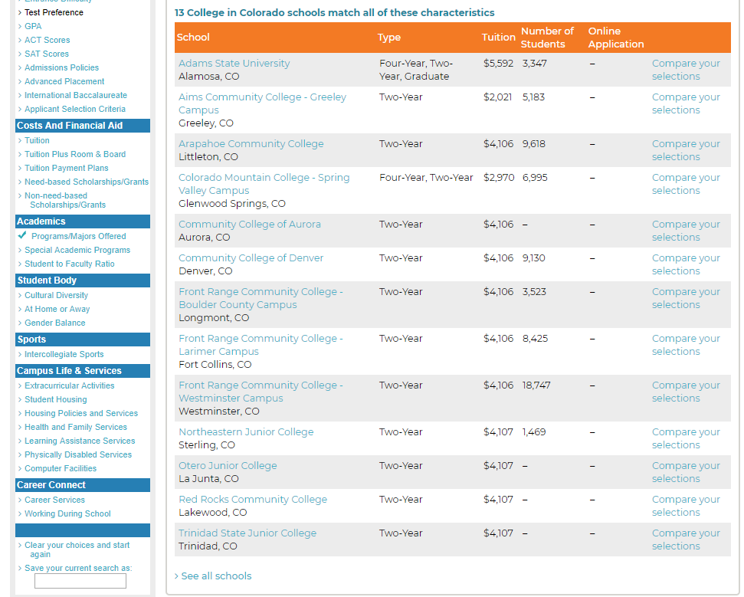

Exploring Certificate Programs

You can earn a certificate at a two-year institution or a private occupational school, such as an coding or culinary school. To find a program of interest near you, navigate to the Colorado Training Providers Website.

STEP 1: When you arrive at Colorado Training Providers Website, click Explore Careers.

STEP 2: Click the general career area you would like to pursue. Then select your pathway, occupation and program of study (shown on the following page).

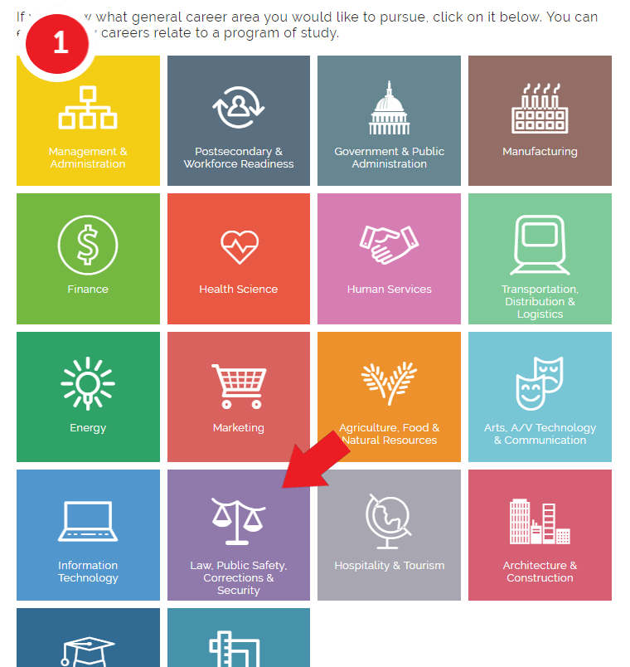

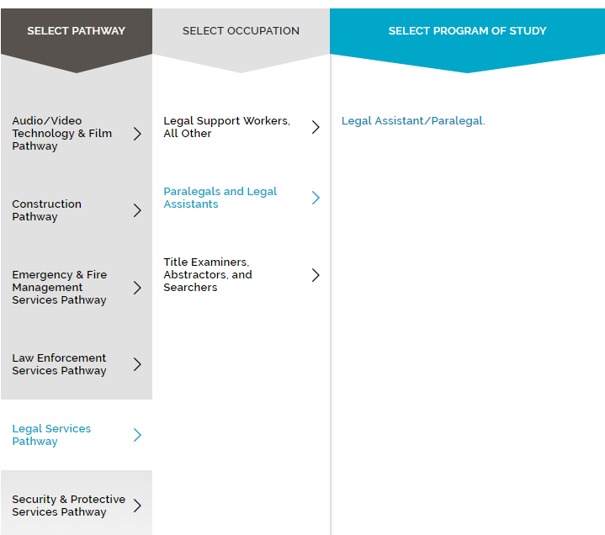

STEP 3: You should see a list of available programs. Use the menus to the left to narrow down your options by zip code and cost. Under the Credential filter, be sure to select Certificate. Once you find a program that works for you, click on the link. This will take to a webpage with more information about the program.

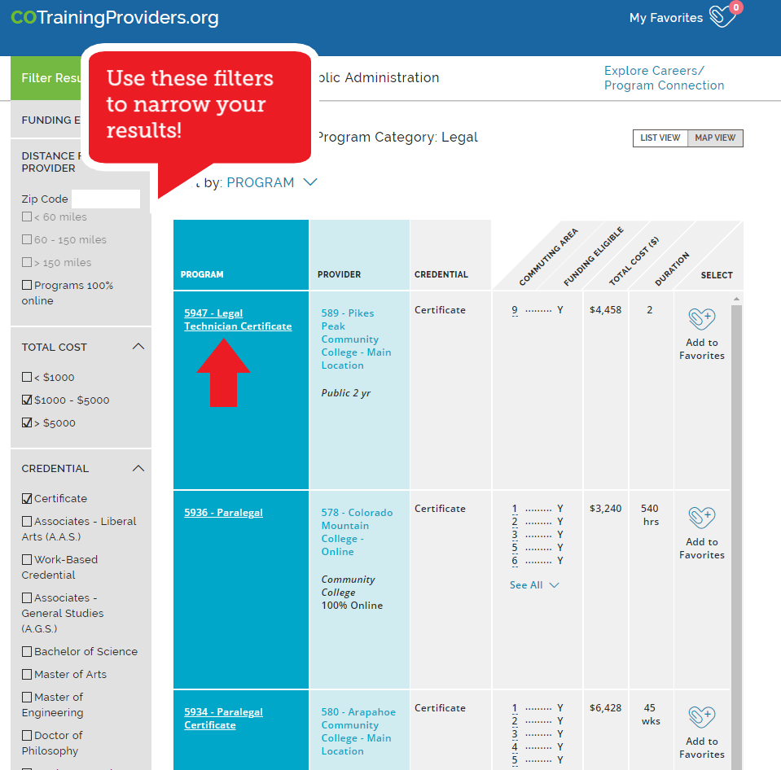
You may be able to receive funding from the Workforce Center in region 9 to take this program – contact them!

STEP 4: Use the Program Overview information to find the program website and program contact. Click the Provider Details tab to learn more about the organization provider the training.

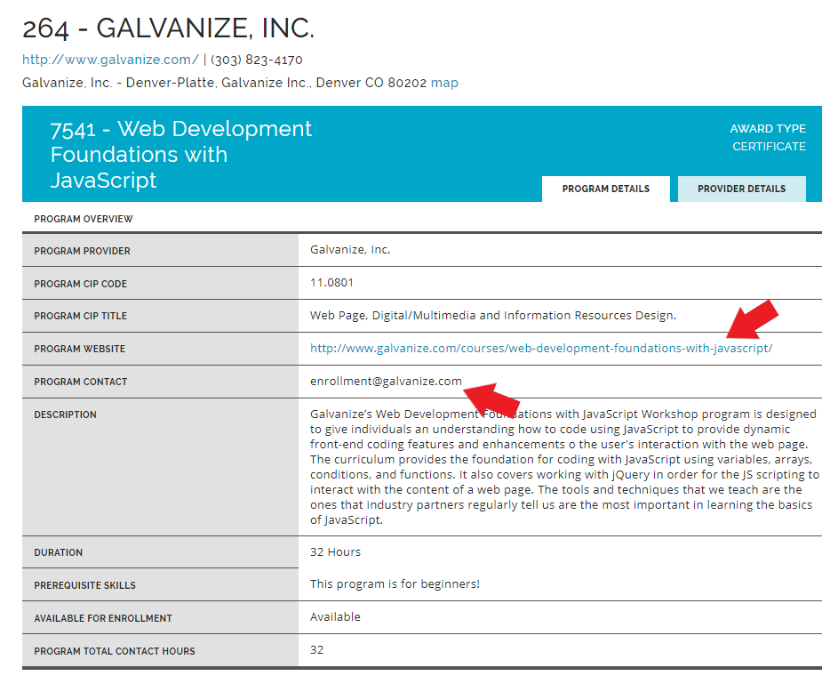

Exploring Military Service

STEP 1: Review the requirements to join the Army, Air Force, Navy, Marine Corps or Coast Guard.
To join the enlisted ranks, in general you must:
- Be a U.S. citizen or Green Card holder
  - Non-citizens must speak, read and write English fluently
  - Non-citizens must currently live in the U.S.
- Be in good health
- Be at least 17 years old
- Have a high school diploma (some branches will accept a GED)
- Pass the Armed Services Vocational Aptitude Battery (ASVAB) test
To become an officer:
- Graduate from one of the U.S. service academies. The academies are colleges that train future commissioned officers.
- United States Military Academy — Army
- United States Naval Academy — Navy and Marine Corps
- United States Coast Guard Academy
- United States Merchant Marine Academy
- United States Air Force Academy
Learn how to apply to academy here.
- You can also earn an officer commission through:
- Officer Candidate School (OCS)
- Reserve Officers Training Corps (ROTC)
- A direct commission from the enlisted ranks
- Certain legal, medical, or clergy professions

STEP 2: Talk with a recruiter for the military branch you wish to join.

STEP 3: If you’re ready to enlist, schedule (with your recruiter) your visit to a Military Entrance Processing Station (MEPS) to start the process. To join, you will need to
- Take and pass the Armed Services Vocational Aptitude Battery (ASVAB)
- Pass the physical examination
- Meet with a career counselor
- Take the oath to serve

Exploring Apprenticeships

If you have selected a career that may have an apprenticeship option, you can prepare to land an apprenticeship in much the same way as a job.

STEP 1: Try out pre-apprenticeship and pre-vocational courses to gain some skills
- Ask your high school counsellor or advisor about career and technical education programs and courses (CTE).
- Pre-apprenticeship and pre-vocational courses can help you try out a trade or job and get some valuable experience. You’ll do some classroom learning that can earn credit towards a full apprenticeship.
- Courses are usually at Certificate II level. If you are currently looking for work, there are courses available that can help you.

STEP 2: Find an employer who will take you on as an apprentice or trainee.
- Talk to local businesses and find out how they recruit for apprentices or trainees. An employer in your area might be looking for someone right now. Check the Apprenticeship Finder or visit ApprenticeshipEvolution.com or find employers registered to take on apprentices or trainees in your field of your choice.
- Check advertisements in newspapers: is anyone looking for apprentices or trainees? The employment section is the best place to start. Remember that some newspapers have online job ads that you can search as well.
- Try online job sites such as Colorado ZipRecruiter or Craigslist. Look for businesses that have openings for jobs in your career – they may be looking for apprentices or trainees.
- Check with your school advisor to see if your district has CareerWise Apprenticeships or other apprenticeships available.

Jot Down Your Options

STEP 3 CONTINUED: Write down a list of options, including colleges, universities, career and technical schools, military branches or apprenticeship programs that interest you!
School/Program Name |  | Program/Major(s) Ideas
Apprenticeships
Military Service
Certificate Programs
Community College
Colleges/Universities

