WEEK 1
EXPLORE AFTER HIGH SCHOOL PATHWAY OPTIONS

Even if you didn’t apply last fall, it’s not too late to apply to a postsecondary program! There are many education options available to apply to after you graduate, including community colleges, technical schools, apprenticeships and military service.

Your Task: Use the College Admissions Tool to research postsecondary pathways.

STEP 1: Open the College Admissions Tool. Sign in using your CollegeInColorado.org account and click BUILD OPTIONS WIZARD.
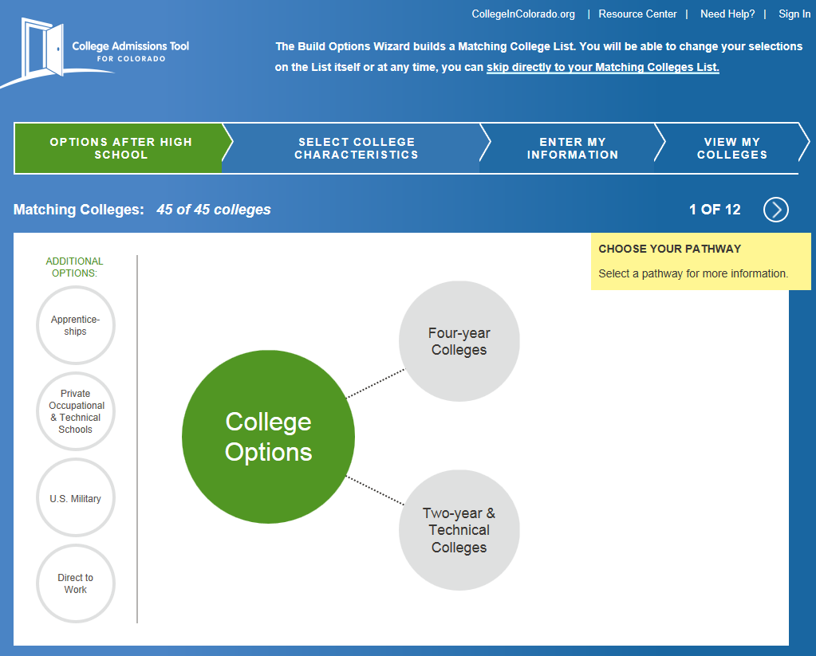

STEP 2: Click Four-year Colleges then select the Benefits and Trade-offs drop-down categories. Read through the items in these two categories.

STEP 3: Continue by clicking the other circles, including Two-Year and Technical Colleges, Apprenticeships, Private Occupational & Technical Schools, U.S. Military and Direct to Work. On each of these other after high school education options, look at their Benefits and Trade-offs.

STEP 4: Complete the chart below as you explore.

Option | Summarize Benefits | Summarize Trade-offs
Two-Year & Technical Colleges

Apprenticeships

Private Occupational & Technical Schools

U. S. Military

As you can see, each option has benefits and trade-offs. Which one or two options are most appealing to you? Record your choices below and discuss your reasons.

