WEEK 3
IDENTIFY COMMUNITY COLLEGES, CERTIFICATE PROGRAMS APPRENTICESHIPS AND MILITARY SERVICE

This week, you’ll use online tools to come up with a list of matching schools and programs to where you might apply.

Your Task: Use online tools to identify possible options after high school.

STEP 1: Think back to your pathways and career exploration. In the table below, enter your four top careers in the first column and then list two programs for each career that sounds interesting.

Hint: Enter the career name in the search box at CollegeInColorado.org, and then, from the Career Profile, click the What to Learn tab.
Career | Level of Education* | Program of Study/Major

*Associate degree, certificate, military or apprenticeship

STEP 2: Start exploring!
We have tools to help you explore matches for each of these pathways. Click the links below and follow the directions to get started!

- Community colleges (two-year associate degrees and certificates)
- Private occupational schools (certificates)
- Military branches (Army, Navy, Air Force, Marines, Coast Guard)

STEP 3: Once you’ve explored your options, jot them down in this handy chart at the back of this packet. This will help you narrow down where you want to apply in the fall of your senior year.

Explore Community Colleges

STEP 1: From the CIC homepage, navigate to the College Planning > Explore Postsecondary Schools > School Finder.

STEP 2: Use the menu on the left side of your screen to filter by dozens of criteria. Click School Type and select Two-Year, then Programs/Majors Offered to select the postsecondary program(s) you identified earlier. When you finish inputting a couple of criteria, scroll down and click See Matching Schools. Hint: Pick only two or three criteria for best results.

STEP 3: Your criteria will generate a list of matching schools. To learn more, click on the two-year institution names.
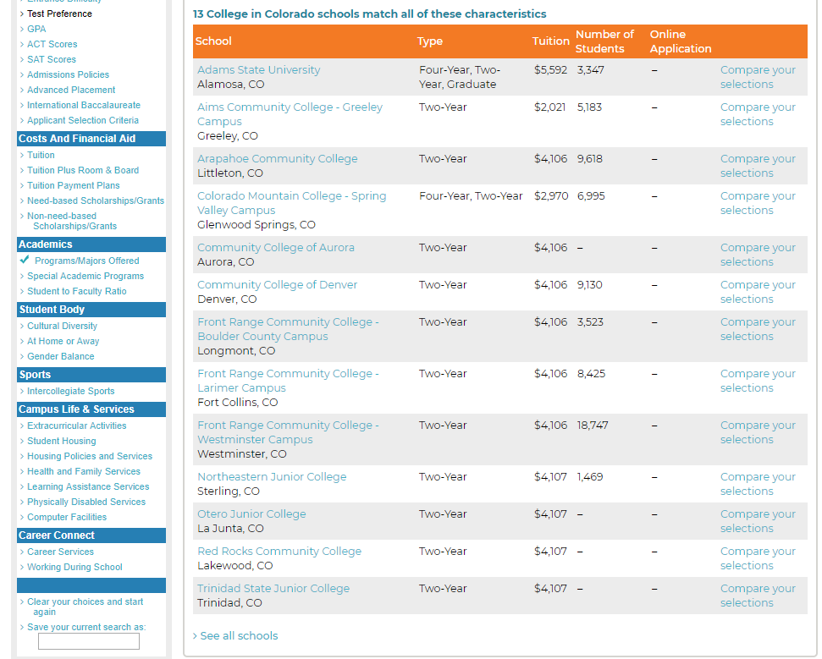

Explore Certificate Programs

You can earn a certificate at a two-year institution or a private occupational school, such as an coding or culinary school. To find a program of interest near you, navigate to the Colorado Training Providers Website.

STEP 1: When you arrive at Colorado Training Providers Website, click Explore Careers.

STEP 2: Click the general career area you would like to pursue. Then select your pathway, occupation and program of study (shown on the following page).

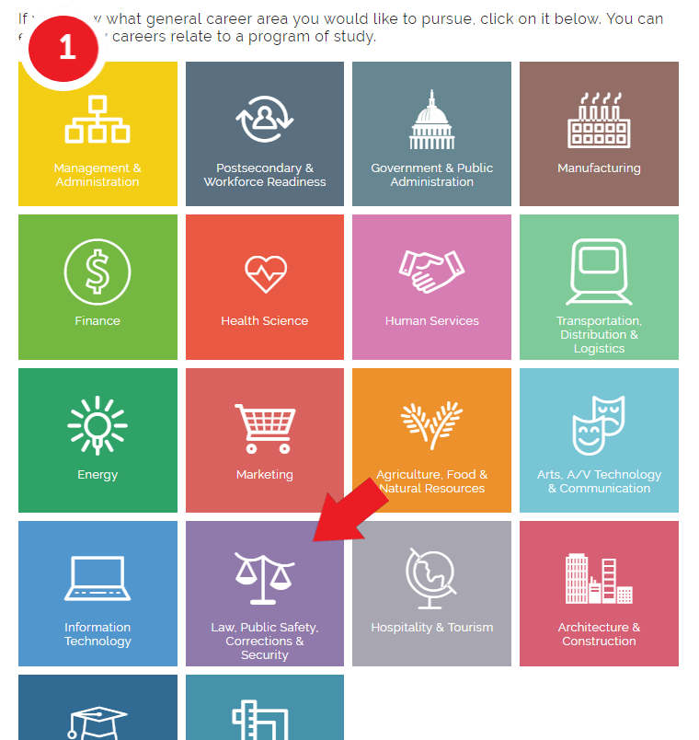

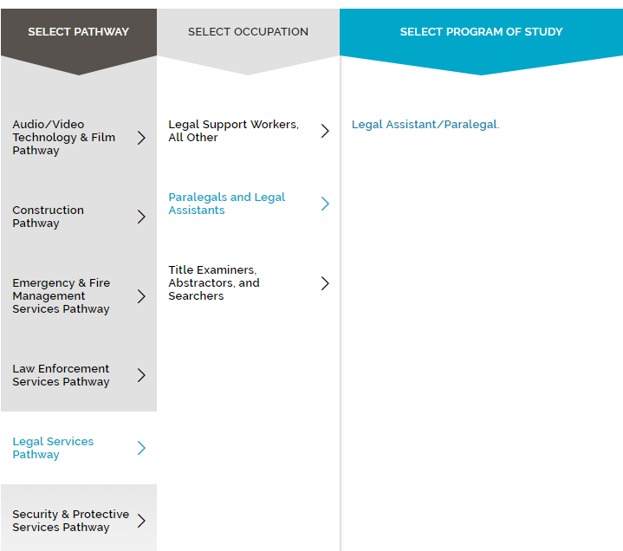

STEP 3: You should see a list of available programs. Use the menus to the left to narrow down your options by zip code and cost. Under the Credential filter, be sure to select Certificate. Once you find a program that works for you, click on the link. This will take to a webpage with more information about the program.

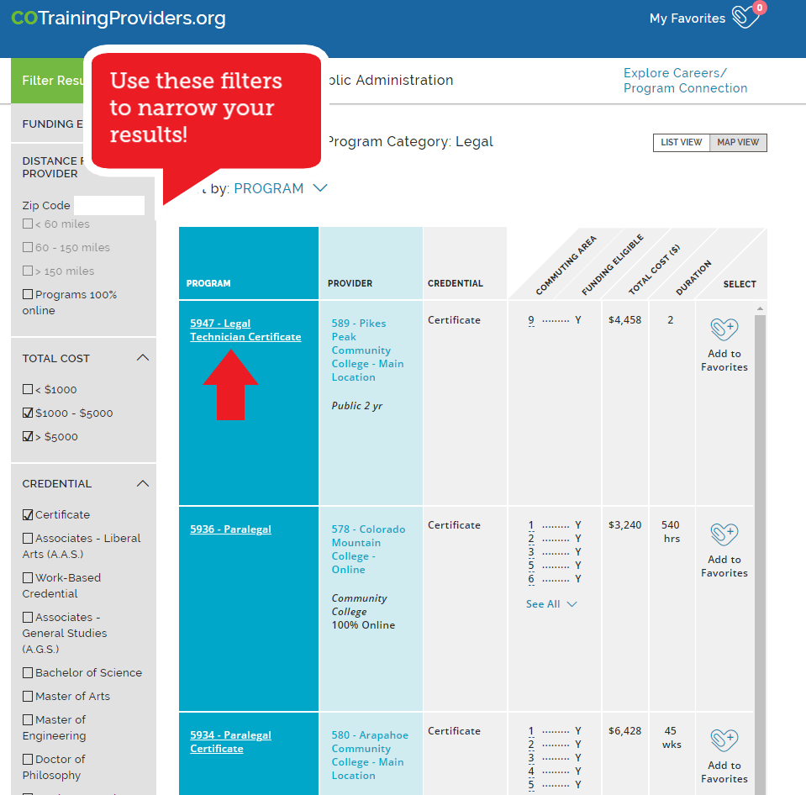
You may be able to receive funding from the Workforce Center in region 9 to take this program – contact them!

STEP 4: Use the Program Overview information to find the program website and program contact. Click the Provider Details tab to learn more about the organization provider the training.

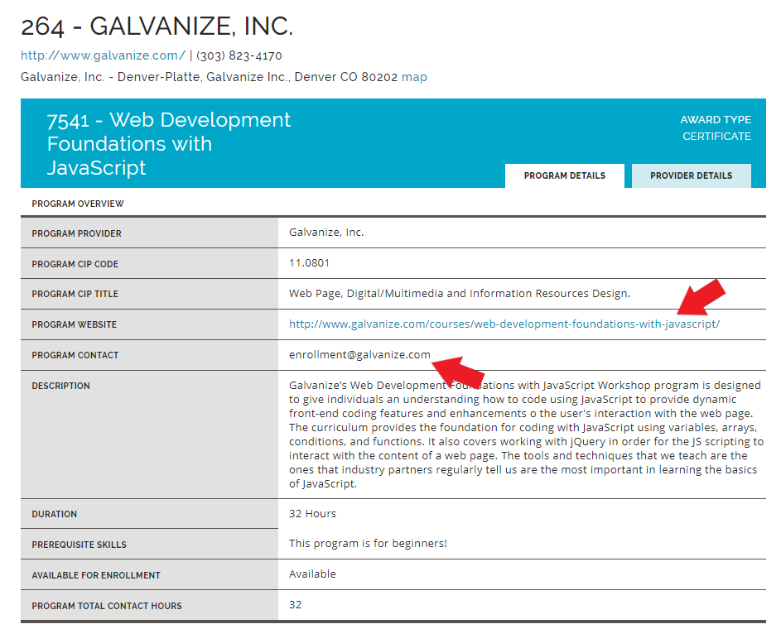

Explore Military Service

STEP 1: Review the requirements to join the Army, Air Force, Navy, Marine Corps or Coast Guard.
To join the enlisted ranks, in general you must:
- Be a U.S. citizen or Green Card holder
  - Non-citizens must speak, read and write English fluently
  - Non-citizens must currently live in the U.S.
- Be in good health
- Be at least 17 years old
- Have a high school diploma (some branches will accept a GED)
- Pass the Armed Services Vocational Aptitude Battery (ASVAB) test
To become an officer:
- Graduate from one of the U.S. service academies. The academies are colleges that train future commissioned officers.
- United States Military Academy — Army
- United States Naval Academy — Navy and Marine Corps
- United States Coast Guard Academy
- United States Merchant Marine Academy
- United States Air Force Academy
Learn how to apply to academy here.
- You can also earn an officer commission through:
- Officer Candidate School (OCS)
- Reserve Officers Training Corps (ROTC)
- A direct commission from the enlisted ranks
- Certain legal, medical, or clergy professions

STEP 2: Talk with a recruiter for the military branch you wish to join.

STEP 3: If you’re ready to enlist, schedule (with your recruiter) your visit to a Military Entrance Processing Station (MEPS) to start the process. To join, you will need to
- Take and pass the Armed Services Vocational Aptitude Battery (ASVAB)
- Pass the physical examination
- Meet with a career counselor
- Take the oath to serve

Explore Apprenticeships

If you have selected a career that may have an apprenticeship option, you can prepare to land an apprenticeship in much the same way as a job.

STEP 1: Try out pre-apprenticeship and pre-vocational courses to gain some skills
- Ask your high school counsellor or advisor about career and technical education programs and courses (CTE).
- Pre-apprenticeship and pre-vocational courses can help you try out a trade or job and get some valuable experience. You’ll do some classroom learning that can earn credit towards a full apprenticeship.
- Courses are usually at Certificate II level. If you are currently looking for work, there are courses available that can help you.

STEP 2: Find an employer who will take you on as an apprentice or trainee.
- Talk to local businesses and find out how they recruit for apprentices or trainees. An employer in your area might be looking for someone right now. Check the Apprenticeship Finder or visit ApprenticeshipEvolution.com or find employers registered to take on apprentices or trainees in your field of your choice.
- Check advertisements in newspapers: is anyone looking for apprentices or trainees? The employment section is the best place to start. Remember that some newspapers have online job ads that you can search as well.
- Try online job sites such as Colorado ZipRecruiter or Craigslist. Look for businesses that have openings for jobs in your career – they may be looking for apprentices or trainees.
- Check with your school advisor to see if your district has CareerWise Apprenticeships or other apprenticeships available.

Putting it All Together

Write down a list of options, including community colleges, career and technical schools, military branches or apprenticeship programs that you plan to apply to!

Postsecondary Option* | Program/Major(s) Ideas

* Community college, private occupational school, apprenticeship or military branch name

