WEEK 1
PASS THE ASVAB GOAL SETTING ACTIVITY

Your Task: If you are considering going into the military, set a goal and create an action plan to pass the ASVAB.

STEP 1: Click Set Your Goals & Action Plans

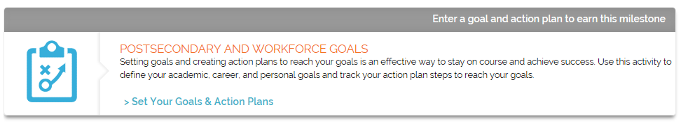

STEP 2: Click Choose a type of goal to view the list of choices.

Since your goal is to pass the ASVAB, choose Academic from the dropdown list.

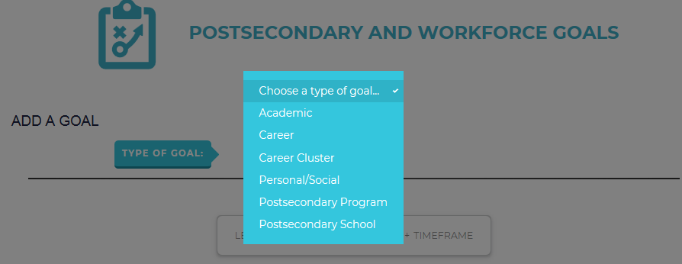

STEP 3: How sure are you of this activity? Click Choose one… to open the list for level of interest.

If you are very certain of your goal, select I will from the dropdown list. Or, if you’re not quite as certain, select among the other items.

STEP 4: In the box, enter goal to pass the ASVAB. The system will remember your level of interest, so enter just include your goal.

For example, if your goal should state, “I will pass the ASVAB,” in the box you will enter simply “pass the ASVAB.”

STEP 5: Click Choose a Timeframe and then select the appropriate timeline from the dropdown list.

STEP 6: You can also click to change the goal priority if you wish. Click Next.

STEP 7: Take a look at your completed goal statement:

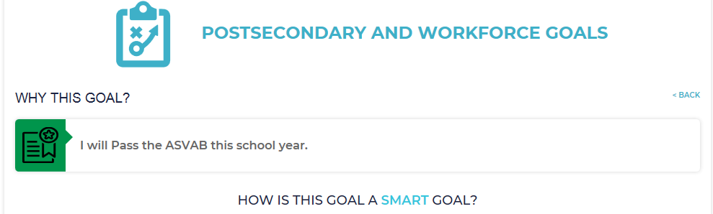

STEP 8: You can continue on with the rest of the activity by discussing how this is a SMART goal; that is, how is your goal specific, measurable, achievable, relevant and timely?

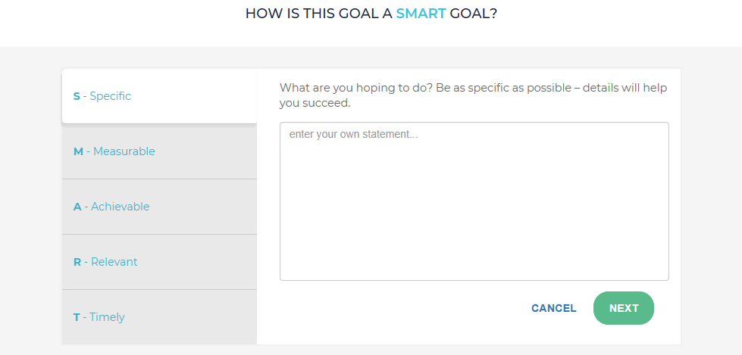
STEP 9: Go on to define an action plan for your goal. Be sure to:
- Look at sample ASVAB questions
- Schedule test preparation activities
- Note your test date on your planner
- Take the test
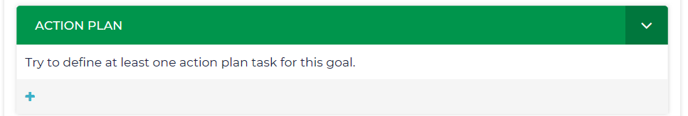

Your goal setting activity is available in your portfolio and ICAP any time you want to refresh your memory and motivation about your future!

STEP 10: Record your ASVAB scores (Your Portfolio > Career Planning > All About You).

